**Events List:**

**2022-23**

|  |  |  |  |
| --- | --- | --- | --- |
| **Sl. No.** | **Event Title** | **Event Date** | **Resource Person** |
| **1** | Career guidance and Oppurtunities | 22-12-2022 | Mr.S. M. M.Trinath in association with ACE Engg Academy |
| **2** | Design of solar PV System | 16-12-2022 to 19-12-2022 | Dr. M. Ranjith |
| **3** | National Energy Conservation day in association with ISTE | 14-12-2022 | Dr. M. Ranjith |
| **4** | Implementation of circuit design using computer aided design tools | 15-12-2022 to 17-12-2022 | Ms.K.Swapna, Ms. V. Sabitha, Ms. R. Lavanya in association with navica communication Pvt.Ltd. |
| **5** | Industrial visit to ISRO,Sriharikota | 06-12-2022 to 9-12-2022 | Ms.B.Sreedevi,Ms.S.Vaishali,Mr.B.Vijay kumar,Mr.B.Nagaraju |
| **6** | International day for the Elimination of violence against women | 1/12/2022 | Smt. Jhansi LaxmiBaigaru,M.Sharada,vasudha ,Vijayalaxmi,Ch.sumithra, &Pavani |
| **7** | Career guidance at Govt School | 16-11-2022 |  |

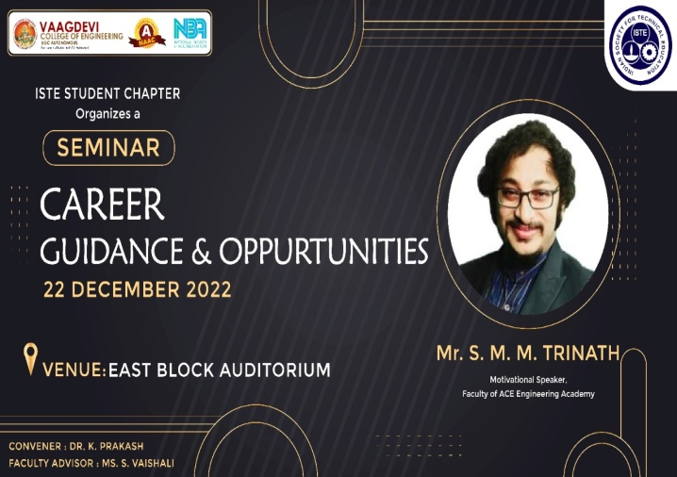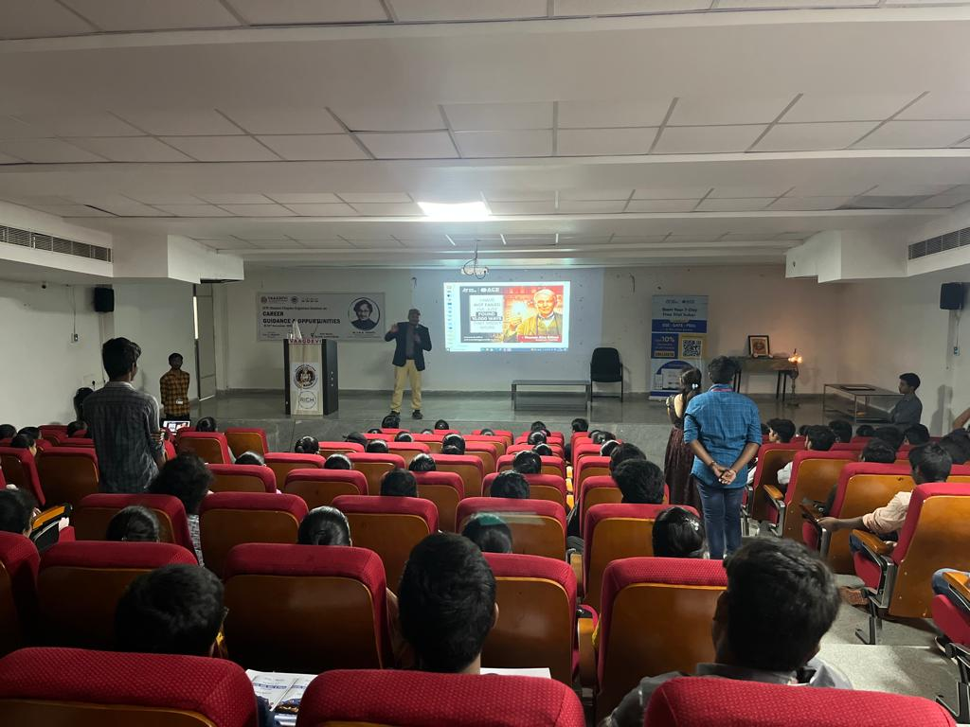

Fig 4.5.1.4:Career guidance and Oppurtunities, Mr.S. M. M.Trinath in association with ACE Engg Academy

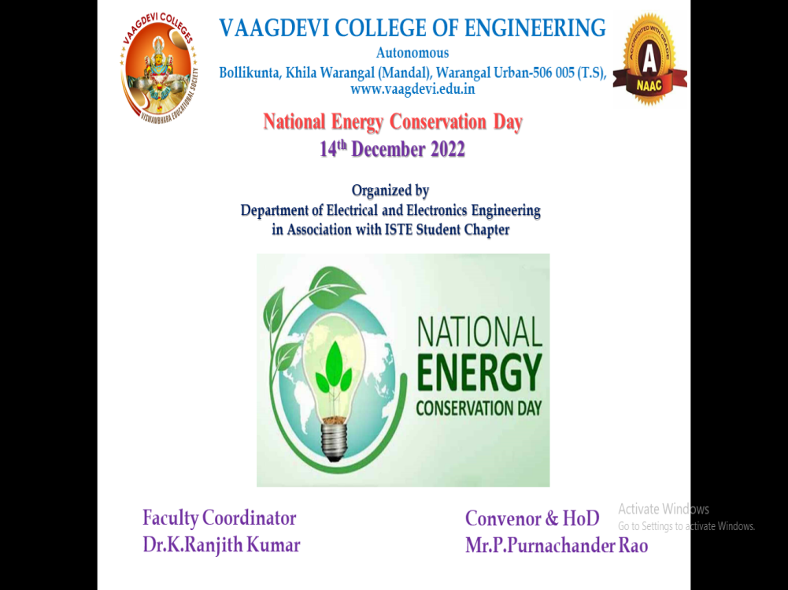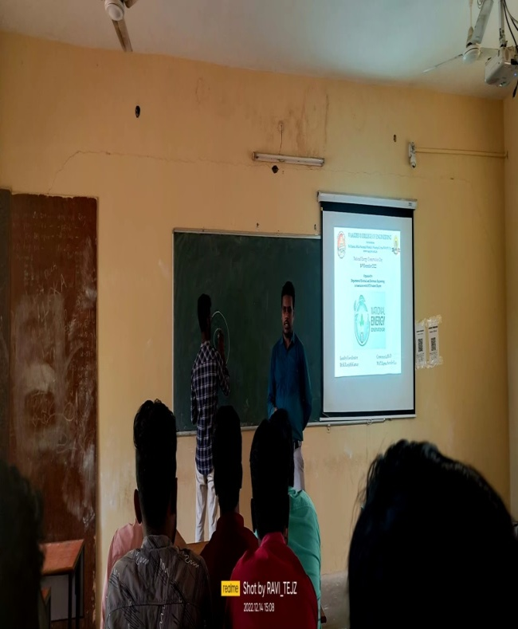

Fig 4.5.1.5: National Energy Conservation day in association with ISTE: Dr. M. Ranjith (EEE)-VCE

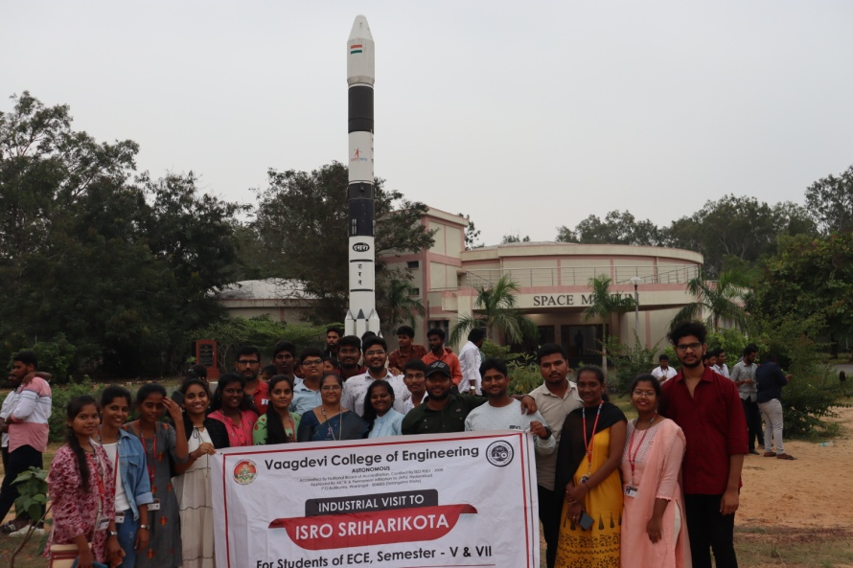

Fig 4.5.1.6:Industrial visit to ISRO,Sriharikota

**2021-22**

|  |  |  |  |
| --- | --- | --- | --- |
| **Sl. No.** | **Event Title** | **Event Date** | **Resource Person** |
| **1** | Higher Education Abroad(offline) | 28-06-2022 | A.Venkat Ram Chandra Reddy,Senior software Engineer,Virginia,USA |
| **2** | Innovation start-up Career guidance | 13-05-2022 | Ms.Harika Thummuri (Digital media executive, Government of Telangana |
| **3** | Life skills Motivational talk(offline) | 13-05-2022 | Mr.Raja Narender Reddy(National Executive Council,ISTE Telangana section) |
| **4** | Introduction to Embedded systems and robotics (offline) | 03-01-2022 and 04-01-2022 | Mr.Manoj kumar,Navica Communications Pvt.Ltd. |
| **5** | Orientation program on Benefits of ISTE | 30-12-2021 | Ms.S.Vaishali and student branch volunteers of ISTE |
| **6** | Interactive session on Prime Minister’s Research Fellowship program | 23-11-2021 | Ms.Roja Vadlamudi,Research Scholar, NIT Trichy. |



Fig 4.5.1.7: Innovation start-up Career guidance

**2020-21**

|  |  |  |  |
| --- | --- | --- | --- |
| **Sl. No.** | **Event Title** | **Event Date** | **Resource Person** |
| **1** | How to become Scientist from Engineer | 1/5/2021 | Mr.Murali Kunde, Scientist, ISRO Sriharikota |
| **2** | Higher education in abroad(online) | 10/4/2021 | A.Venkat Ram Chandra Reddy,Senior software Engineer,Virginia,USA |
| **3** | Start-up & Entrepreneurship(online) | 27-02-2021 | Dr.Rajesh Kulkarni ,Hetic Bengaluru |
| **4** | Online Quiz on Aptitude test and Interview related topics.(online) | 24-01-2021 | **ISTE Student Chapter** |
| **5** | Webinar on “Career Guidance, Gate and Interview Guidance(online) | 17-01- 2021 | Dr.B.N.Rao Professor in Unacademy |
| 6 | Webinar on VLSI technology(online) | **18-10-2020 to 19-10-2020** | Mr.Mahesh Goud |

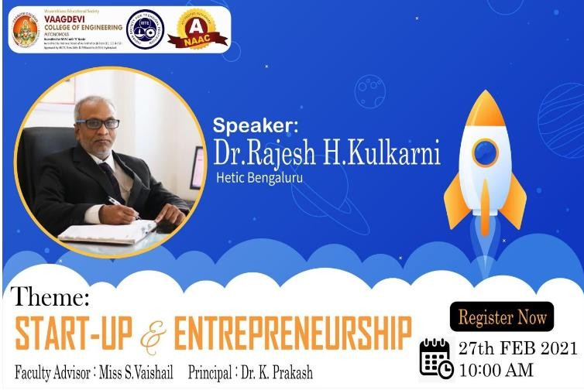

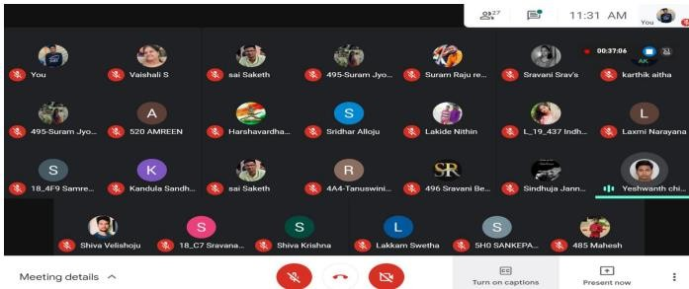

Fig 4.5.1.8:Start-up & Entrepreneurship (online): Dr.Rajesh Kulkarni ,Hetic Bengaluru

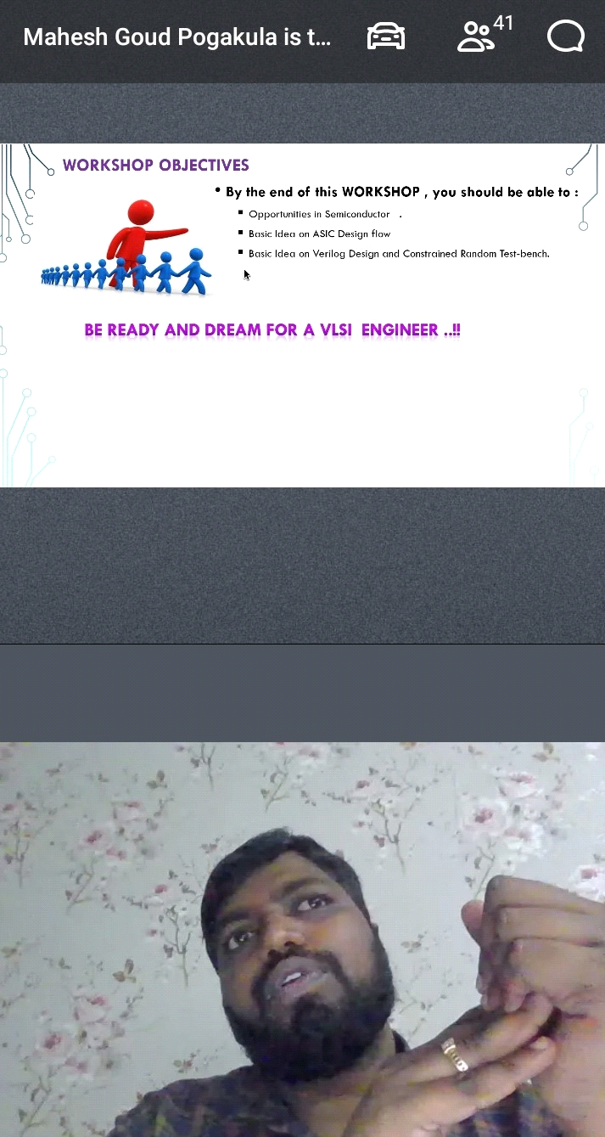

Fig 4.5.1.9: Resource person Mr. Mahesh Goud delivering online webinar related to VLSI Technology

**2019-20**

|  |  |  |  |
| --- | --- | --- | --- |
| **Sl. No.** | **Event Title** | **Event Date** | **Resource Person** |
| **1** | Motivational Talk(offline) | 22-01-2020 | Dr.Jaya Lakshmi Coppisetty(Psychologist) |
| **2** | Awareness on child welfare and Sexual Abuse | 05-03-2020 | Kasturba school,Inavolu |