(2019-2020)

Sl, no | Activity /Achievement |  |  | Date | Remark
1 | Combined Annual Training Camp, PTC Mamnoor |  |  | 19-06-2019 To 28-06-2019 | 53 Cadets & 01 ANO
2 | International yoga Day, Vaagdevi College of Engineering |  |  | 21-06-2019 | 59 Cadets participated
3 | Kargil Vijay Diwas, Vaagdevi College of Engineering |  |  | 26-07-2019 | 75 Cadets & 01 ANO
4 | Blood Donation |  |  | 31-07-2019 | 45 Cadets & 01 ANO
5 | Trees Distribution to Cadets, Vaagdevi College of Engineering |  |  | 31-07-2019 | 25 Cadets participated
6 | 1 Year Orientation, Vaagdevi College of Engineering |  |  | 08-08-2019 | CO & 01 Year cadets
7 | Independence Day, Vaagdevi College of Engineering |  |  | 15-08-2019 | 50 Cadets & 1 ANO
8 | Tree Plantation |  |  | 23-08-2019 | 35 Cadets & 01 ANO
9 | Ganapathi Nimarjanam Hanamkonda |  |  | 11-09-2019 | 15 Cadets participated
10 | RCTC Camp |  |  | 31-10-2019 To 11-11-2019 | 01 Cadets participated
11 | National Unity Day, Vaagdevi College of Engineering |  |  | 31-10-2019 | 65 cadets & 01 ANO
12 | Swatch Bharat |  |  | 11-11-2019 | 35 cadets & 01 ANO
13 | Visit TO Inavolu village For Social Awareness |  |  | 19-11-2019 | 53 Cadets & 01 ANO
14 | Construction Day Celebrations |  |  | 26-11-2019 | 1 Year Students
15 | Plogging, Vaagdevi College of Engineering |  |  | 07-12-2019 | 30 Cadets & 01 ANO
16 | NER Trek-1 |  |  | 11-12-2019 to 18-12-2019 | 01 Cadets participated
17 |  | AFIC Southern Command |  | 05-02-2020 To 19-02-2020 | 01 Cadets participated
18 |  | I Stand for The Nation (Expire Jawan) | 20-02-2020 |  | 41 Cadets & 01 ANO

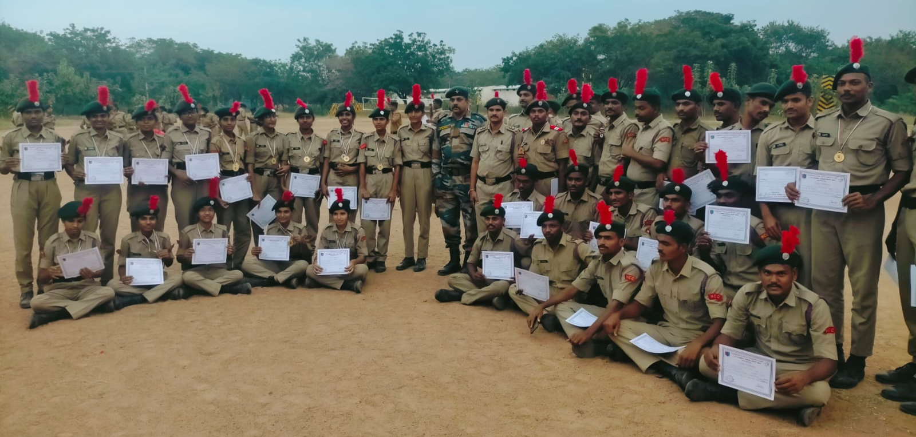

Combined Annual Training Camp, PTC (Mamnoor) (19-06-2019 To 28-06-2019)

International yoga Day, Vaagdevi College of Engineering
(21-06-2019)
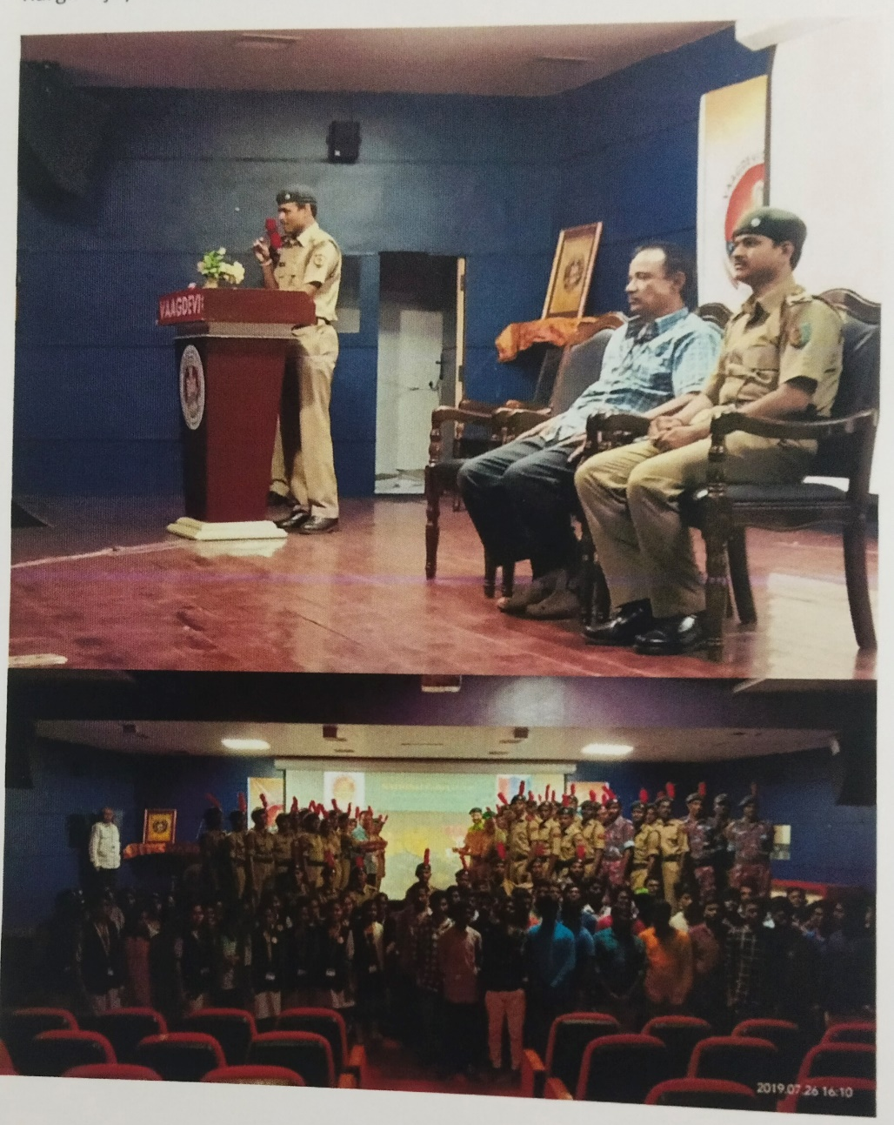
Kargil Vijay Diwas, Vaagdevi College of Engineering (26-07-2019)

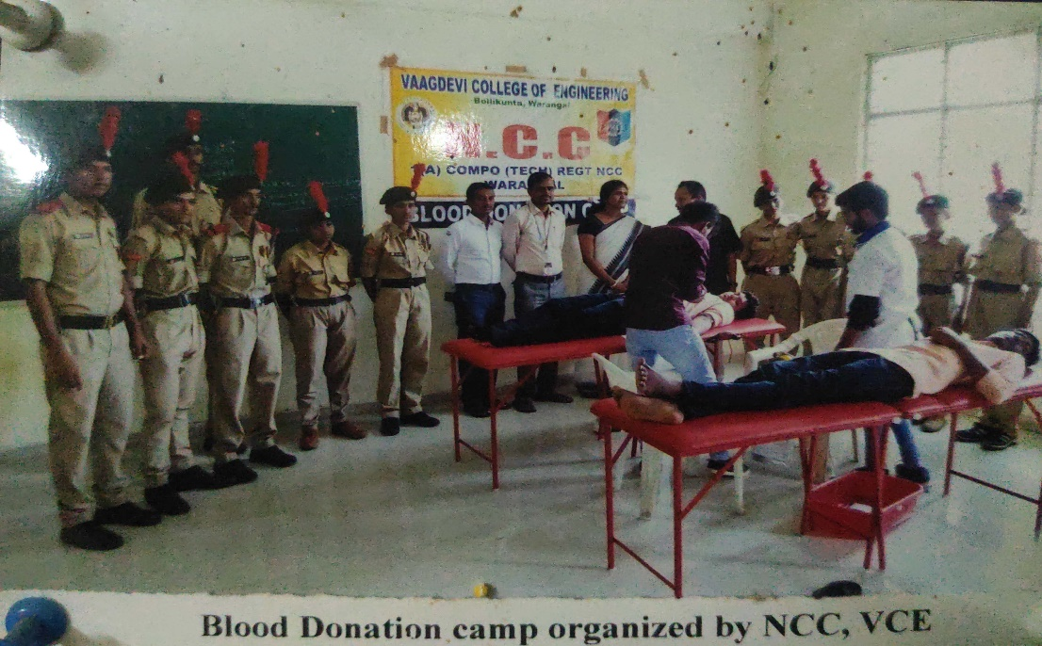
Blood Donation (31-07-2019)

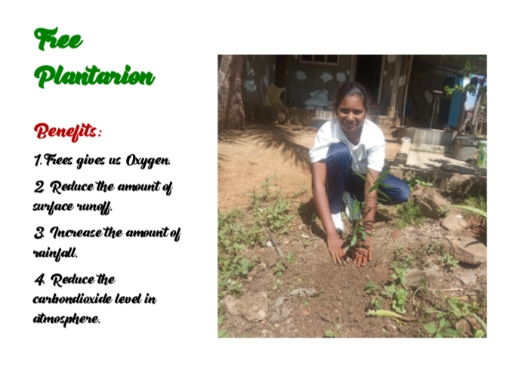 | 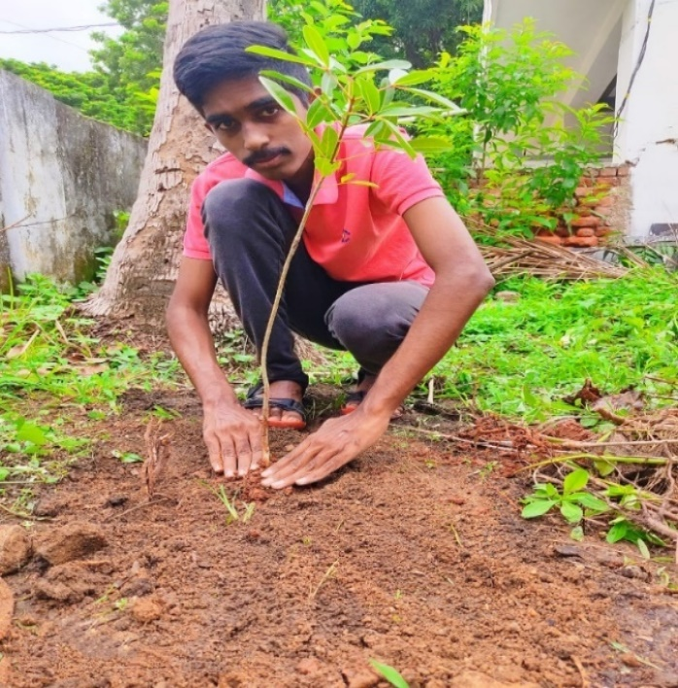

Trees Distribution to Cadets, Vaagdevi College of Engineering
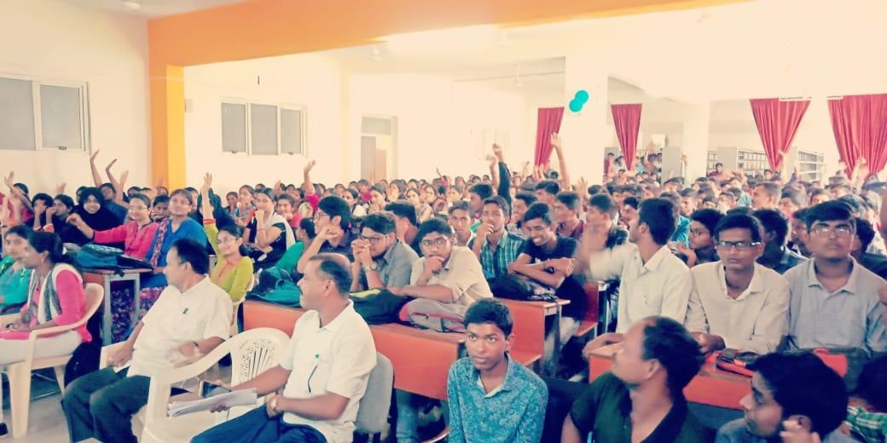
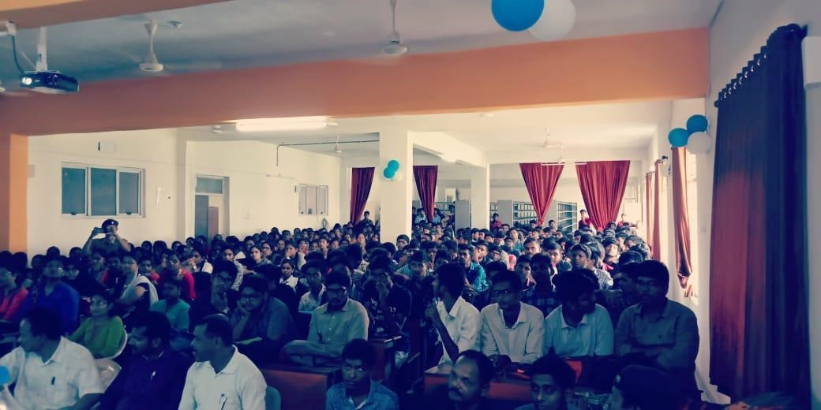
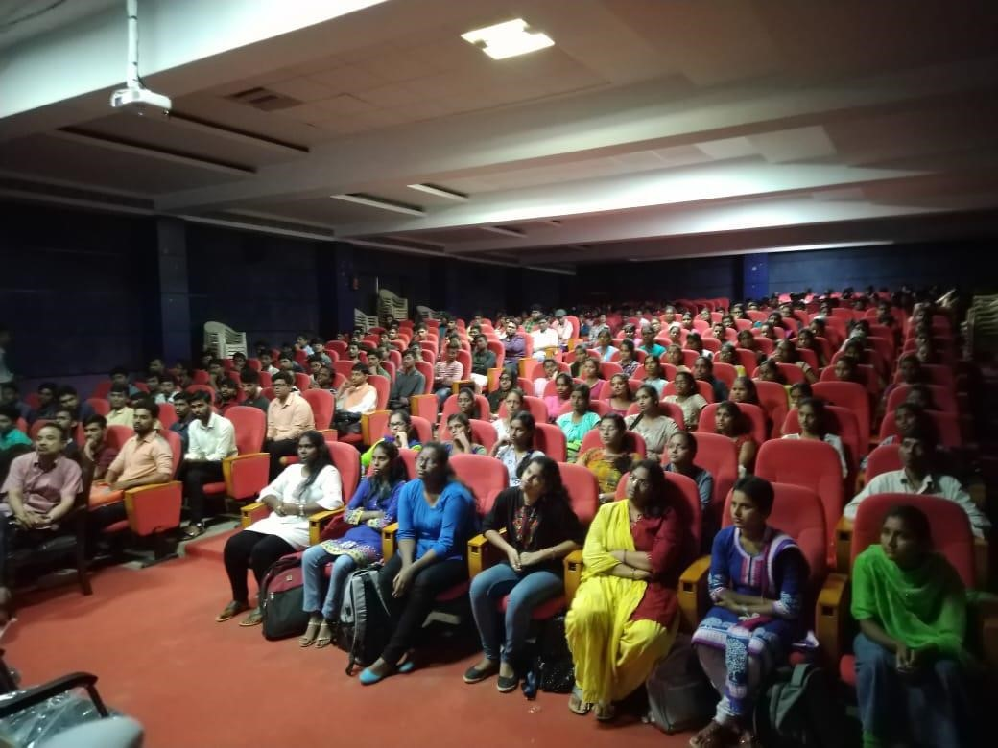
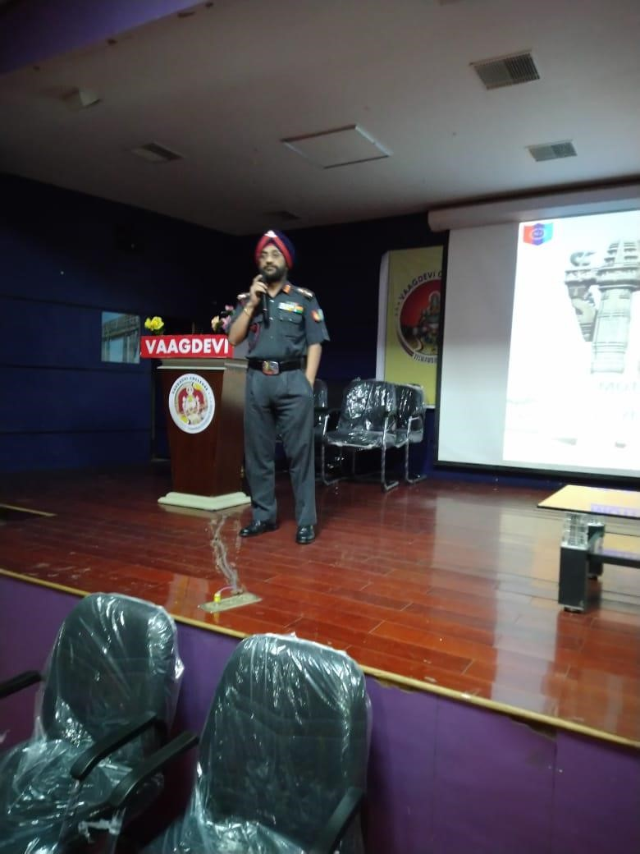

1 Year Orientation, Vaagdevi College of Engineering (Co Sir -1(T) CTR Battalion, Warangal)

Independence Day, Vaagdevi College of Engineering (15-08-2019)
Tree Plantation (23-08-2019)
Ganapathi Nimarjanam, Hanamkonda (11-09-2019)
RCTC CAMP Cdt. SURAM ABHIRAM
S, NO | Regt. No | RANK | NAME
01 | TS/17/SDA/200150 | CDT | SURAM ABHILASH

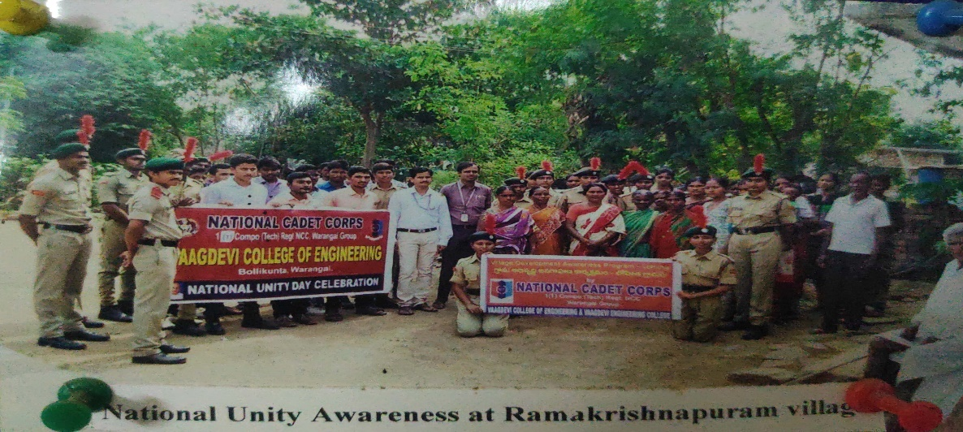
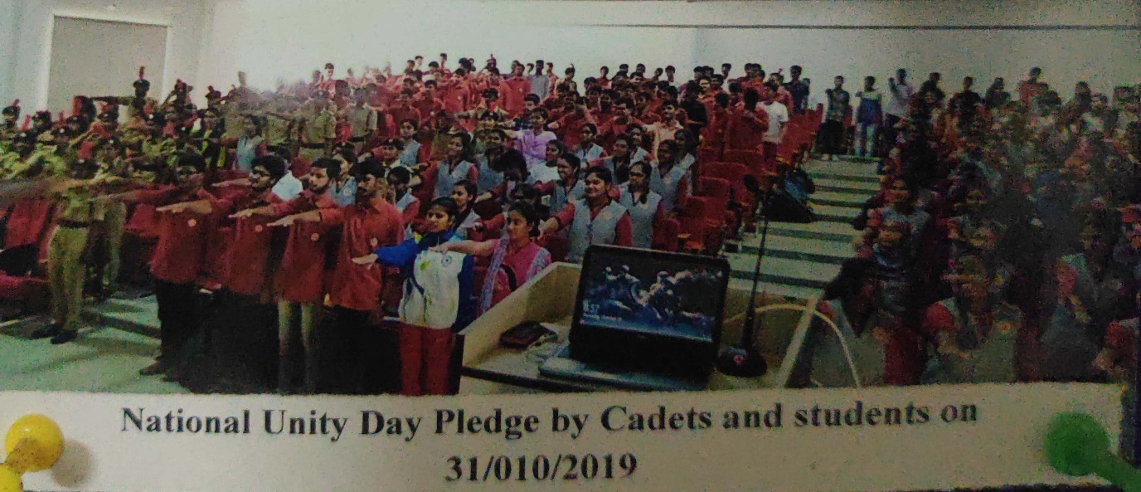
National Unity Day(31-10-2019)
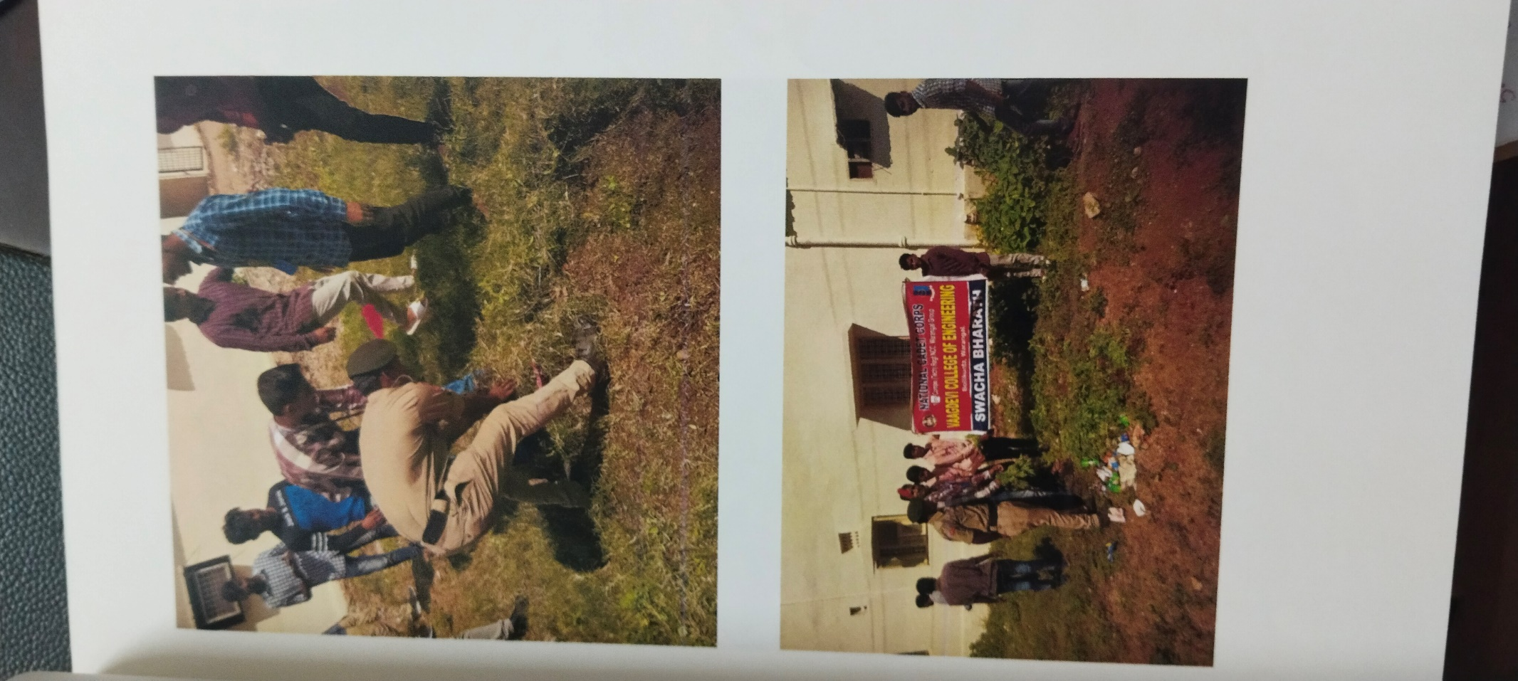
Swatch Bharat (11-11-2019)

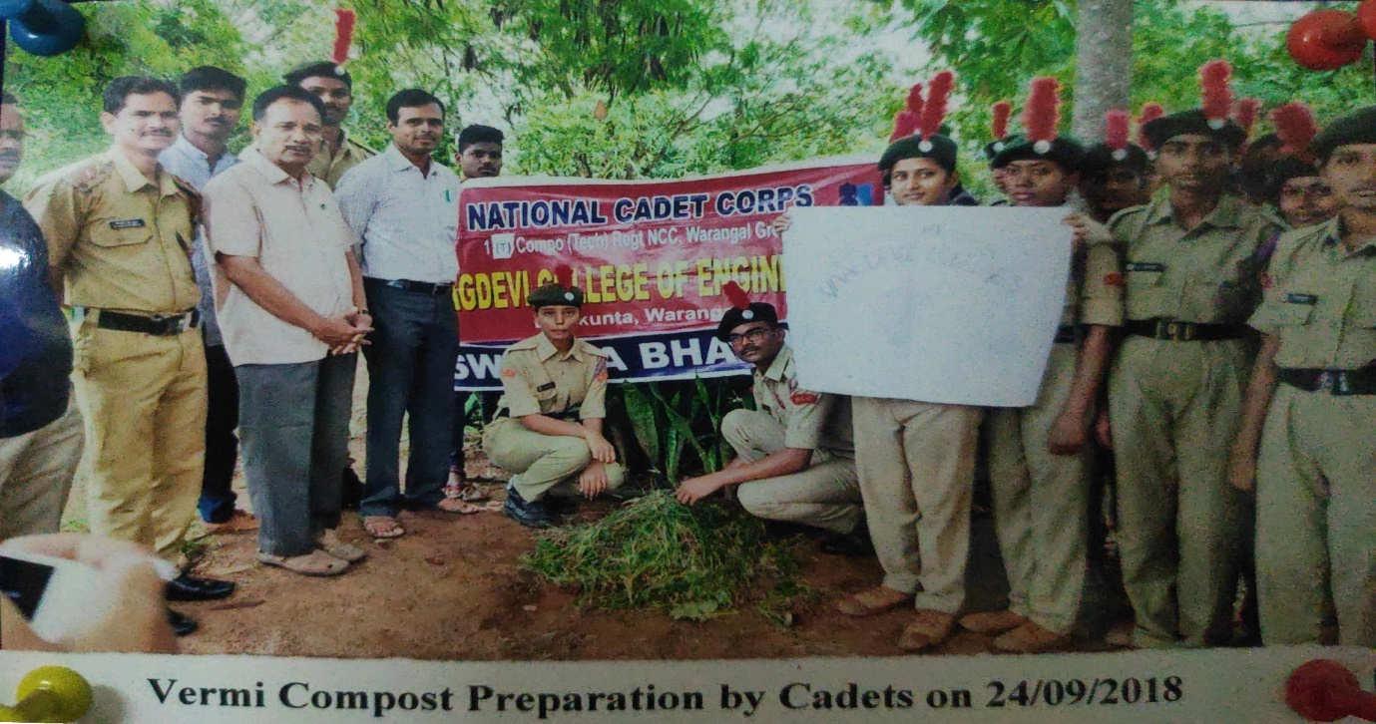
SWATCH BHARAT

Visit to Inavolu village For Social Awareness (19-11-2019)
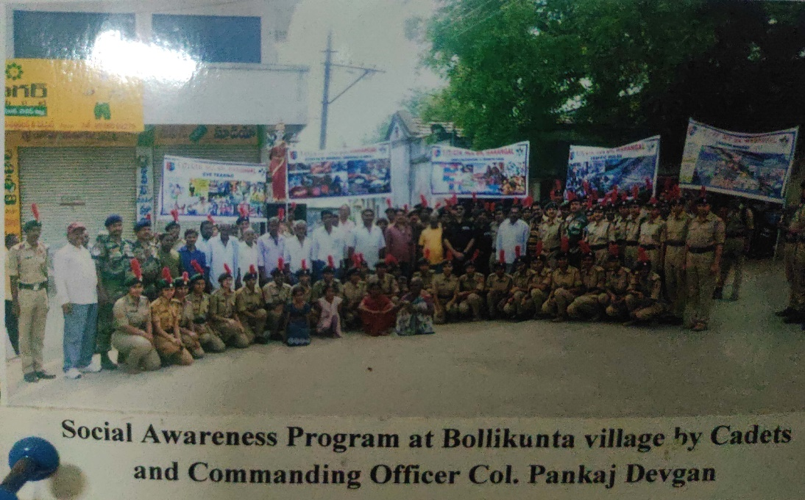
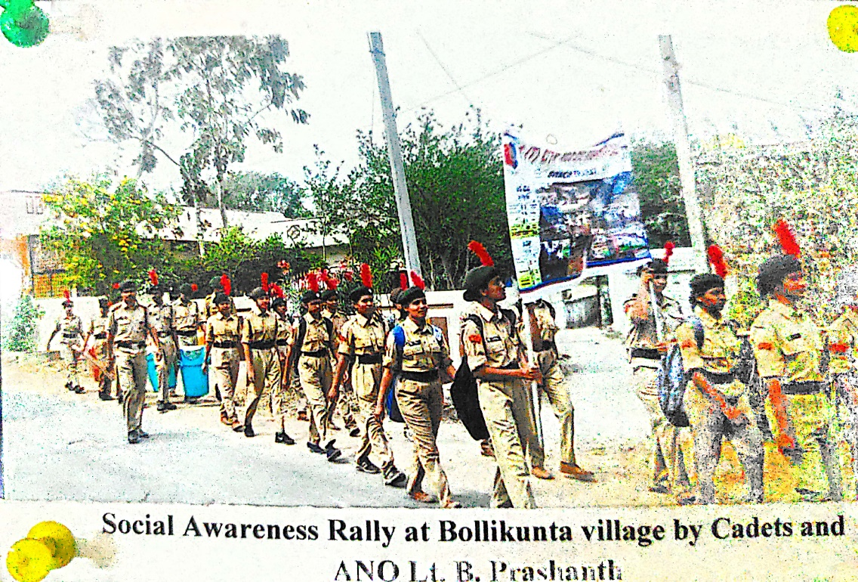
Social Awerness Program

Plogging, Vaagdevi College of Engineering (07-12-2019)
NER(Niligeri) Treck-2 Cdt. GANDI SHARANYA
S, NO | Regt. No | RANK | NAME
01 | TS/17/SWA/200580 | CDT | GANDI SHARANYA

AFIC Southern command Cdt. DHARAVATH KISHORE
S, NO | Regt. No | RANK | NAME
01 | Ts/17/SDA/200148 | CDT | DHARAVATH KISHORE

