(2020-2021)
Sl.no | Activity /Achievement | Date | Remark
1 | International yoga Day | 21-06-2020 | 48 Cadets & 1 ANO
2 | Tree Plantation (Pakwada) | 17-07-2020 | 34 Cadets &1 ANO
3 | Kargil Vijay Diwas | 26-07-2020 | 46 Cadets & 1 ANO
4 | Physical Activity | 24-8-2020 | 45 Cadets
5 | Fit India | 25-08-2020 | 50 Cadets & 1 ANO
6 | International Sports Day | 29-08-2020 | 52 Cadets
7 | Tree plantation | 16-09-2020 | 50 Cadets & 1ANO
8 | Vijay Diwas | 19-09-2020 | 46 Cadets
9 | The Kargil War | 20-12-2020 | 40 Cadets
10 | Republic Day Event | 26-01-2021 | 40 Cadets & 1ANO

International yoga Day 21-06-2020
Cadets are participated in International Yoga Day.
"Yoga is a philosophy of discipline and meditation that transforms the spirit and makes the individual a better person in thought action, knowledge and devotion ".
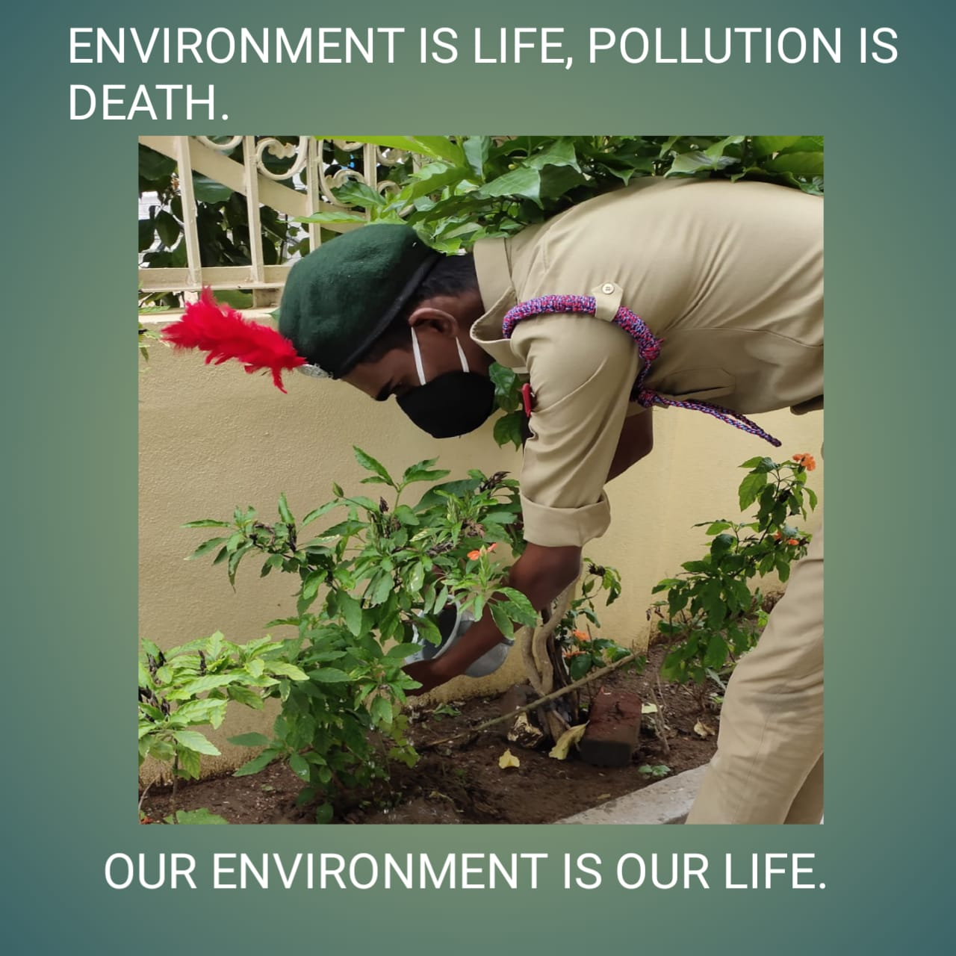 | 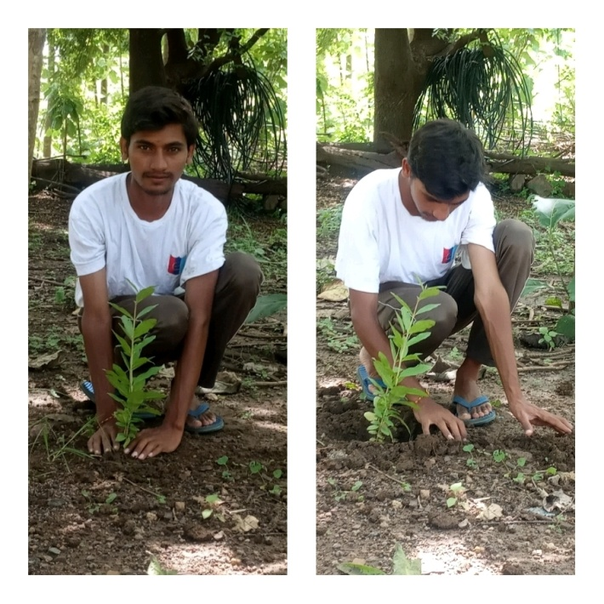

Tree Plantation (Pakwada)

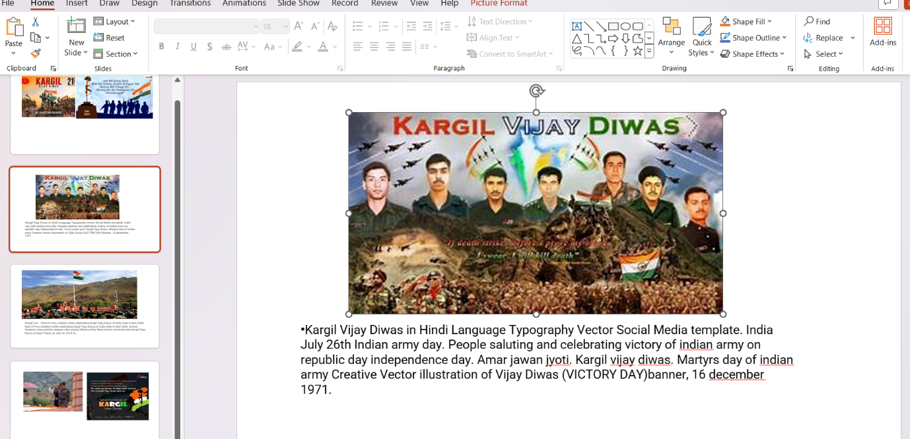
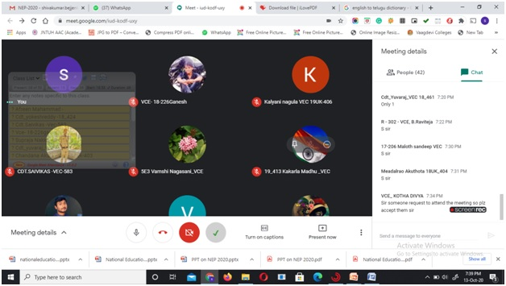

Kargil Vijay Diwas
July 26 is observed as Kargil Vijay Diwas in the memory of soldiers who sacrificed their life in Kargil war. Cadets are participated in drawing competition which is conducted in online mode by Vaagdevi College of Engineering.

Kargil Vijay Diwas 26-07-2020
July 26 is observed as Kargil Vijay Diwas in the memory of soldiers who sacrificed their life in Kargil war. Cadets are participated in drawing competition which is conducted in online mode by Vaagdevi College of Engineering.
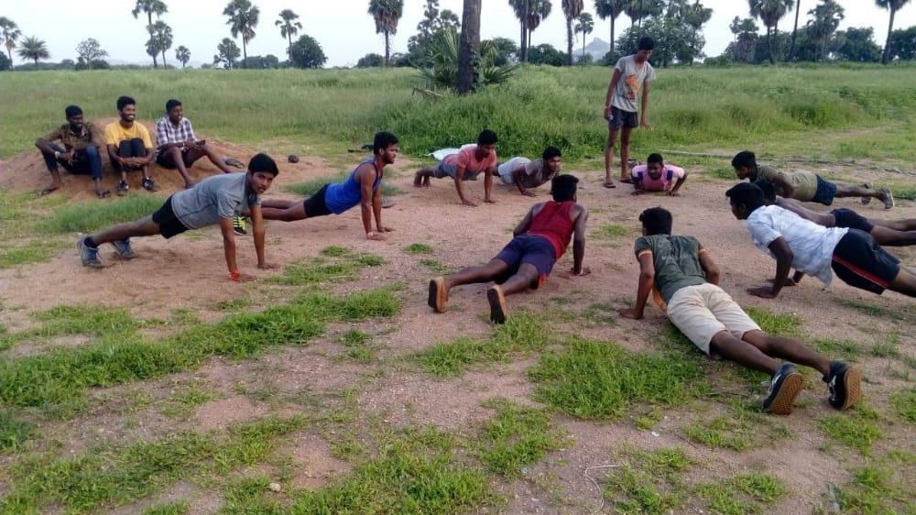 | 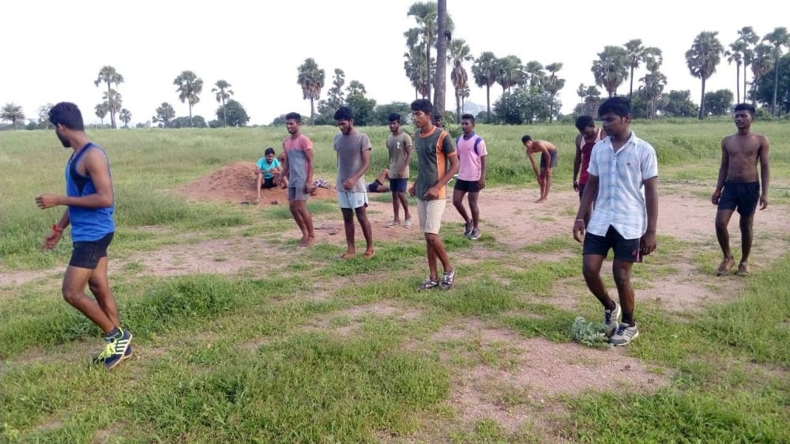

Physical Activity (24-8-2020)
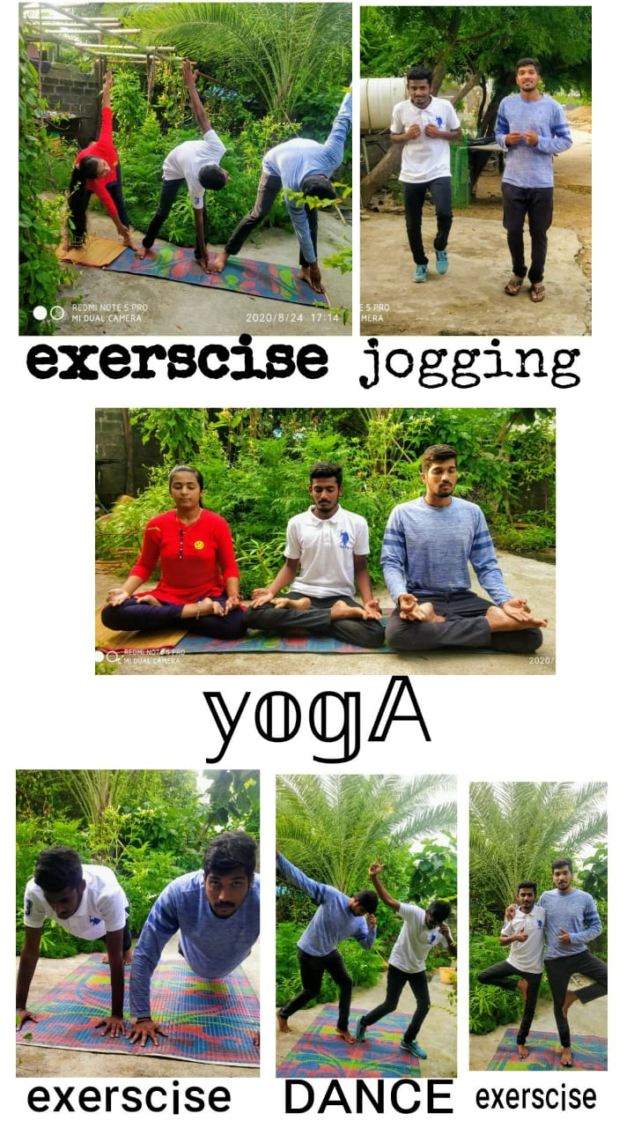
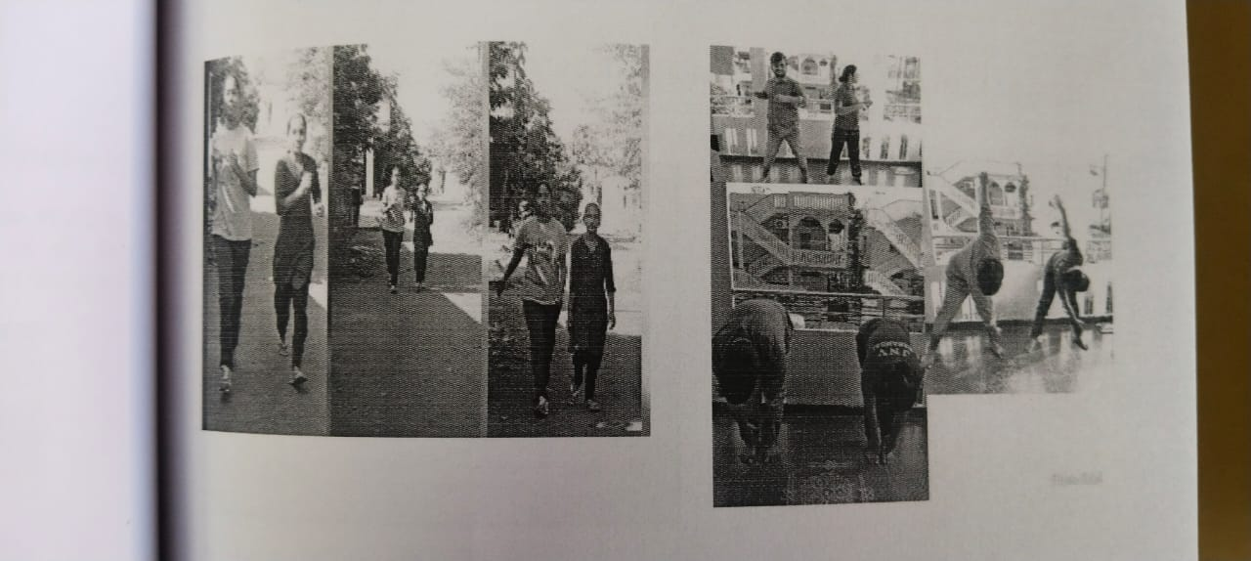

Fit India 25-08-2020
Cadets are participated in fit India movement. The quit India movement is a national wide movement in India that encourages people to stay healthy and fit by Incorporating physical activities and sports into their daily lives.
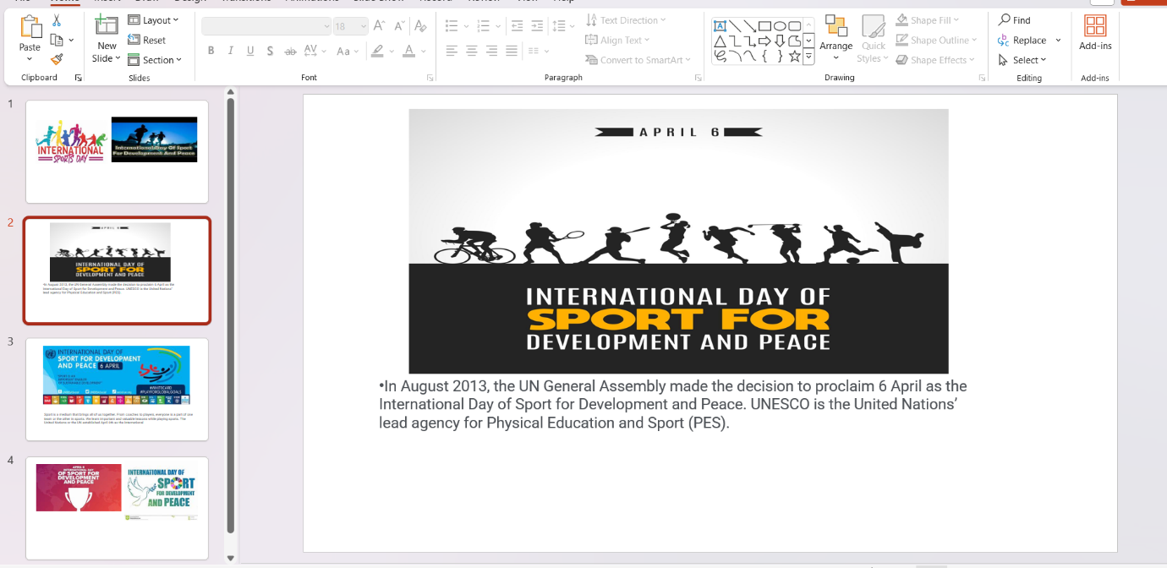
International Sports Day
Cadets are participated in International Sports Day. The quit India movement is a national wide movement in India that encourages people Regarding International Sports Day
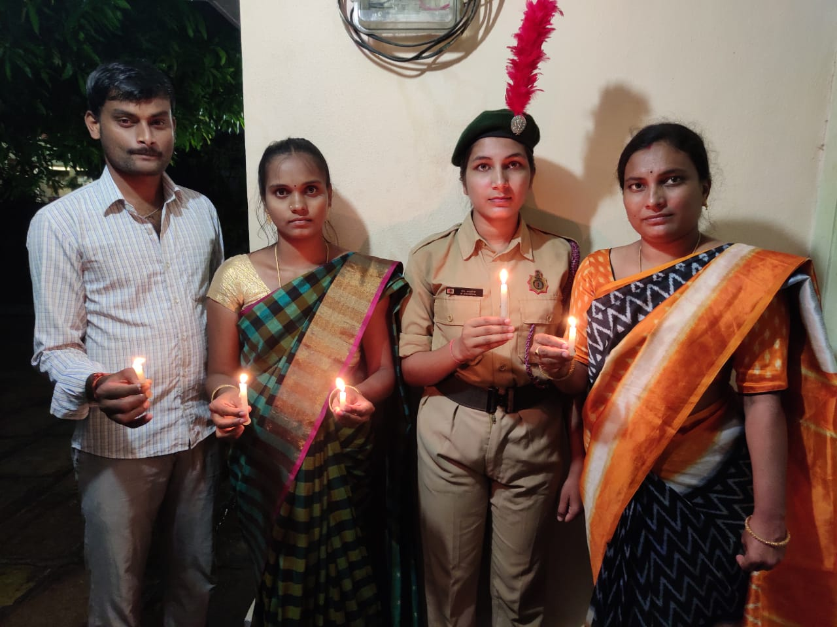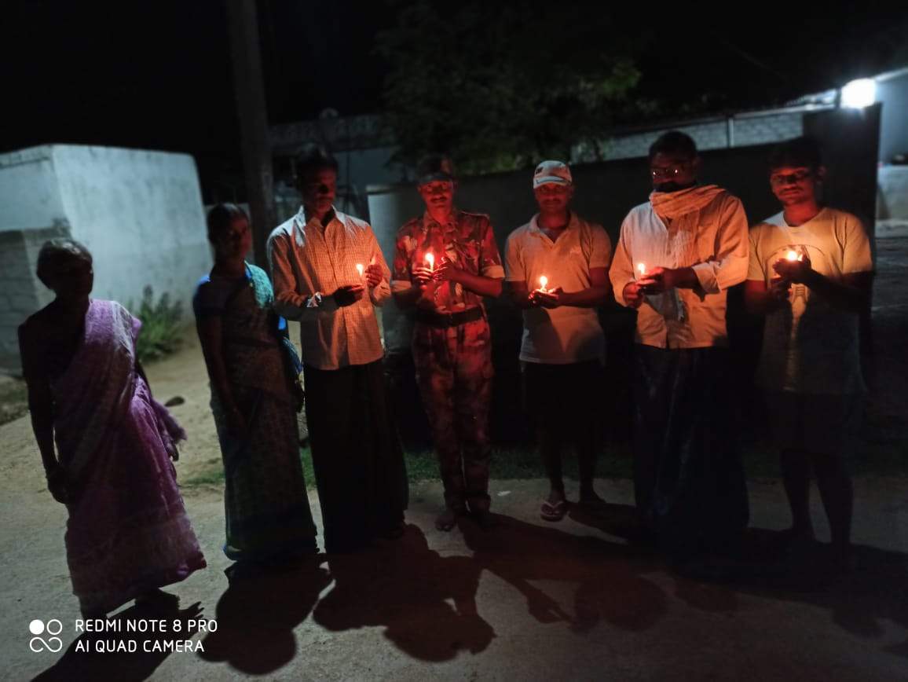

The Kargil War (20-12-2020)
Tribute to the Soldier who Sacrificed Their Life for our Nation in the Kargil War, Cadets

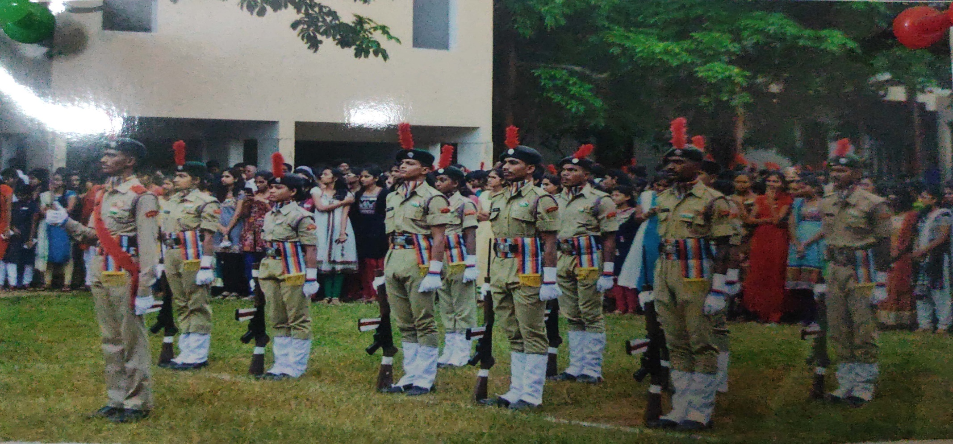
Republic Day (2021)

