(2021-2022)
Sl.no | Activity /Achievement | Date | Remarks
1 | NAAC Inspection | 04-07-2021 | 40 Cadets & 1 ANO
2 | Swatch Bharath | 03-08-2021 | 35 Cadets & 1 ANO
3 | INDIPENDENCE DAY | 15-08-2021 | 38 Cadets & 1 ANO
4 | Graduation Day | 09-09-2021 | 30 Cadets & 1 ANO
5 | Punith Sagar Abhiyan | 05-11-2021 | 20 Cadets
6 | All India trekking camp Thirupathi | 12-11-2021/25-11-2021 | 01 Cadet
7 | Haritha Haram | 06-01-2022 | 35 Cadets
8 | Republic Day-Parade (Vaagdevi College) | 26-01-2022 | 47 Cadets & 1ANO
9 | Blood Donation | 05-03-2022 | 20 Cadets Participated

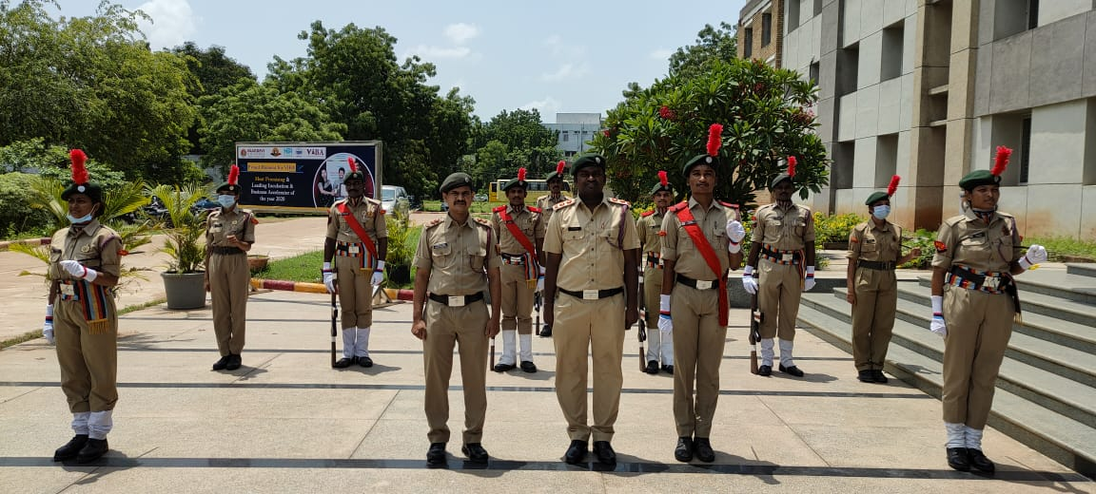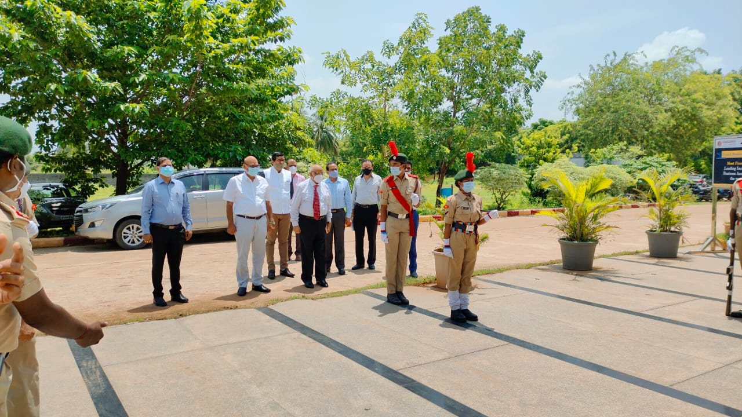

NAAC Inspection

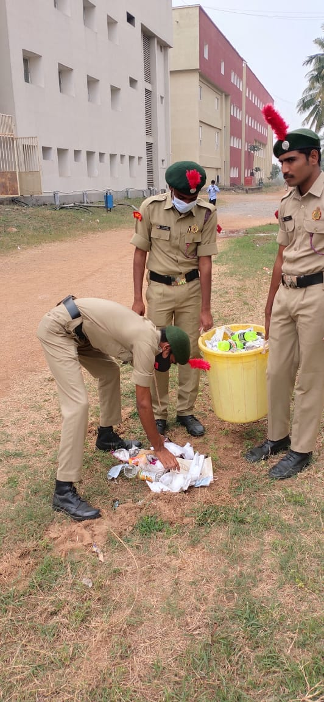
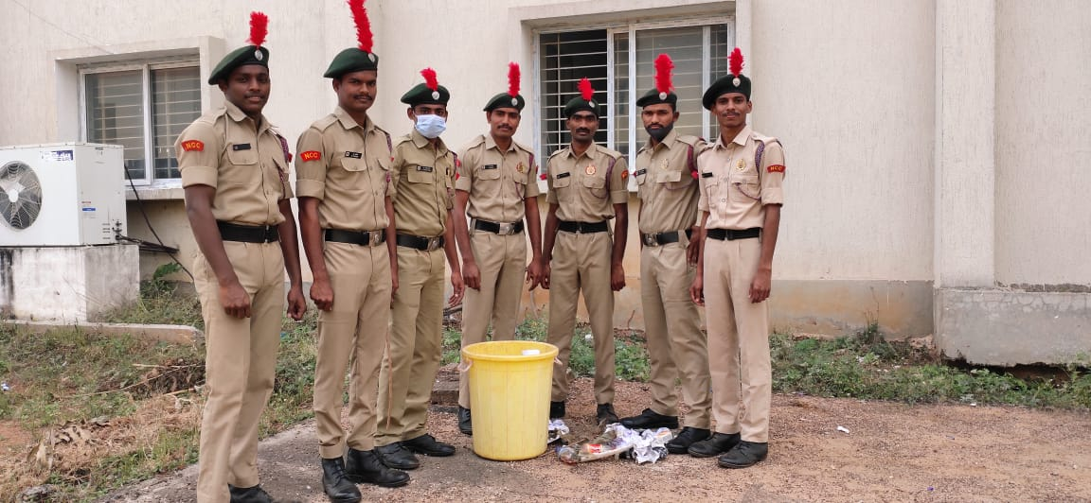

Swatch Bharath
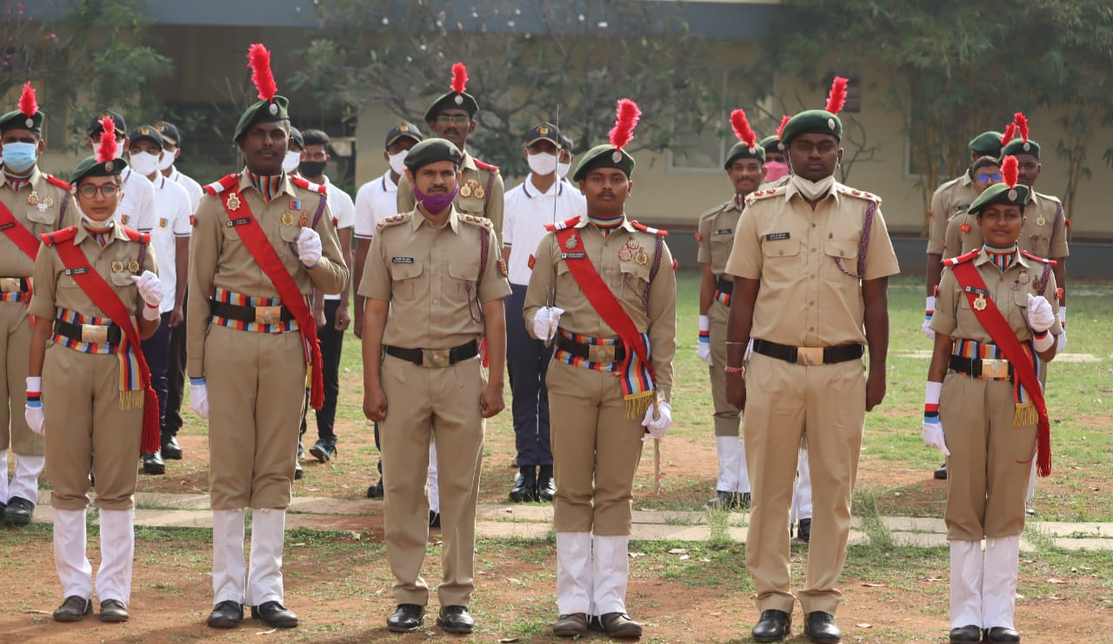
INDIPENDENCE DAY (15-08-2021)
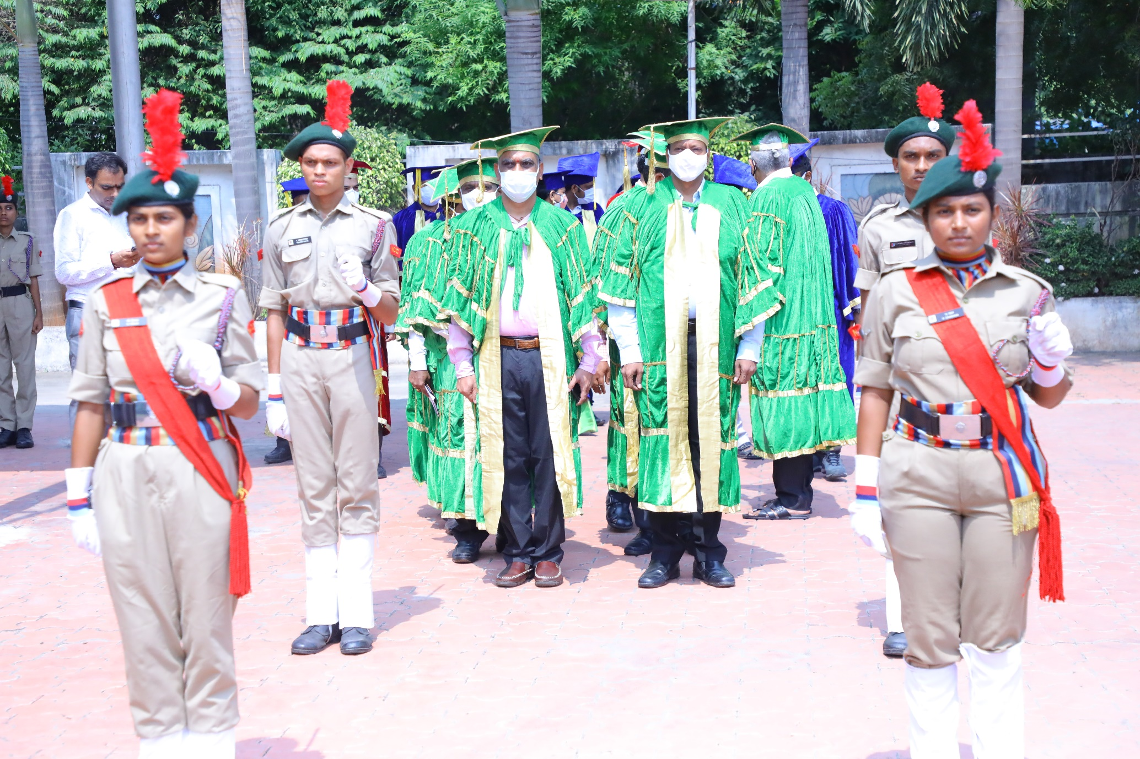
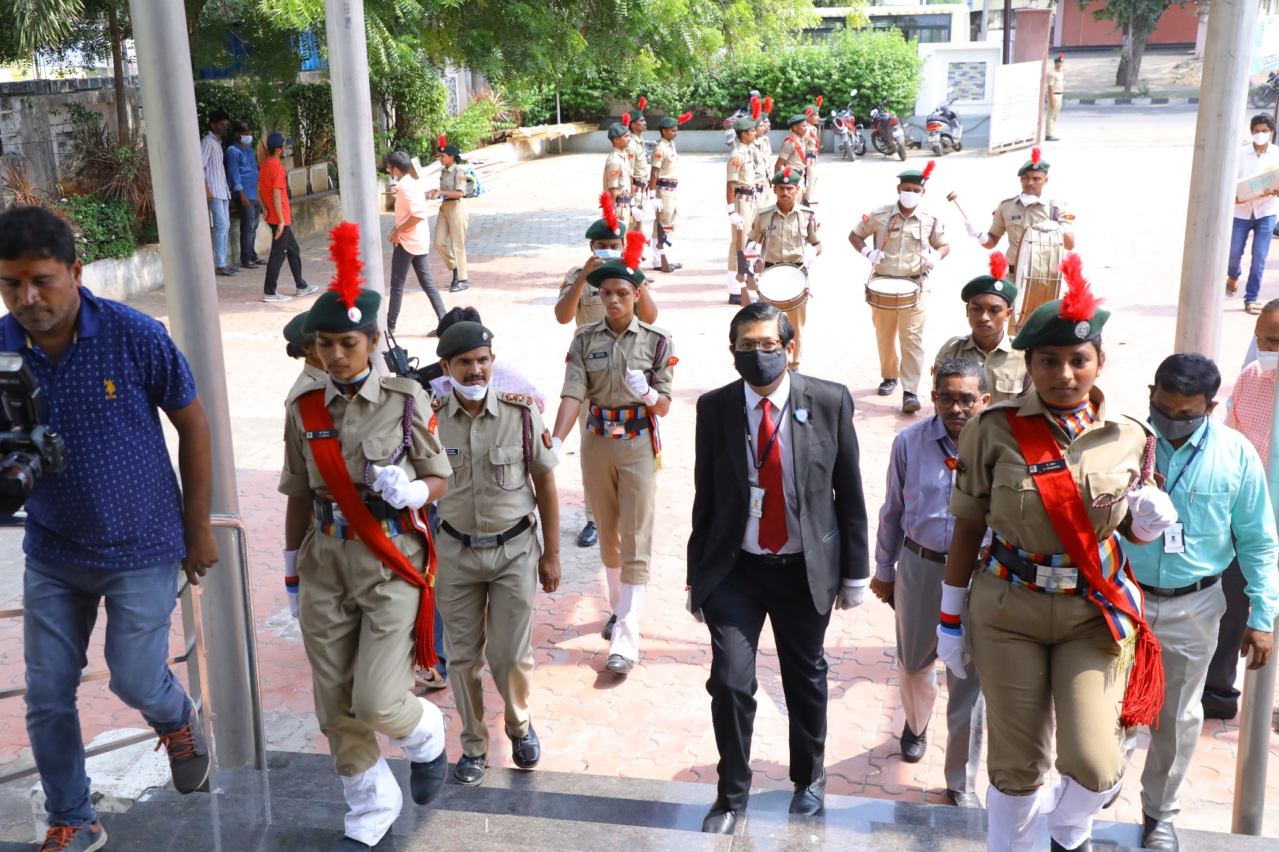
Graduation Day (09-09-2021)
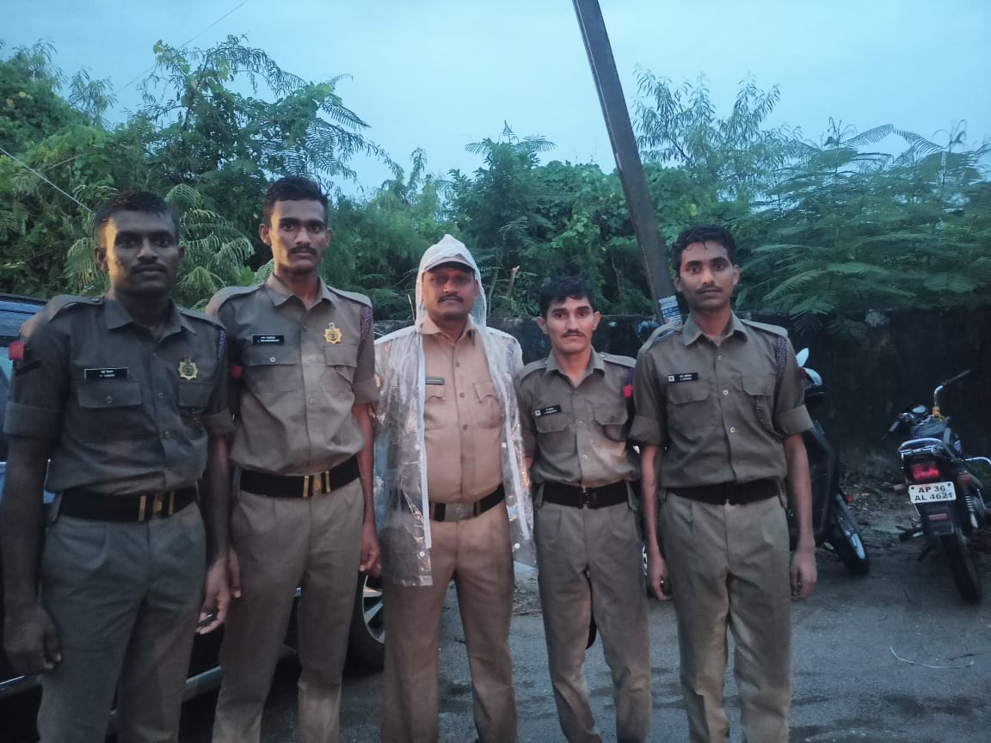
Punit Sagar Abhiyan (05-11-2021)

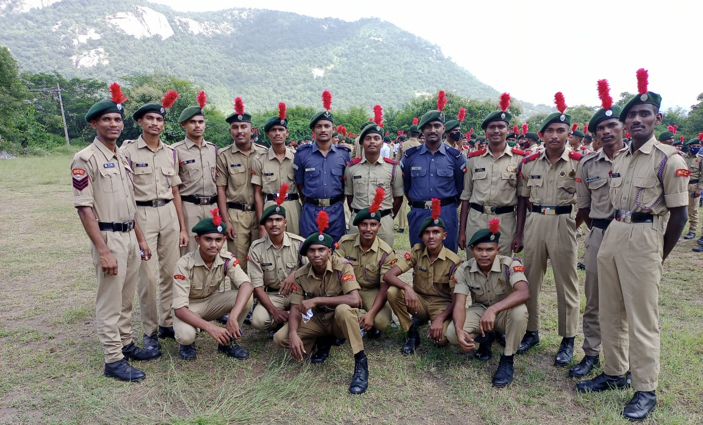
All India trekking camp Thirupathi (12-11-2021/25-11-2021)
S, NO | Regt. No | RANK | NAME | ROLL NO | BRANCH | YEAR
1 | TS/19/SDA/200052 | SUO | B NIKHIL KUMAR | 19641A05A3 | CSE | 3RD

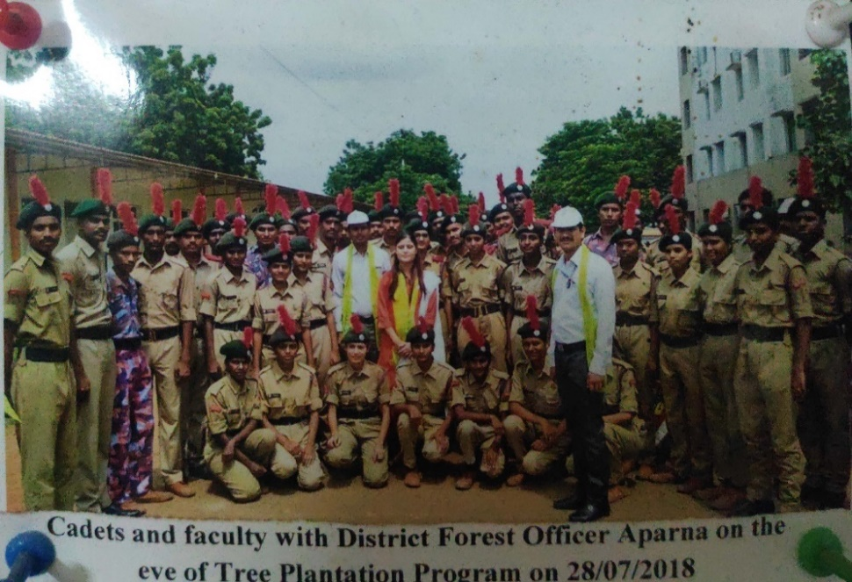
Haritha haram (06-01-2022)
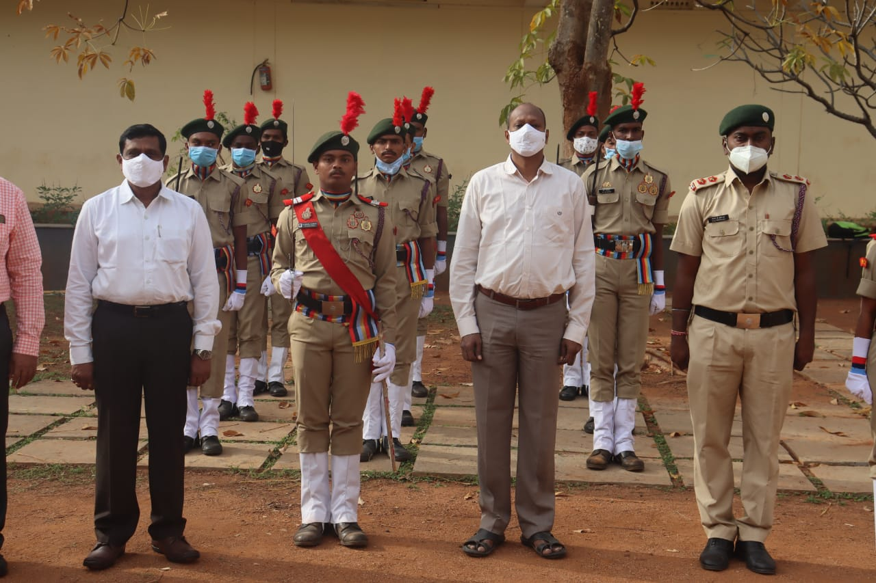

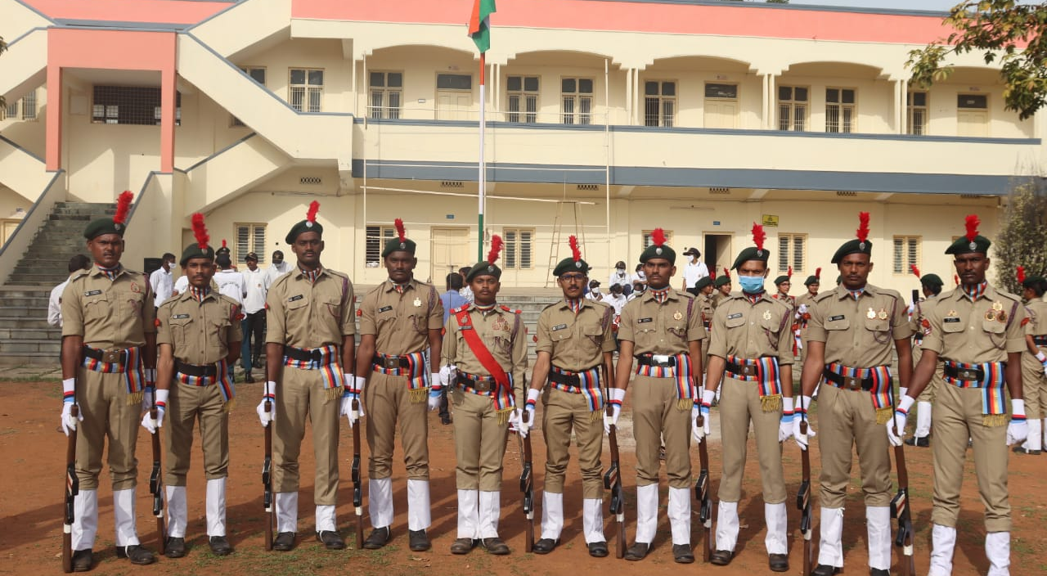
REPUBLIC DAY (26-01-2022)
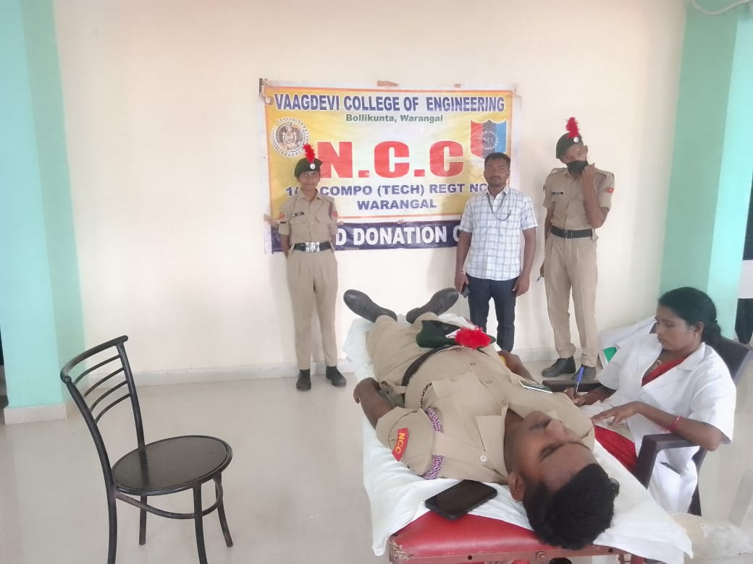
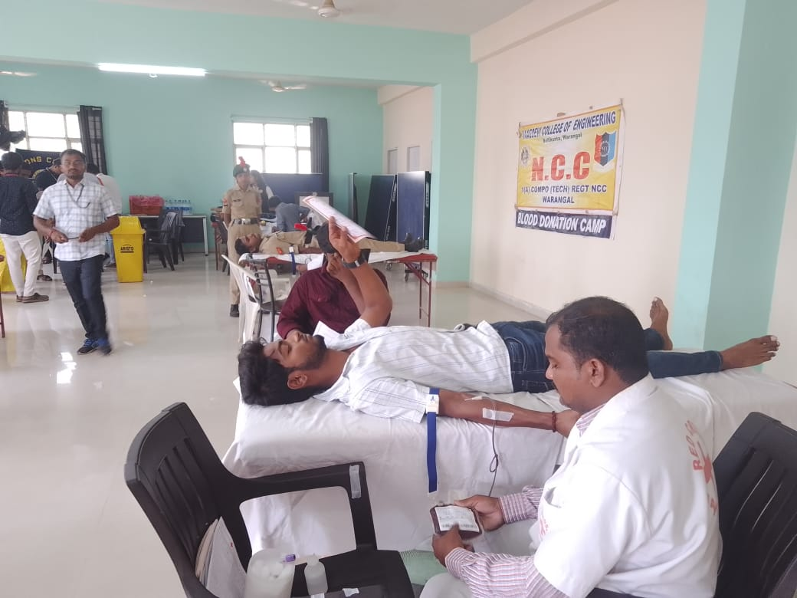
Blood Donation VCE college

