(2022-2023)

Sl.No | Activity /Achievement | Date |  | Remarks
1 | Puneeth Sagar Abhiyan | 07-08-2022 | 30 Cadets Participated
2 | Tree Plantation | 9-08-2022 | 20 Cadets Participated
3 | Har Ghar Tiring | 12-08-2023 | 30 Cadets &01 ANO
4 | INDIPENDENCE DAY | 15-08-2022 | 40 Cadets &1 ANO
5 | Kargil Diwas | 26-07-2022 | 50 Cadets & 01 ANO
6 | ALL INDIA TRECKING EXPERDITION CAMP (KERALA) | 06-10-2022 | 01 CADET
7 | ALL INDIA ROCK CLIMBING & TRAINING CAMP(RCTC)GWALIOR (2022) | 18-11-2022/30-11-2022 | 01 Cadet
8 | Republic Day | 26-01-2023 | 45 Cadets & 01 ANO
9 | Jawan Amar Event (Bipin Rawat) | 02-02-2023
10 | Black Day | 14-02-2023 | 32 Cadets Participated
11 | Yoga Mahotsav | 04-03-2023 | 20 Cadets Participated

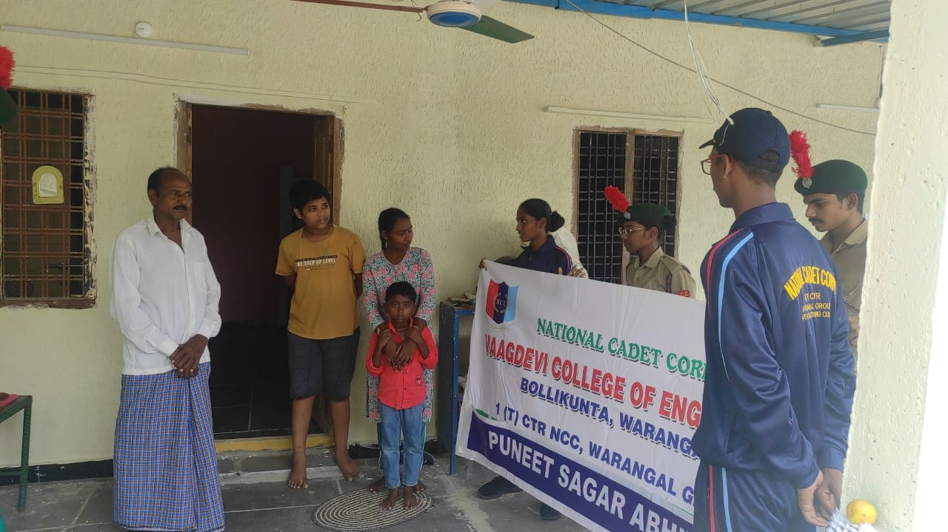
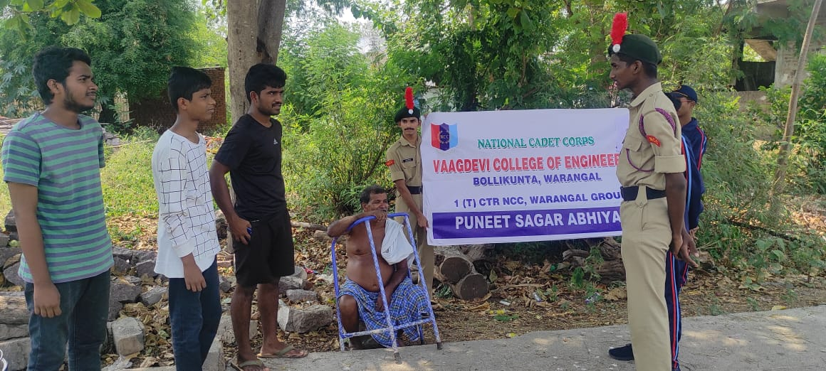

Puneet Sagar Abhiyaan (2022)
Tree Plantation (9-08-2022)
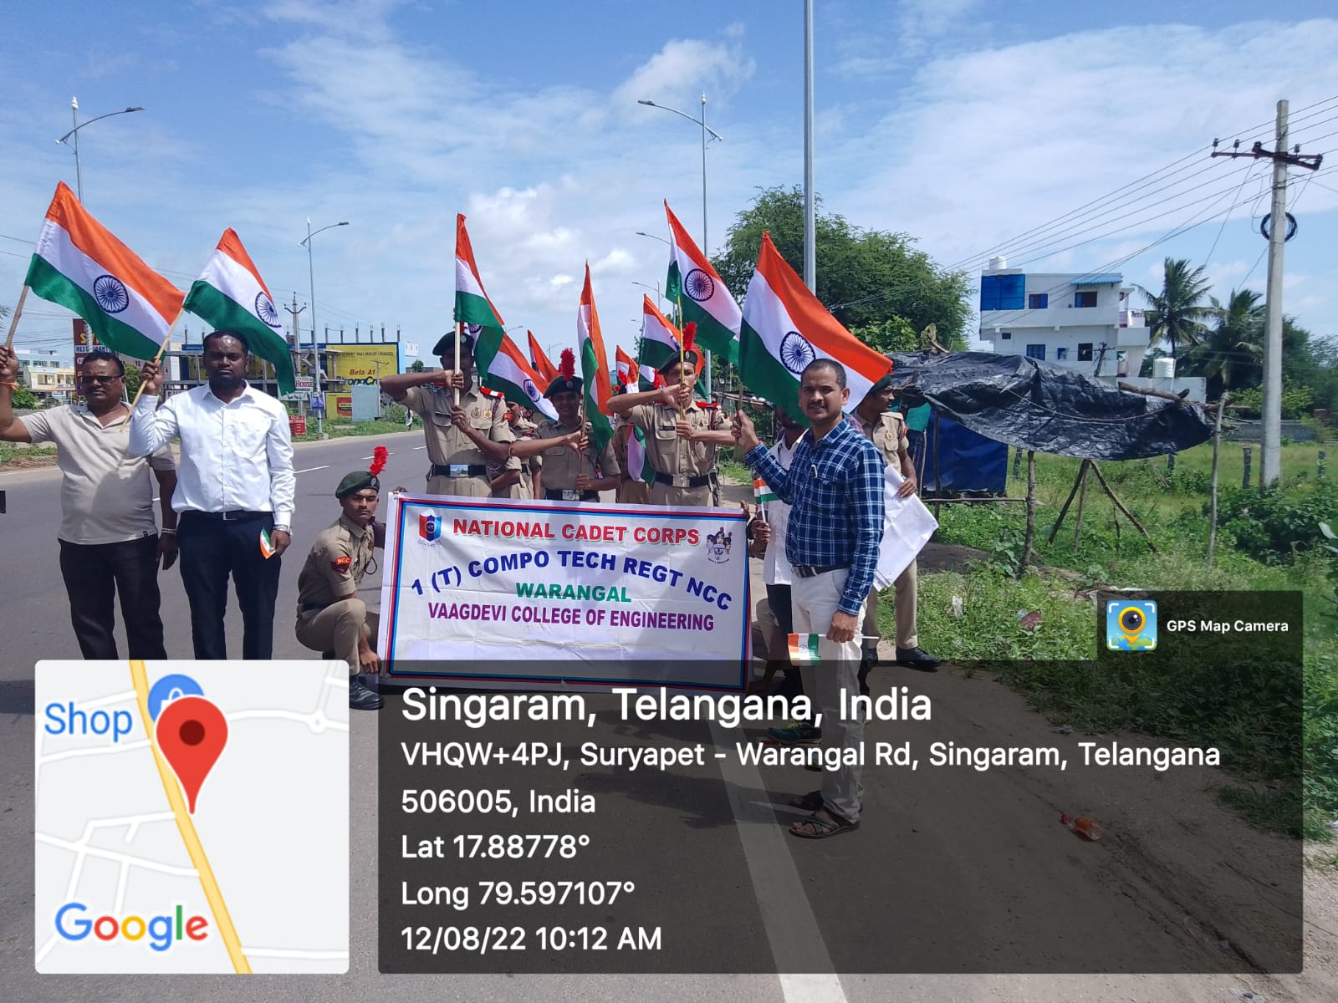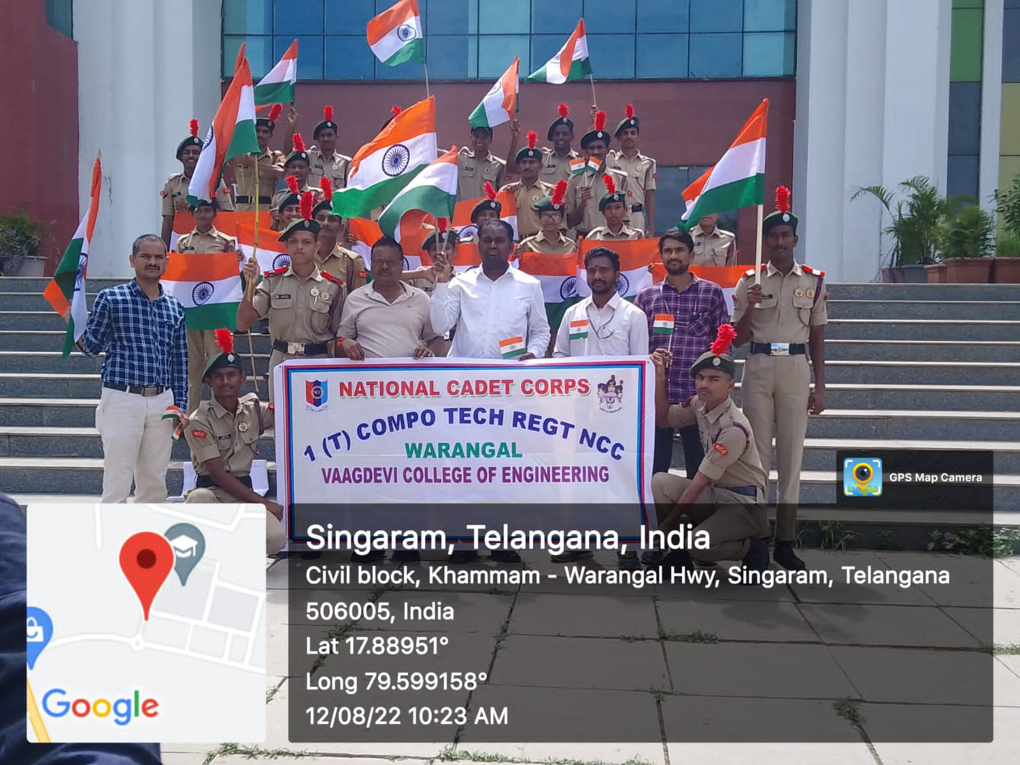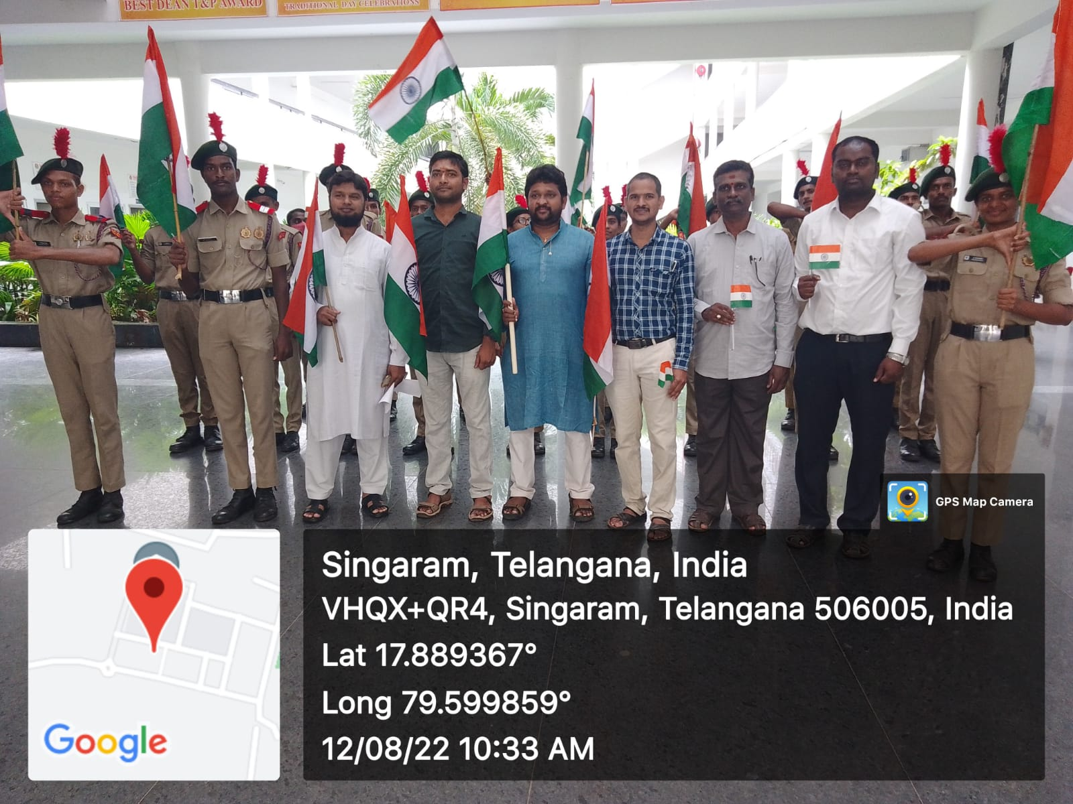
Har Ghar Tiring( Vaagdevi College of Engineering)
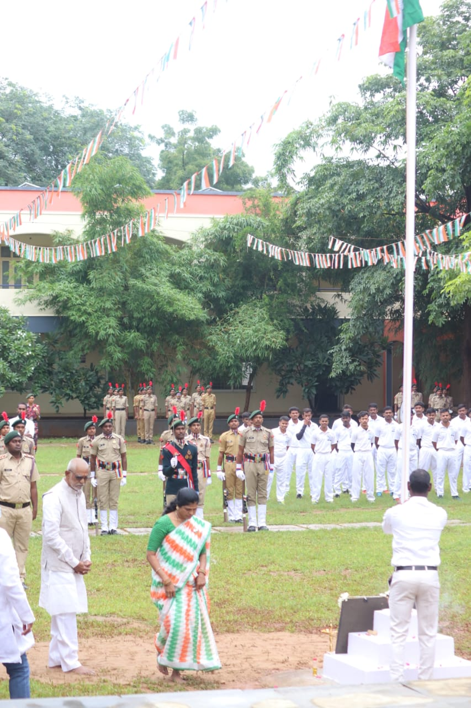
INDIPENDENC DAY VAAGDEVI COLLEGE OF ENGINEERING (15-08-2022)
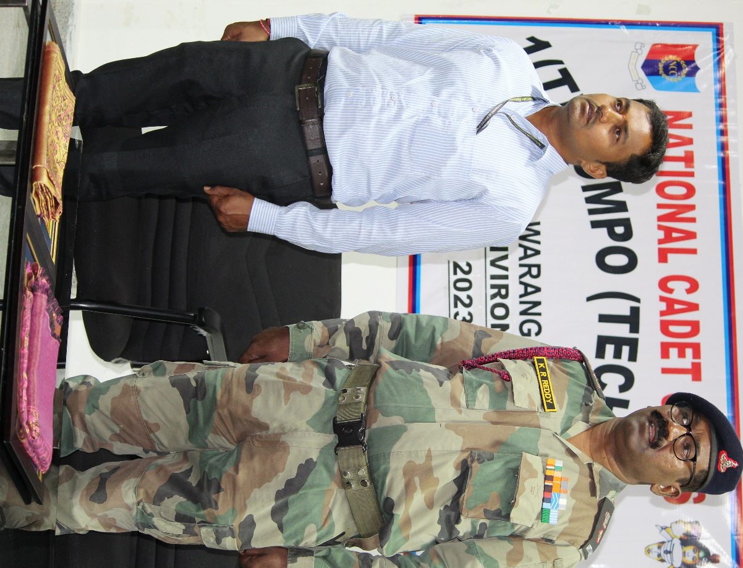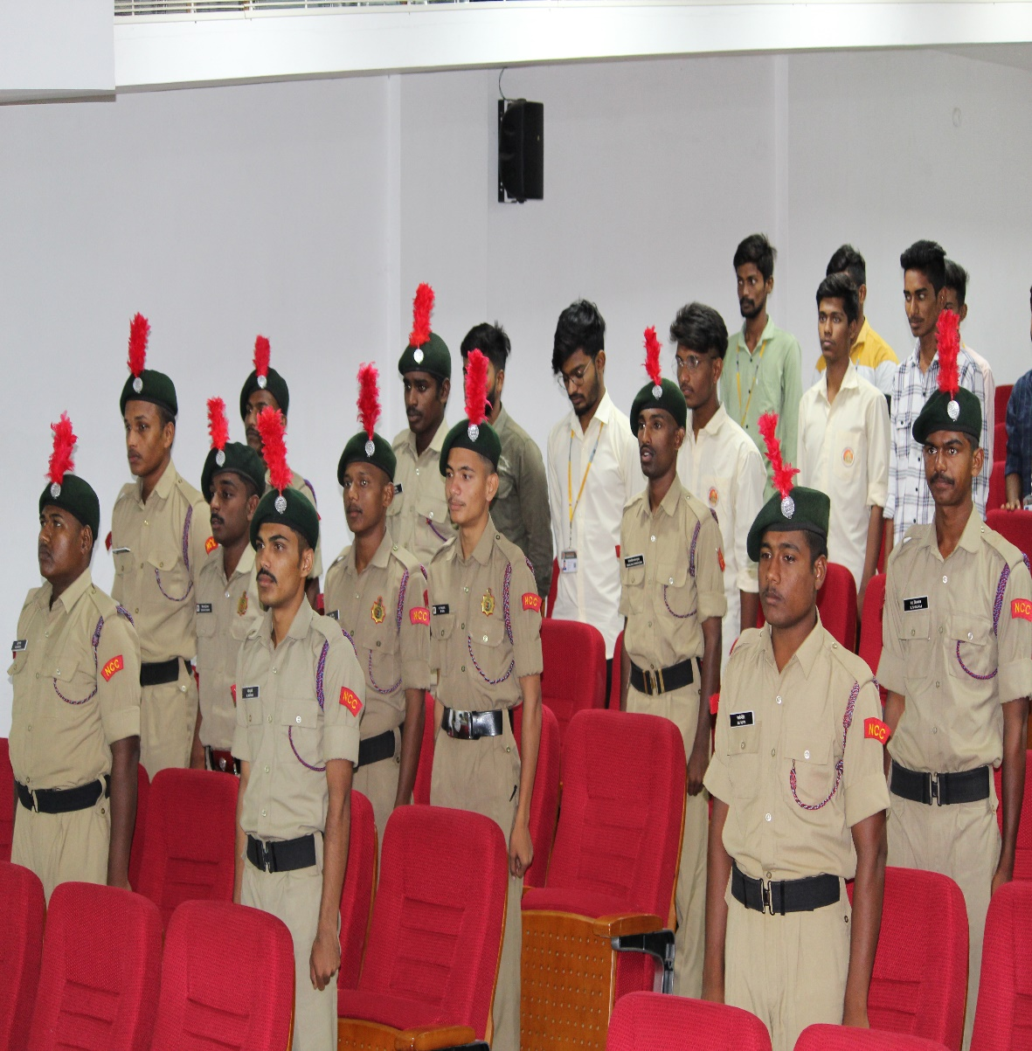
Kargil Diwas
s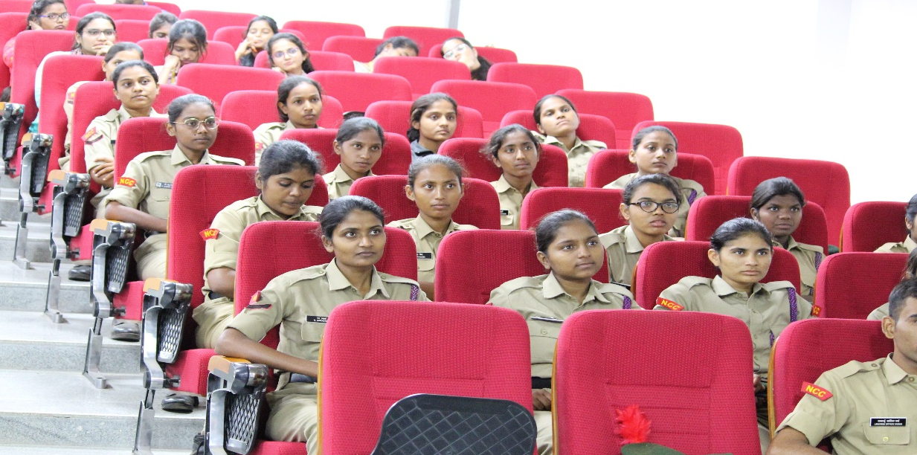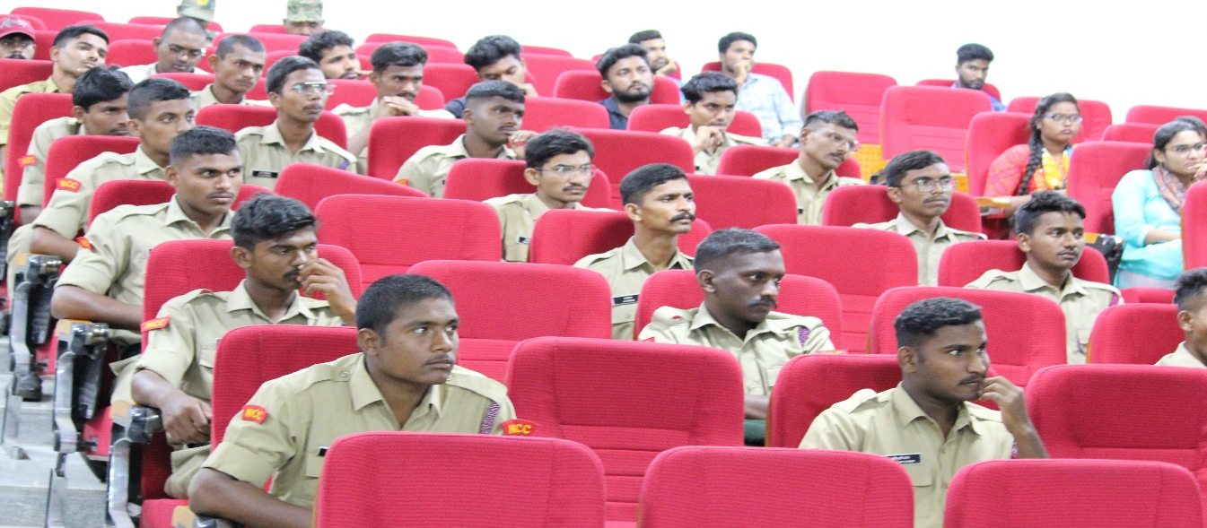
Kargil Diwas (26/07/2022)

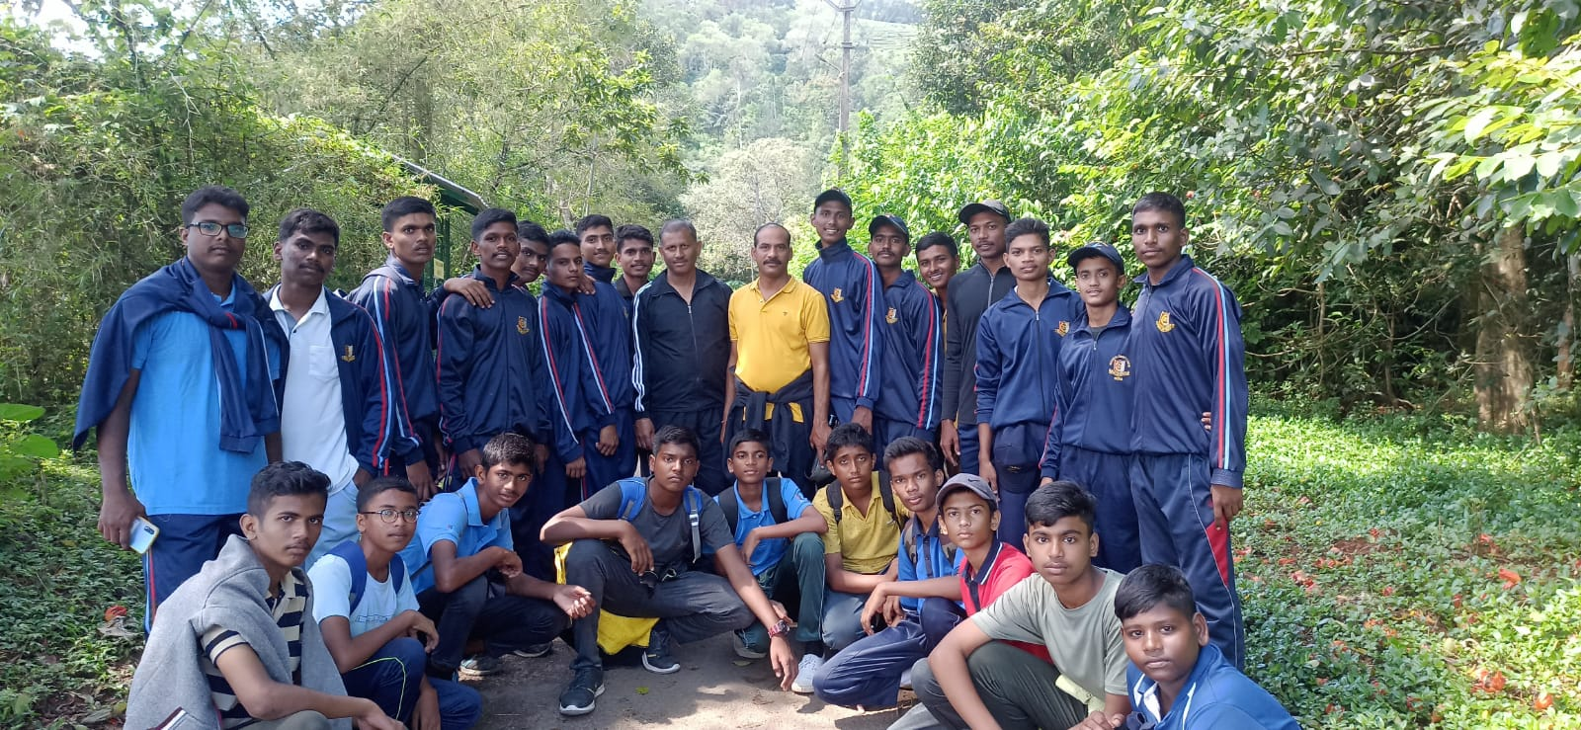
ALL INDIA TRECKING EXPERDITION CAMP (KERALA)
S, NO | Regt. No | RANK | NAME | ROLL NO | BRANCH | YEAR
01 | TS/20/SDA/200148 | CPL | N Hariharan | 20645A0170 | CIVIL | 4TH
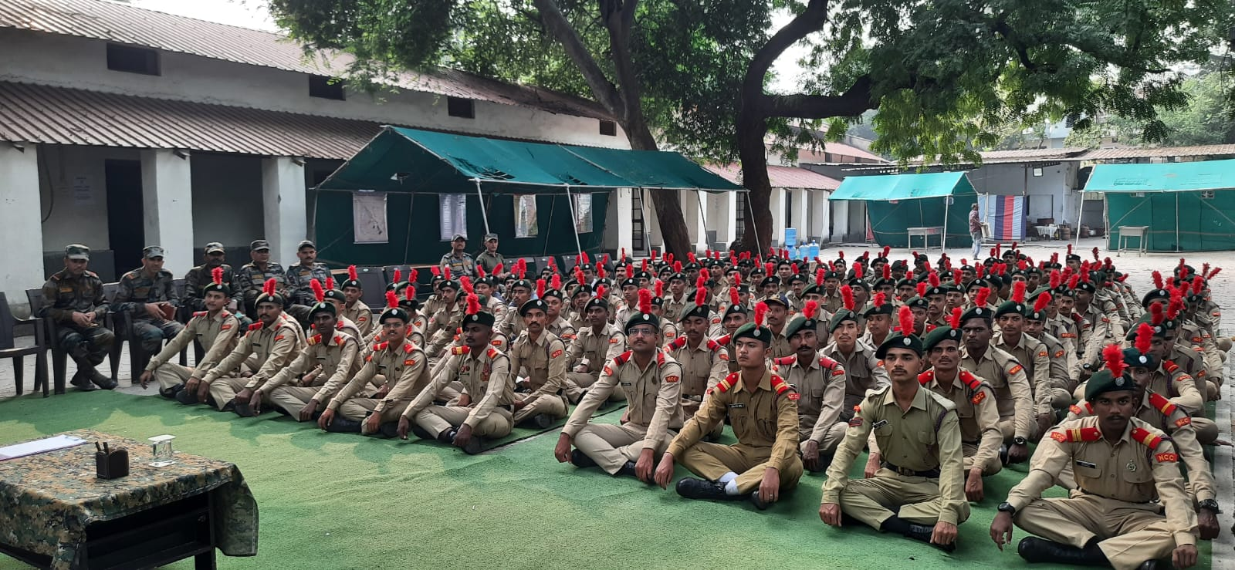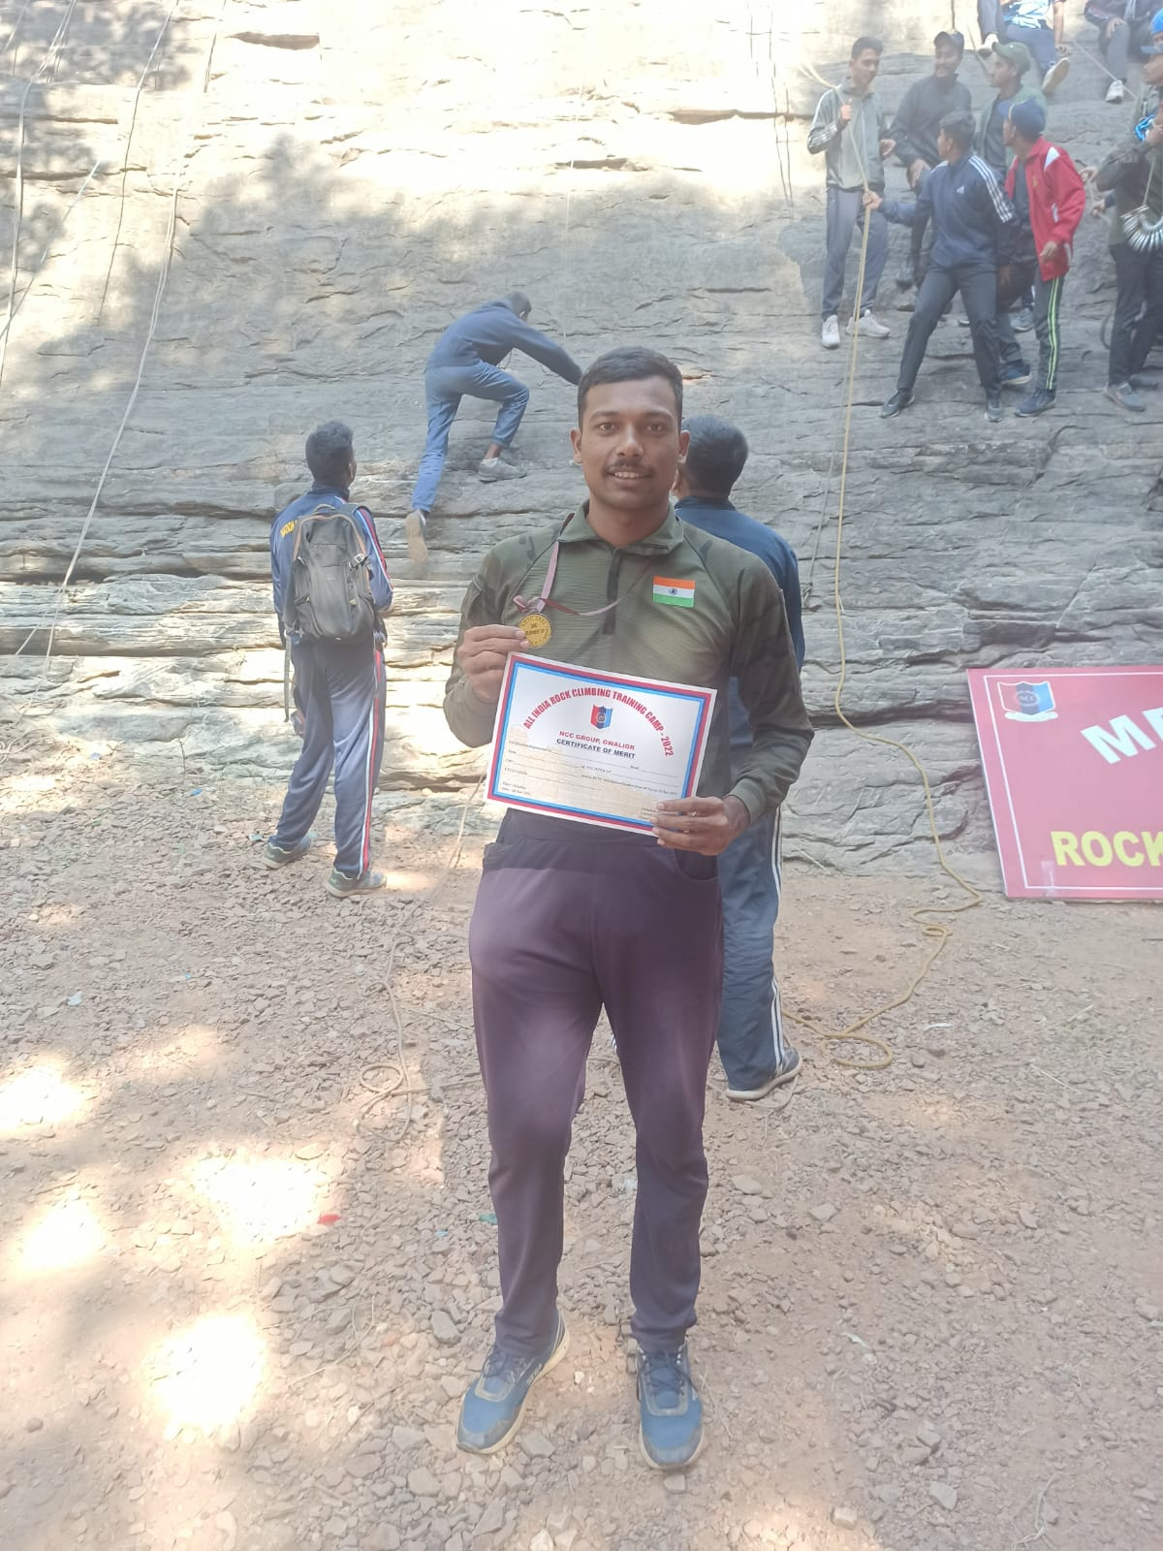
ALL INDIA ROCK CLIMBING & TRAINING CAMP(RCTC)CPL HARI HARAN
S, NO | Regt. No | RANK | NAME | ROLL NO | BRANCH | YEAR
01 | TS/20/SDA/200148 | CPL | N Hariharan | 20645A0170 | CIVIL | 4TH

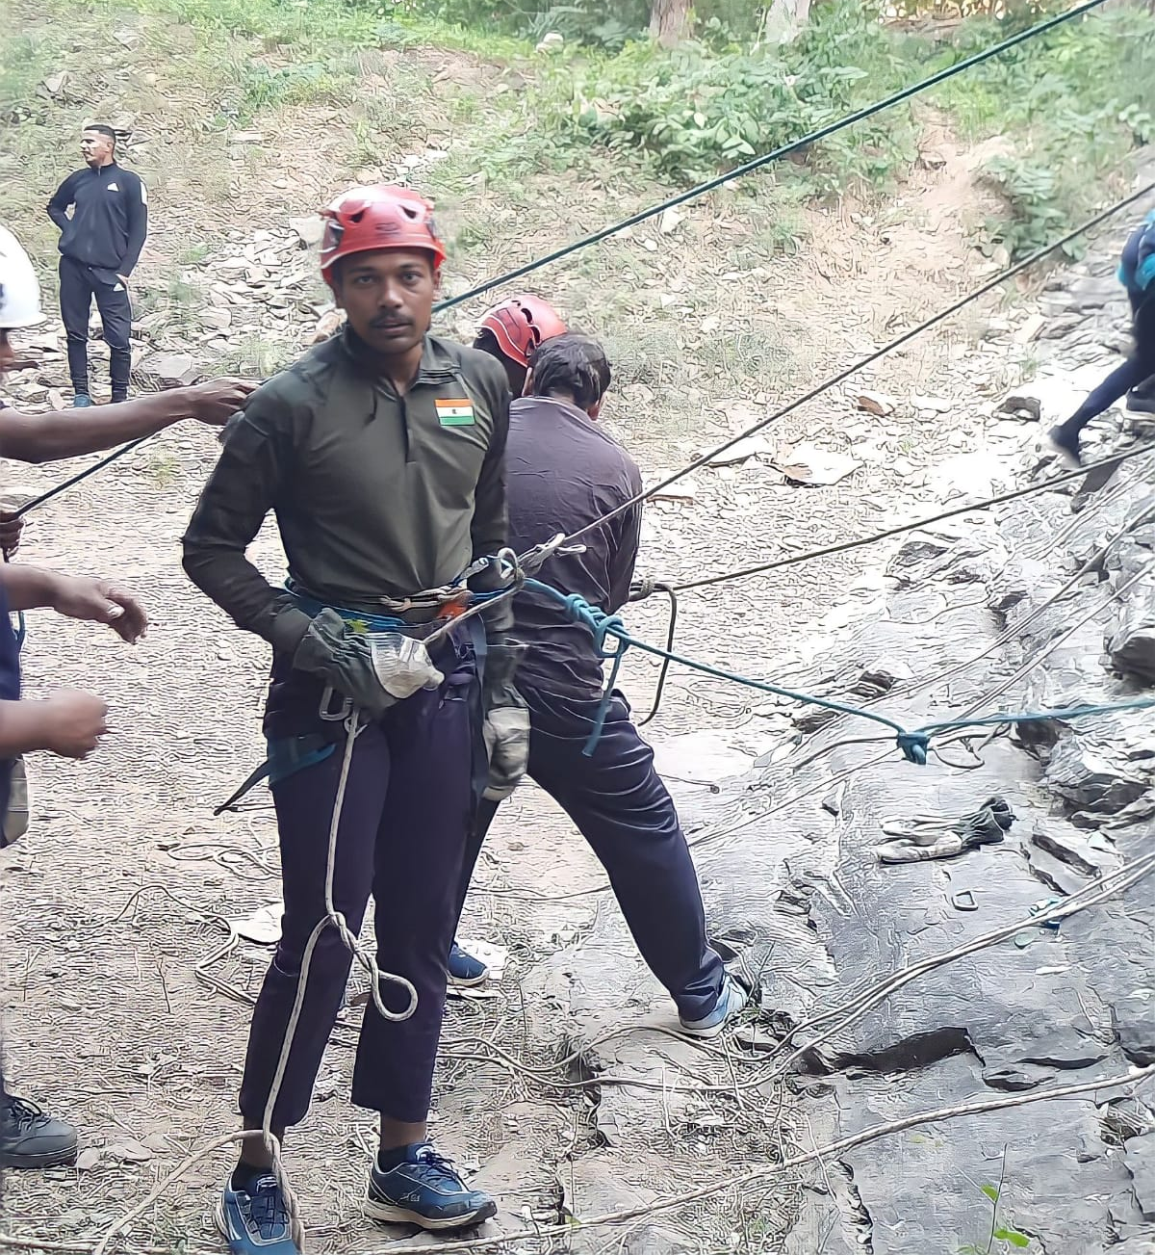
ALL INDIA ROCK CLIMBING & TRAINING CAMP(RCTC)CPL HARI HARAN
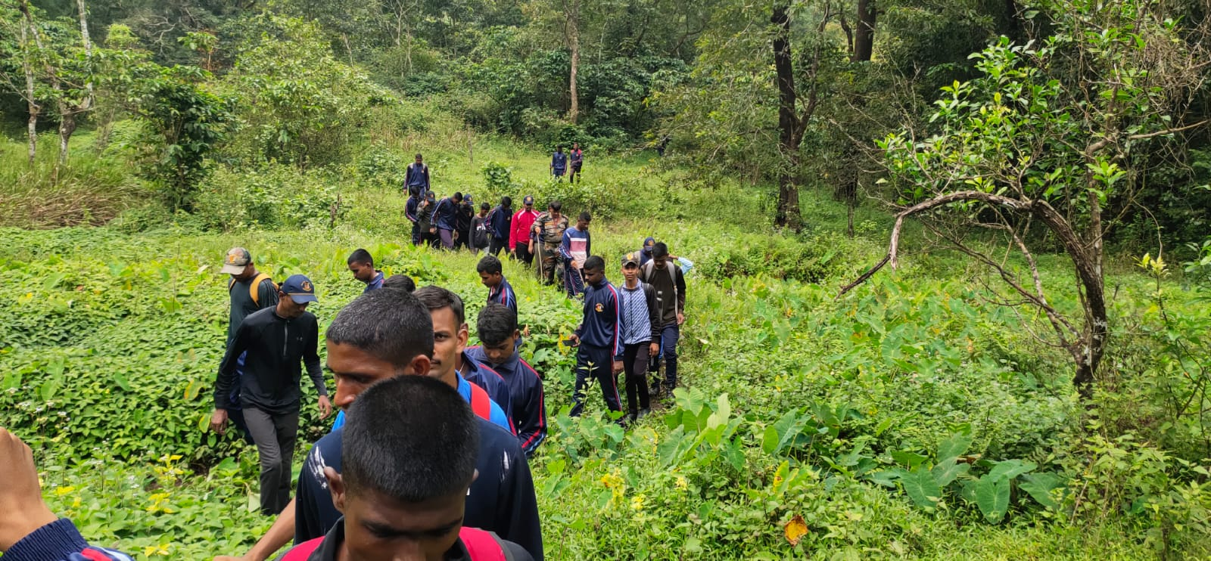
ALL INDIA ROCK CLIMBING & TRAINING CAMP(RCTC)GWALIOR (2022) (18-11-22/30-11-2022)
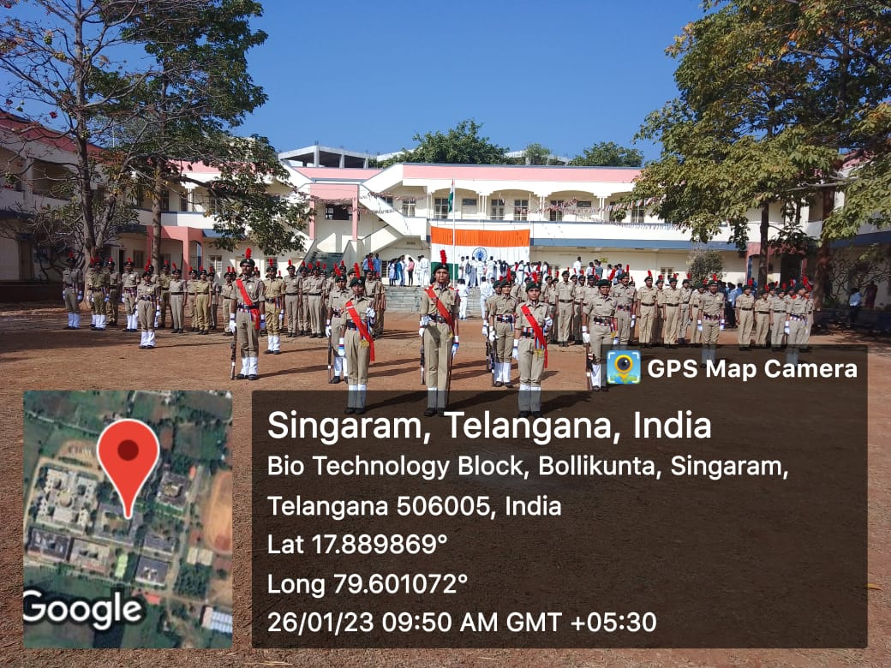
REPUBLIC DAY PARADE VAAGDEVI COLLEGE OF ENGINEERING (26-01-2023)

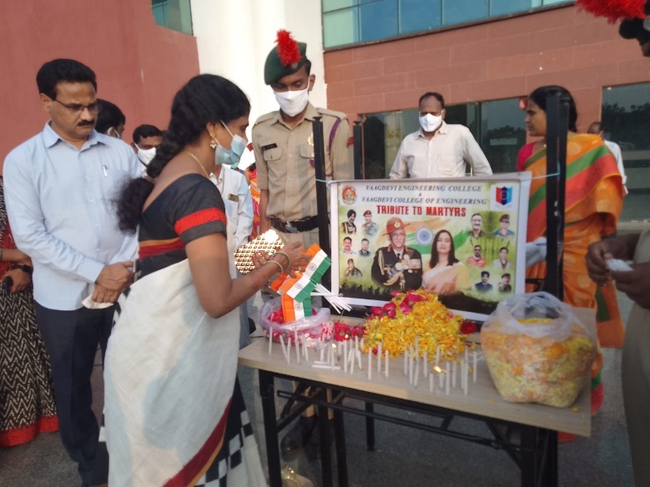
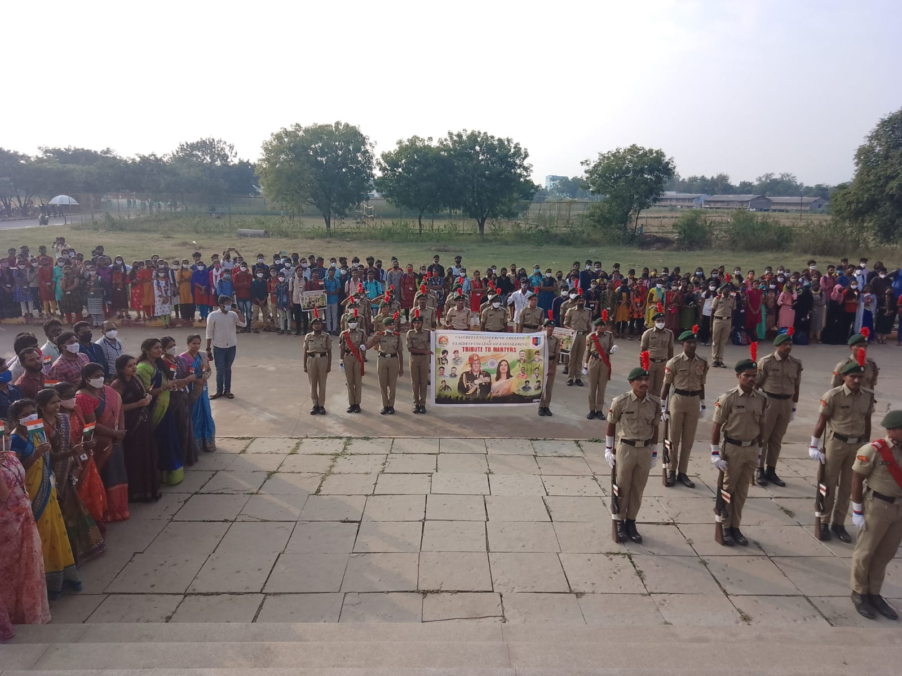
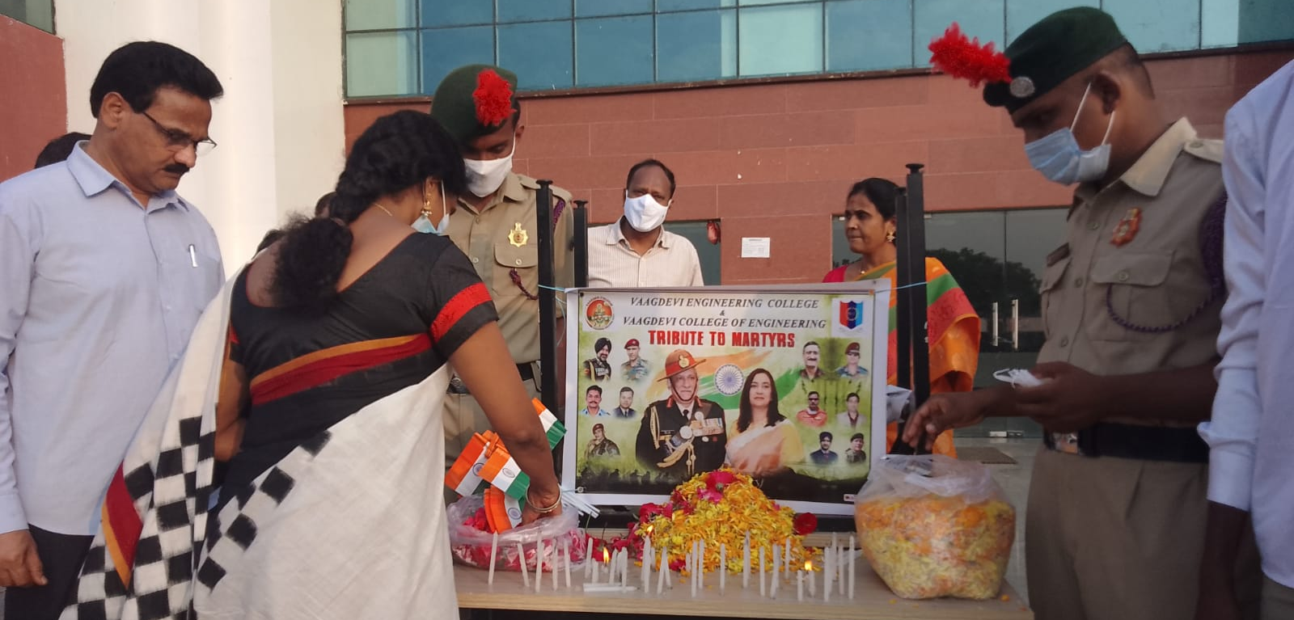

Jawan Amar Event (Bipin Rawat)
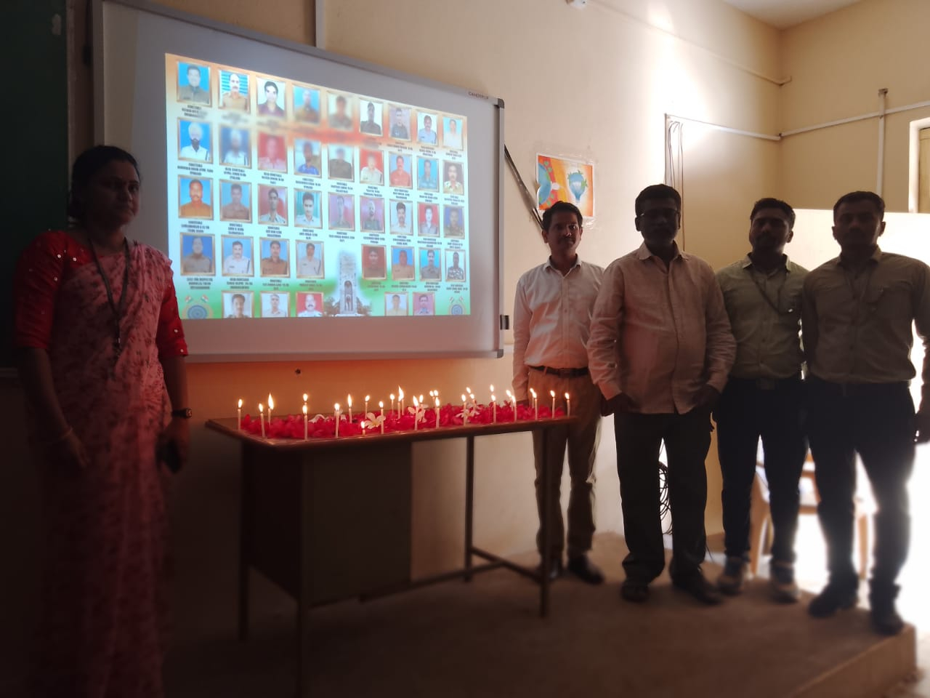
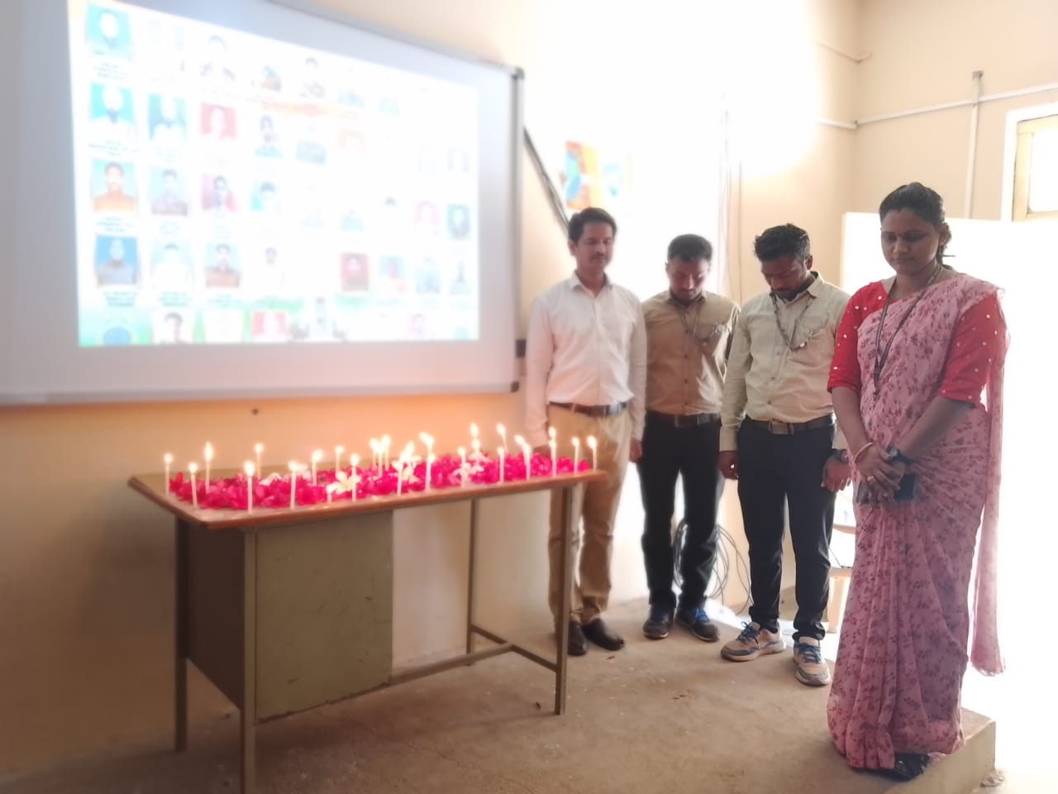
BLACK DAY (14-02-2023)
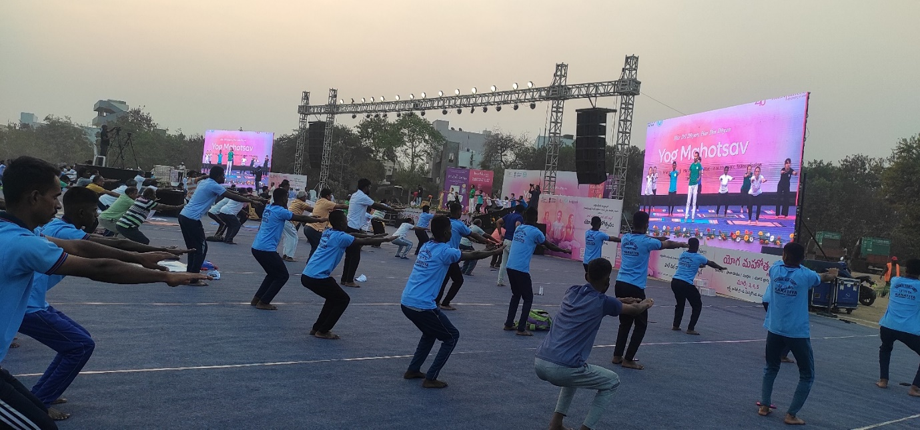

Yoga Mahotsav (2023) Arts &science Clg Hnk

