(2023-2024)
Sl.No | Activity /Achievement | Date | Remarks
01 | International yoga day | 21-06-2023 | 20 Cadets & 1 ANO
02 | Army Attachment Camp (MEHDIPATNAM) | 22-07-2023/02-08-2023 | 03 Cadets
03 | Independence Day (Vaagdevi college) | 15-08-2023 | 29Cadets & 1 ANO
034 | Swatch hi Seva Program (Inavolu) | 23-09-2023 | 20 Cadets & 1ANO
05 | NCC ENROLLMENT | 15-09-2023 | 250 Students Participated
06 | NCC Day Celebrations &Blood Donation camp (Vaagdevi college) | 24-11-2023 | 40 Cadets &1 ANO
06 | ALL INDIA ROCK CLIMBING & TRAINING CAMP(RCTC)  GWALIOR | 15-11-2023/26-11-2023 | 01 Cadet
07 | Millet Rally  (SINGARAM) | 11-12-2023 | 31 Cadets  & 1ANO
08 | Republic Day | 26-01-2024 | 48 Cadets &1 ANO
09 | Swatch Bharath Abhyan (Swatch Hi Seva) | 26-01-2024 | 48 Cadets &1 ANO
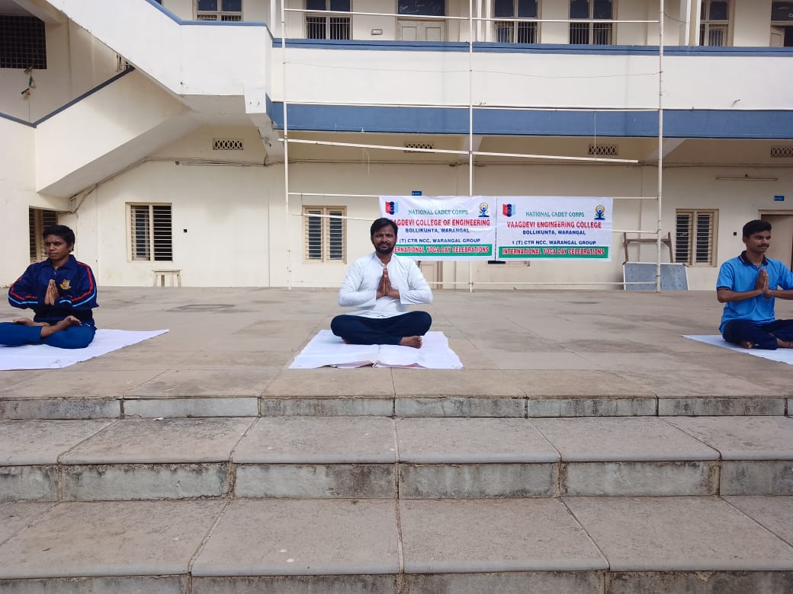
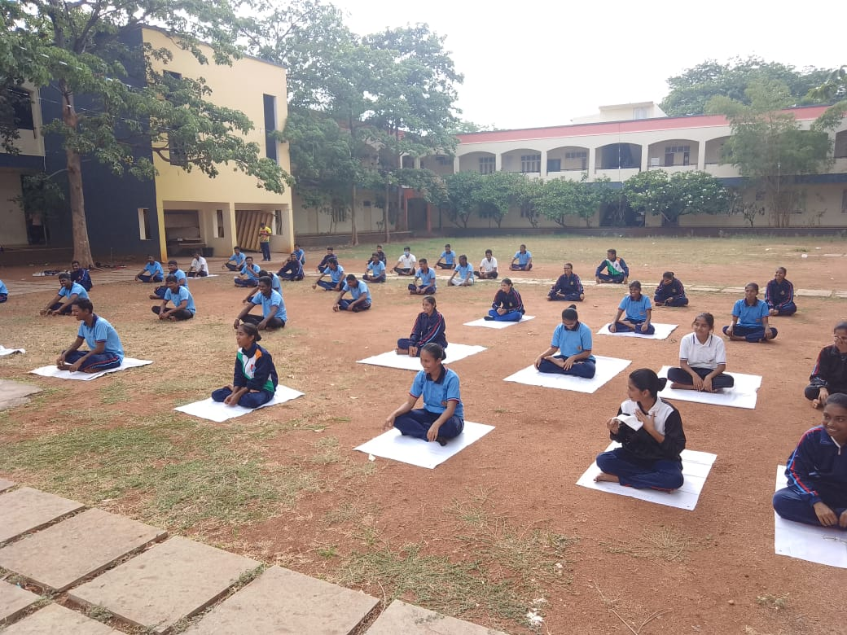

International Yoga Day (21-06-2023)
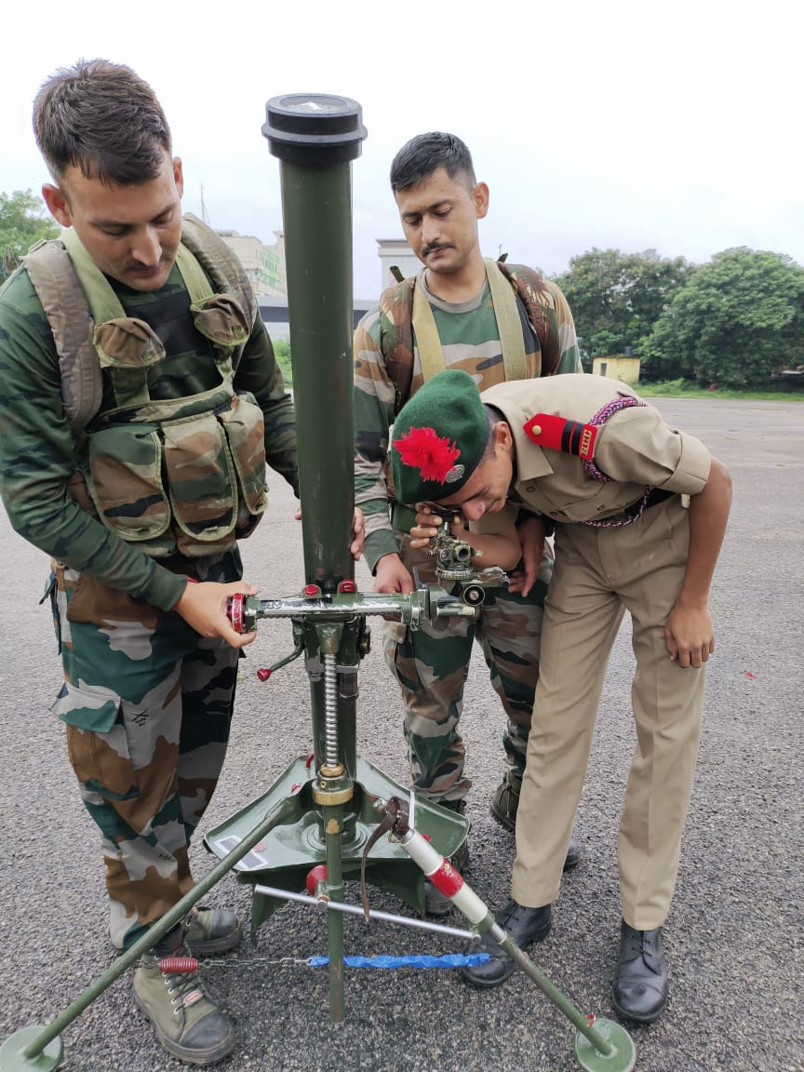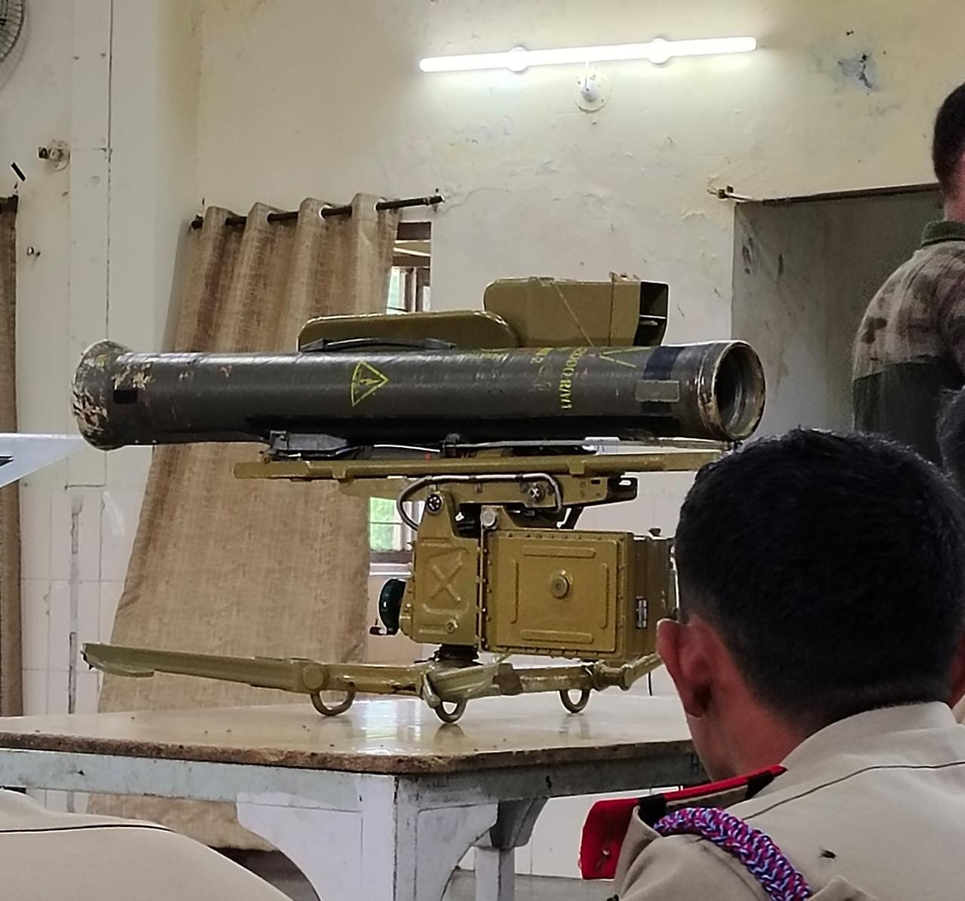
Army Attachment Camp (MEHDIPATNAM) EXPLANATION OF DIFFERENT WEPON’S USED IN INDIAN ARMY (60MM GRANADE LAUNCHER AND ATGM

Army Attachment Camp (MEHDIPATNAM)SUO PRAVEEN WITH 60MM GRANADE LAUNCHER&ATGM
S, NO | Regt. No | RANK | NAME | ROLL NO | BRANCH | SECTION | YEAR
01 | TS/21/SDA/200139 | SUO | B PRAVEEN | 21645A0508 | CSE | D | 4TH

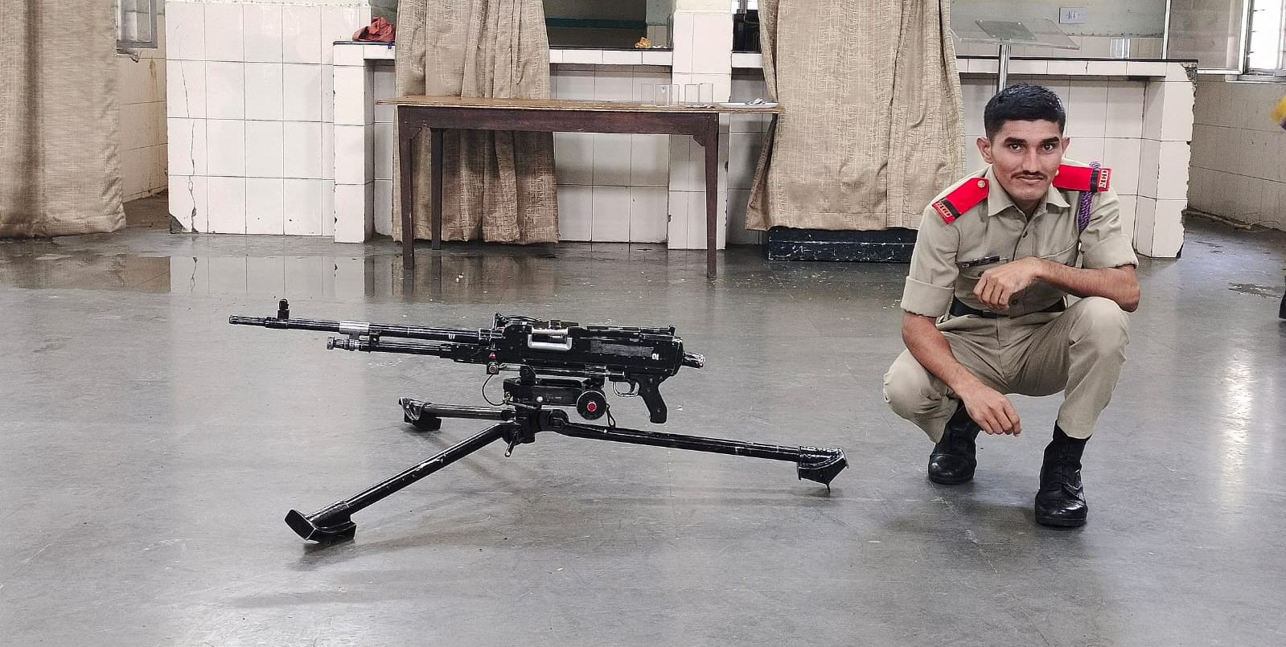

Army Attachment Camp (MEHDIPATNAM) JUO PRASANTH WITH MMG (MEDIUM MACHINE GUN)
S, NO | Regt. No | RANK | NAME | ROLL NO | BRANCH | SECTION | YEAR
01 | TS/21/SDA/200132 | JUO | J. PRASHANTH | 21645A0515 | CSE | D | 4TH

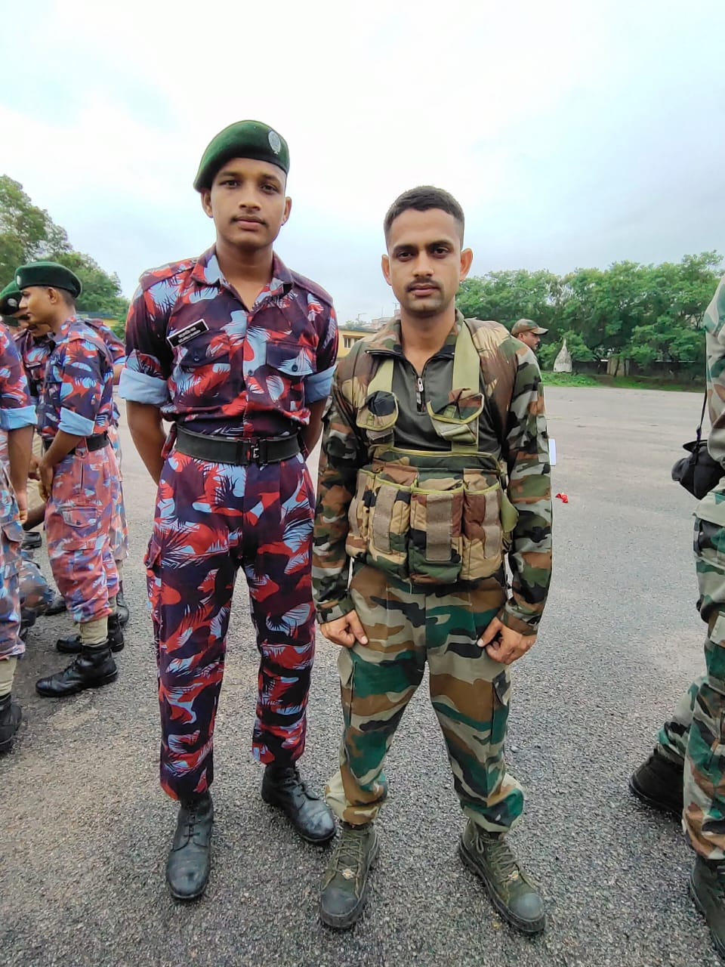

Army Attachment Camp (MEHDIPATNAM) LCPL. BHARATH SATLAPALLA
S, NO | Regt. No | RANK | NAME | ROLL NO | BRANCH | SECTION | YEAR
01 | TG/22/SDA/200134 | LCPL | BHARATH SATLAPALLI | 21641A66E6 | CSM | C | 3RD

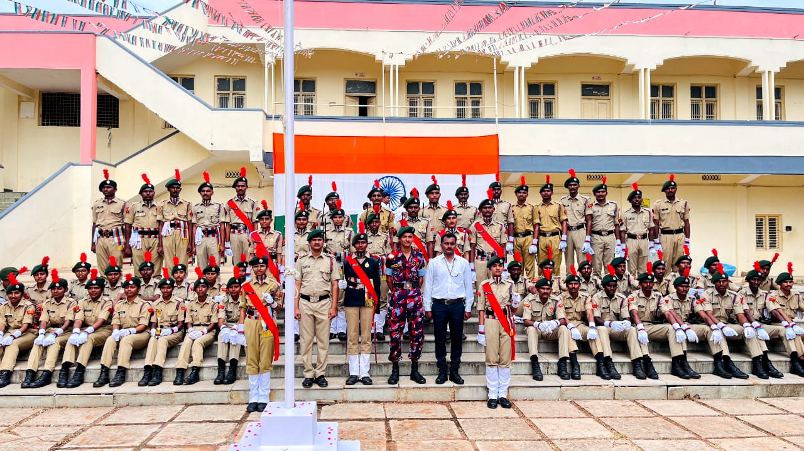Independence Day (Vaagdevi college’s) (15/08/2023)
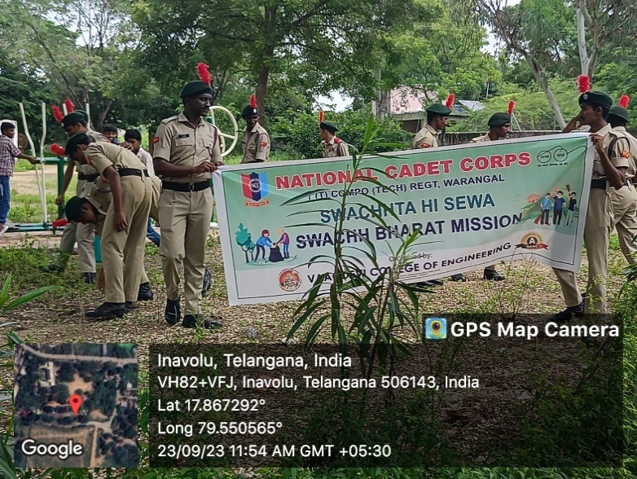
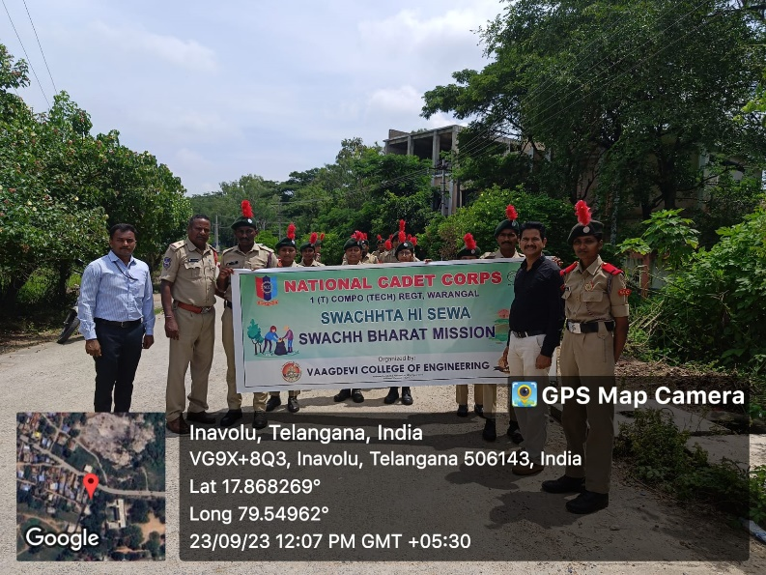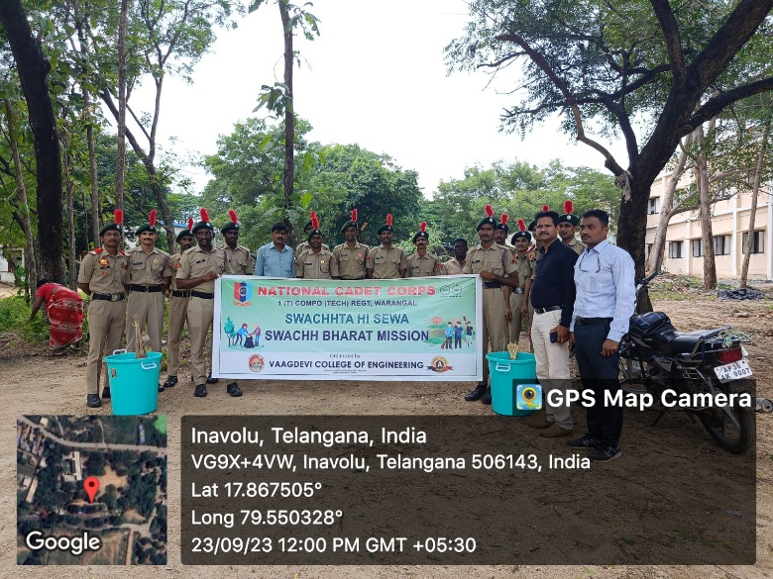
Swatch hi Seva Program (Inavolu) (23/09/2023)
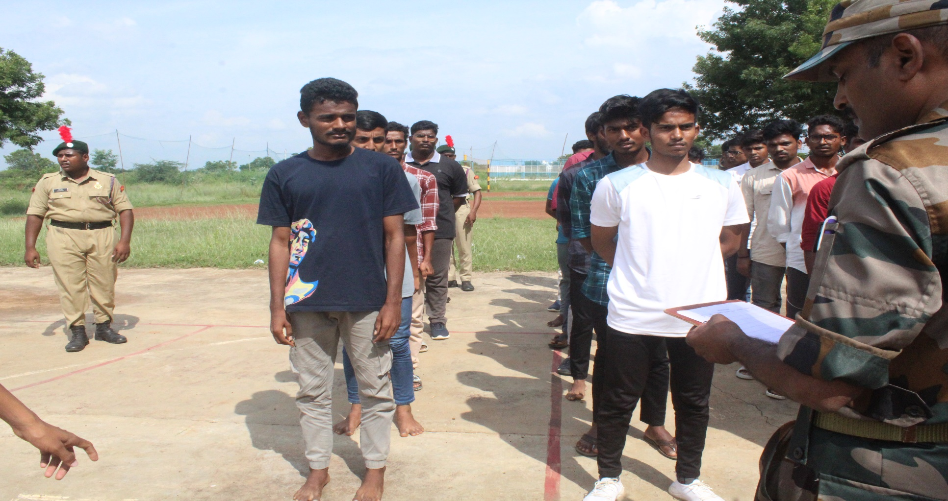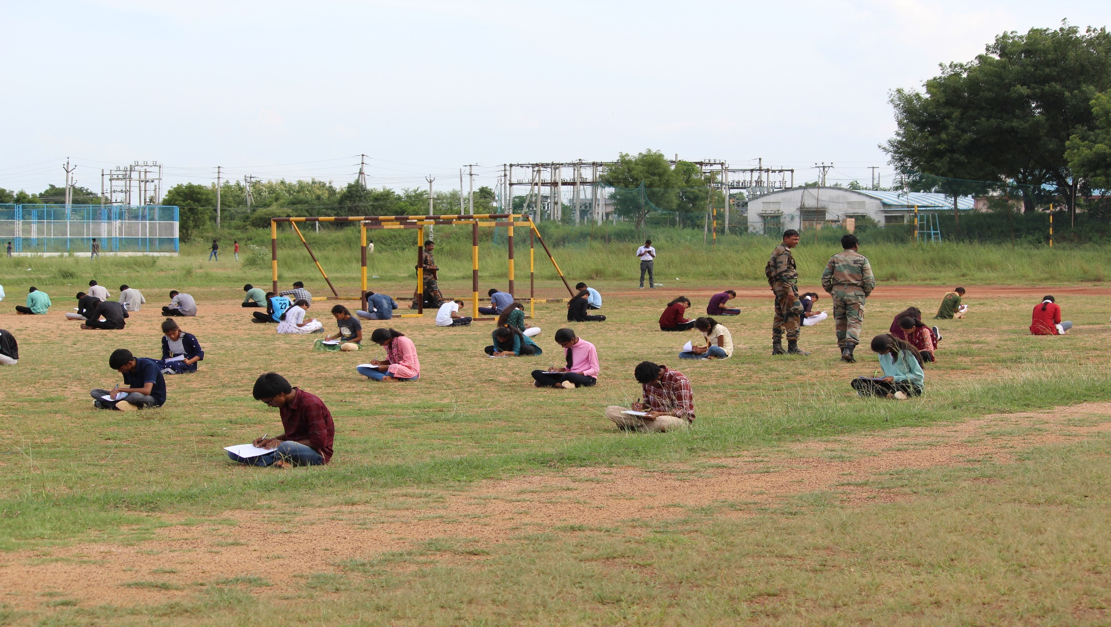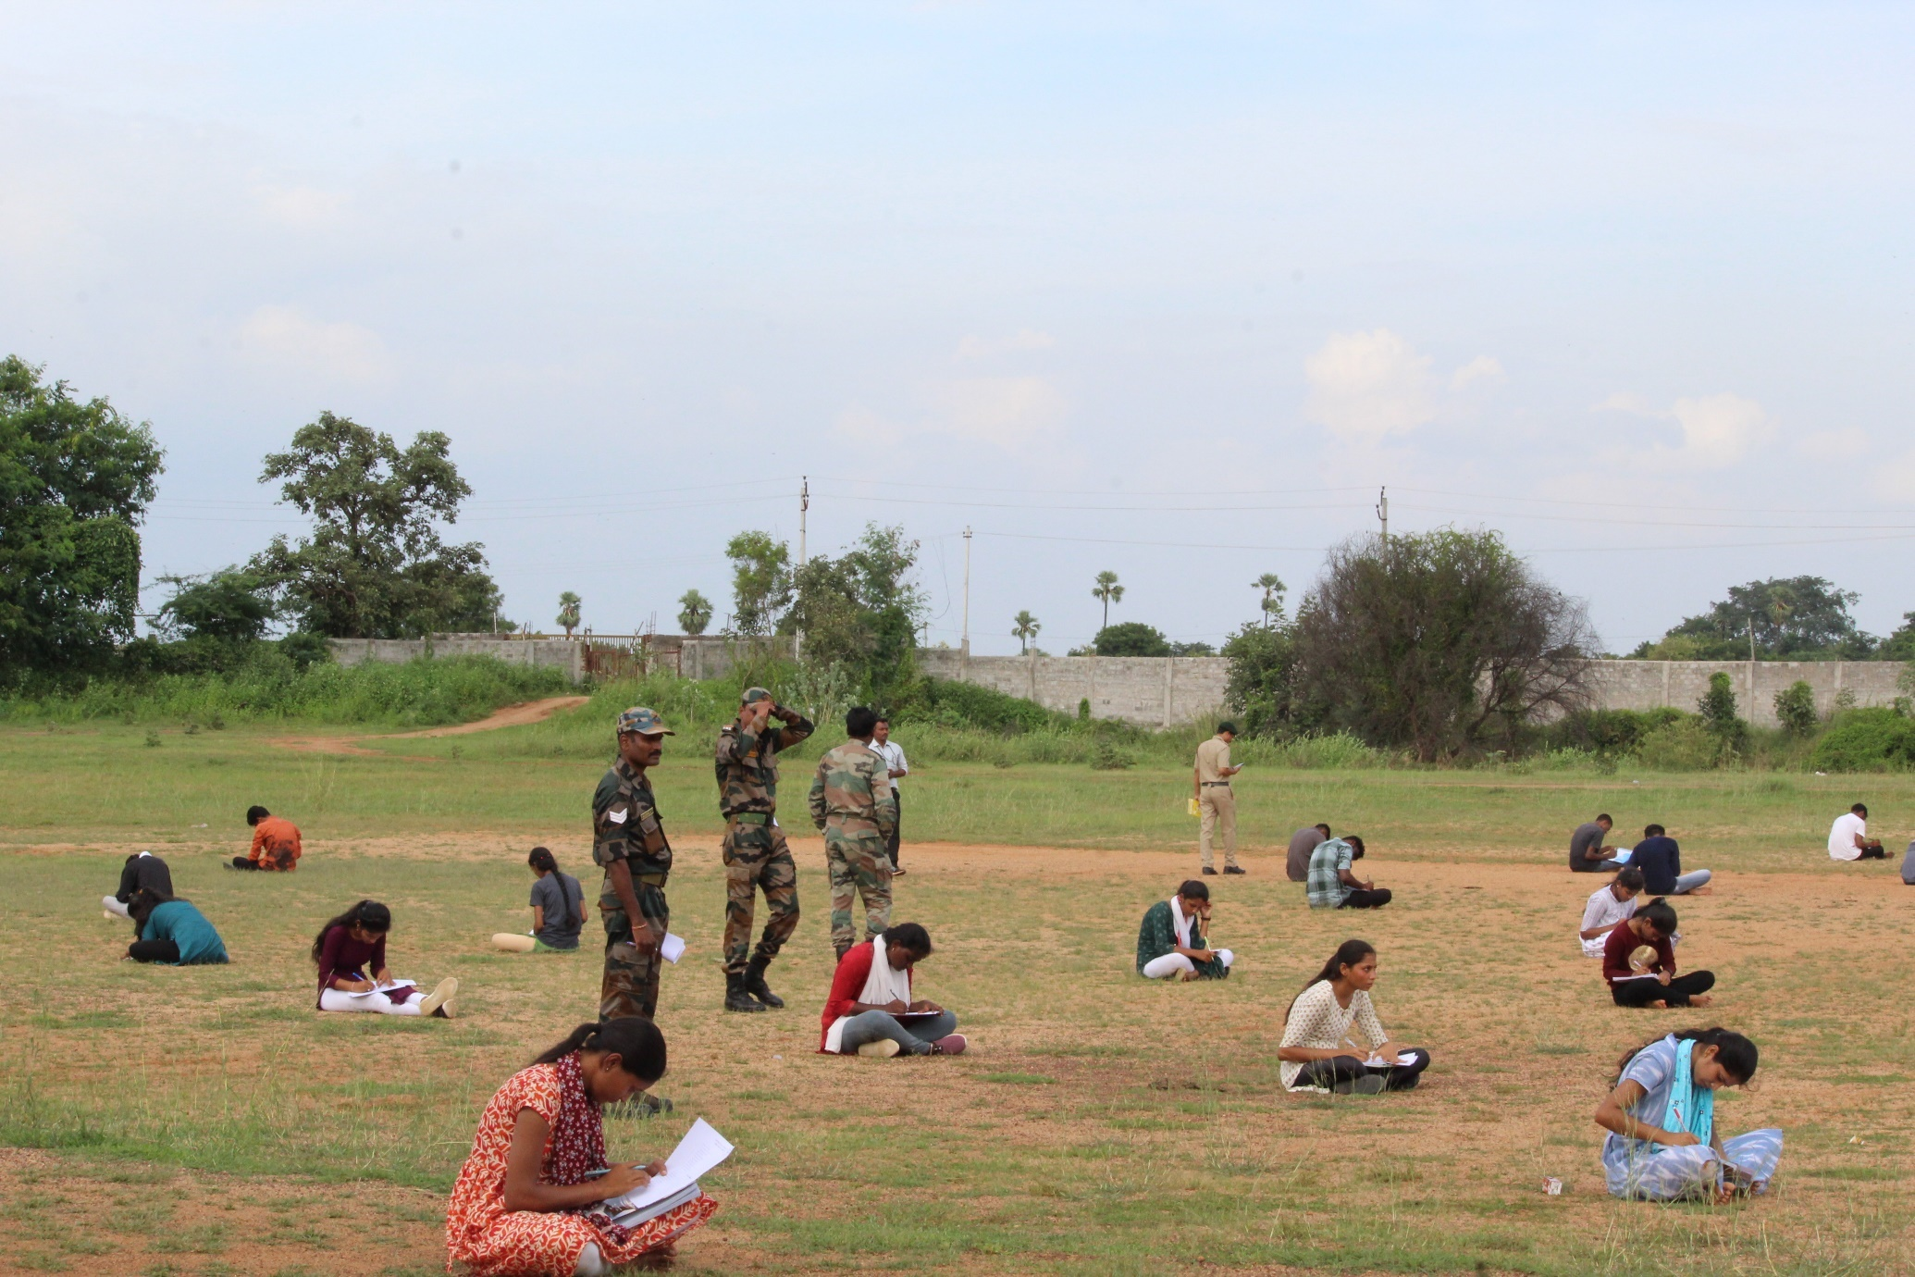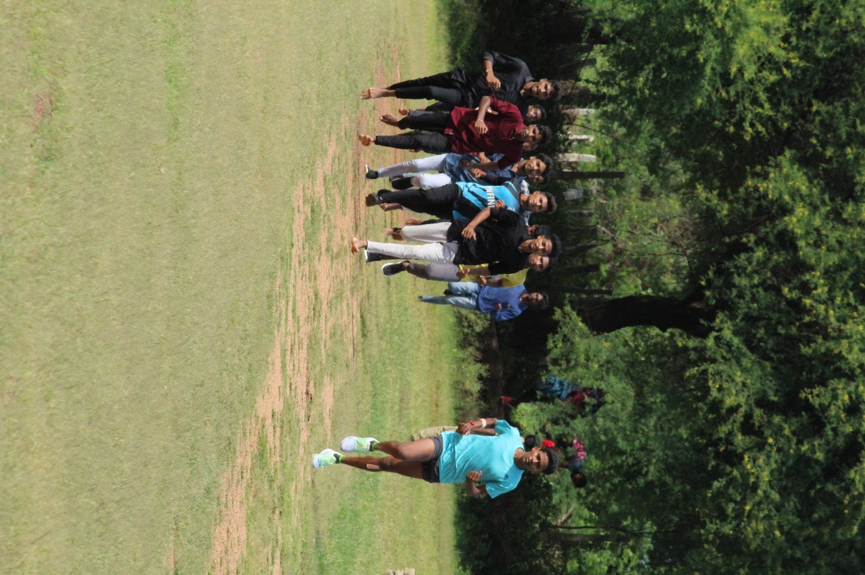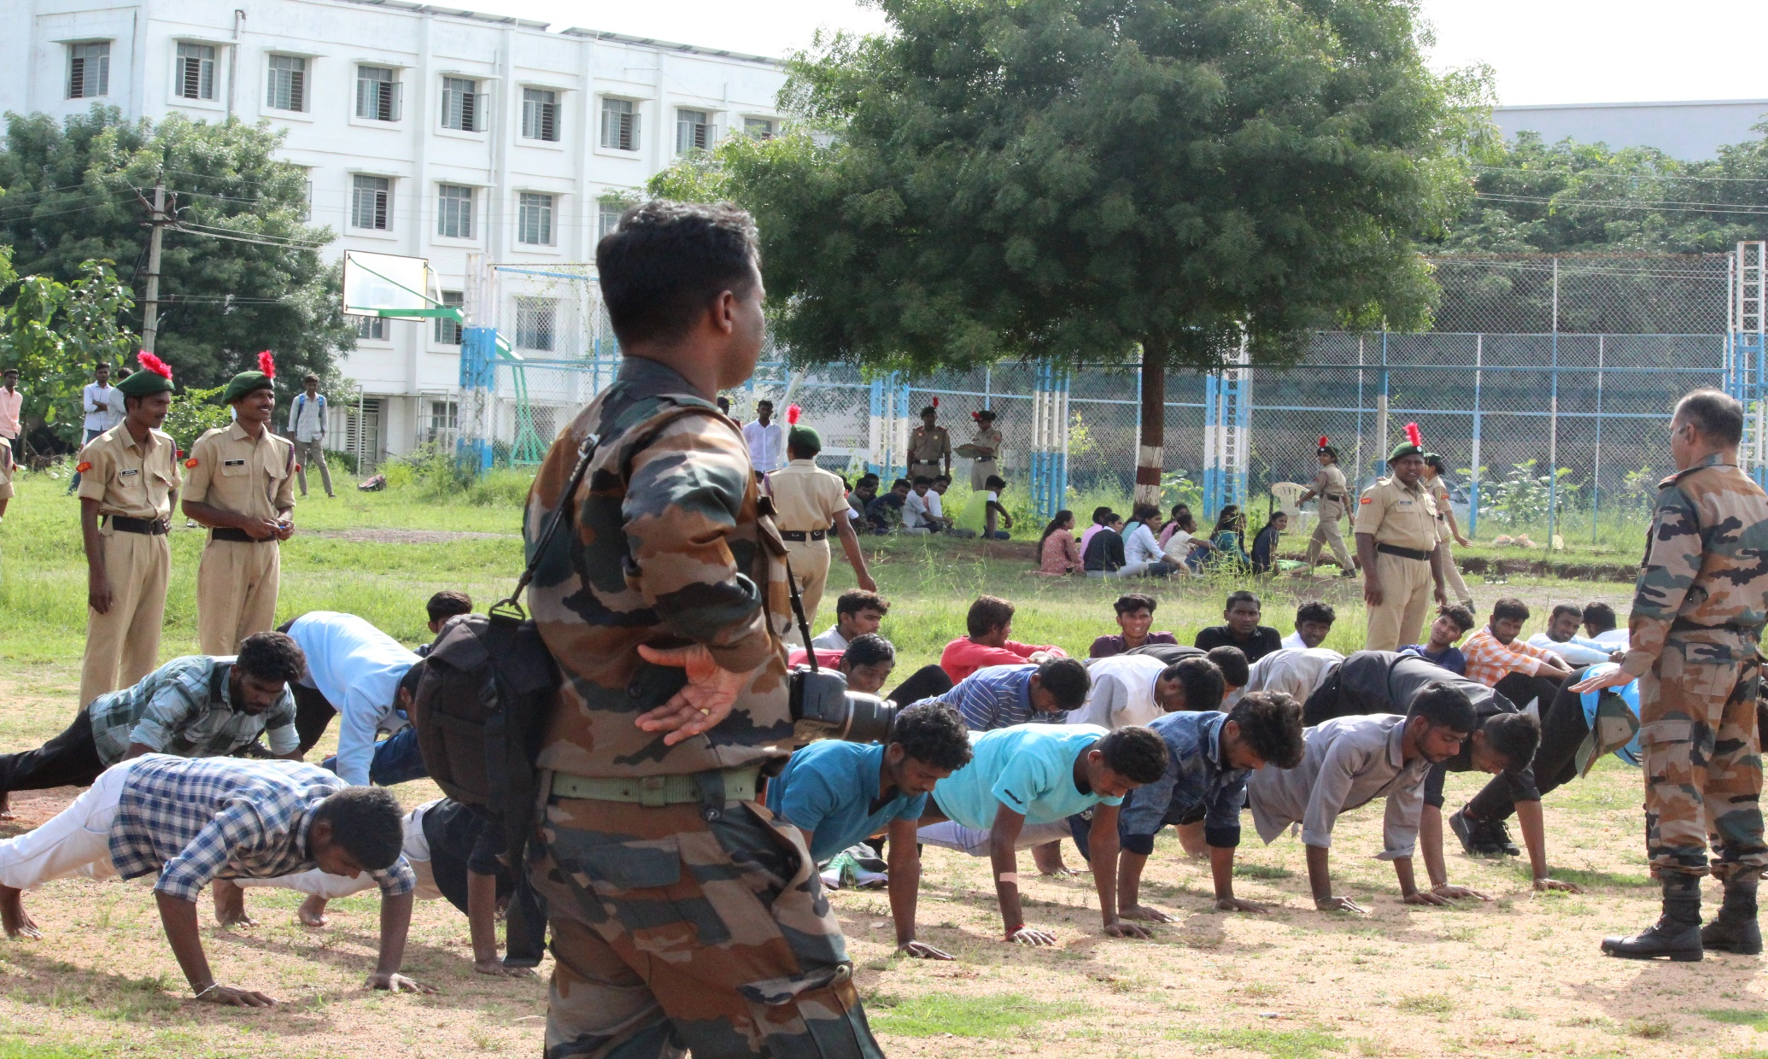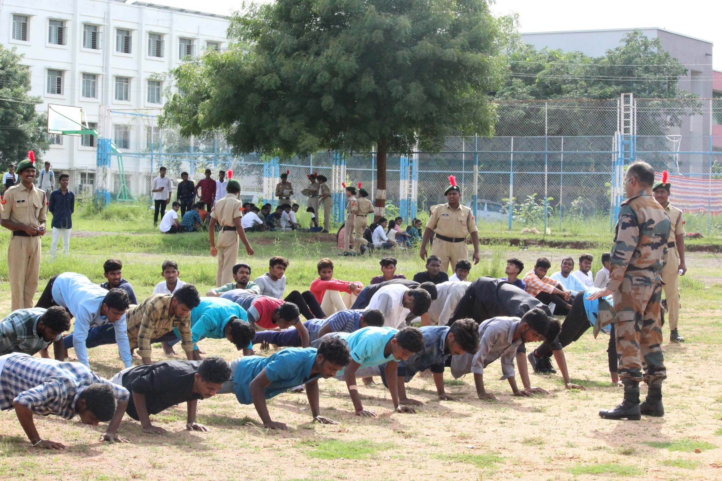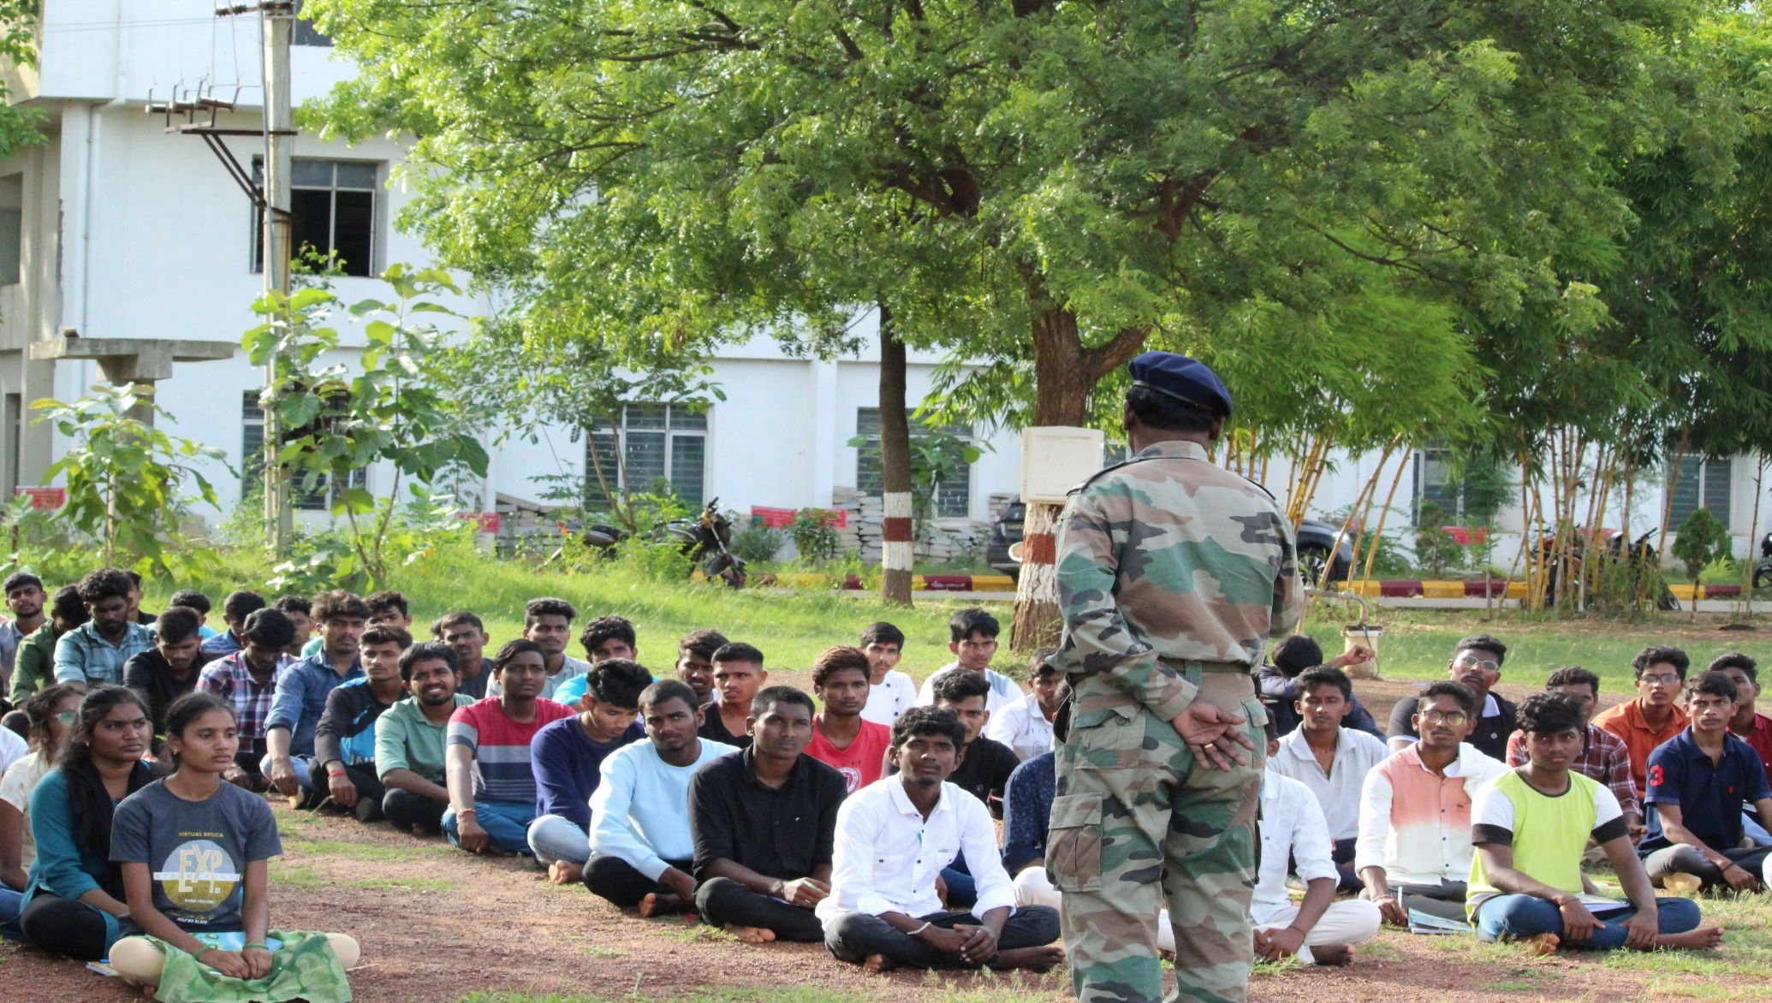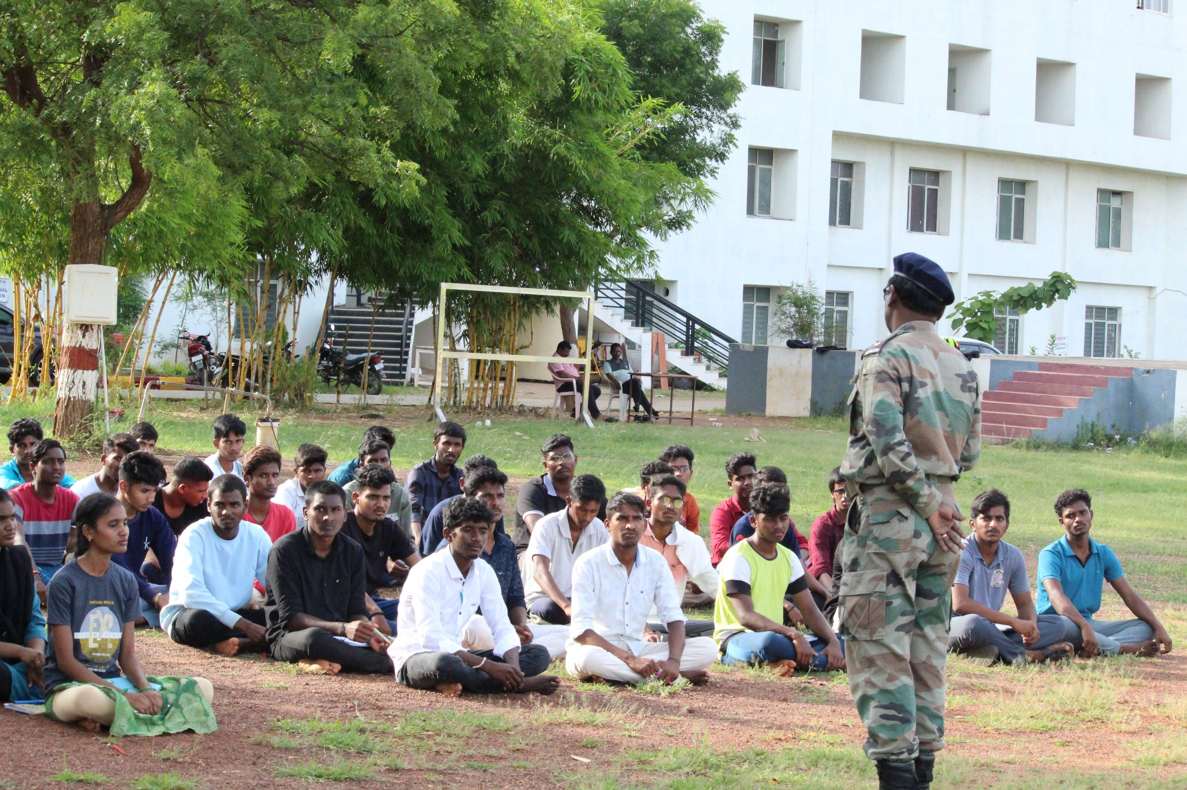
STUDENT’S PARTCIPATED IN NCC ENROLLMENT (2023-2024)
WRITEN TEST FOR STUDENT’S
PHYSICAL TEST (RUNNING& PUSHUPS)
INTERACTION OF AO SIR REGARDING NCC ENROLLMENT & BENFITS OF JOINING NCC TOWARDS NATIONAL INTIGRATION
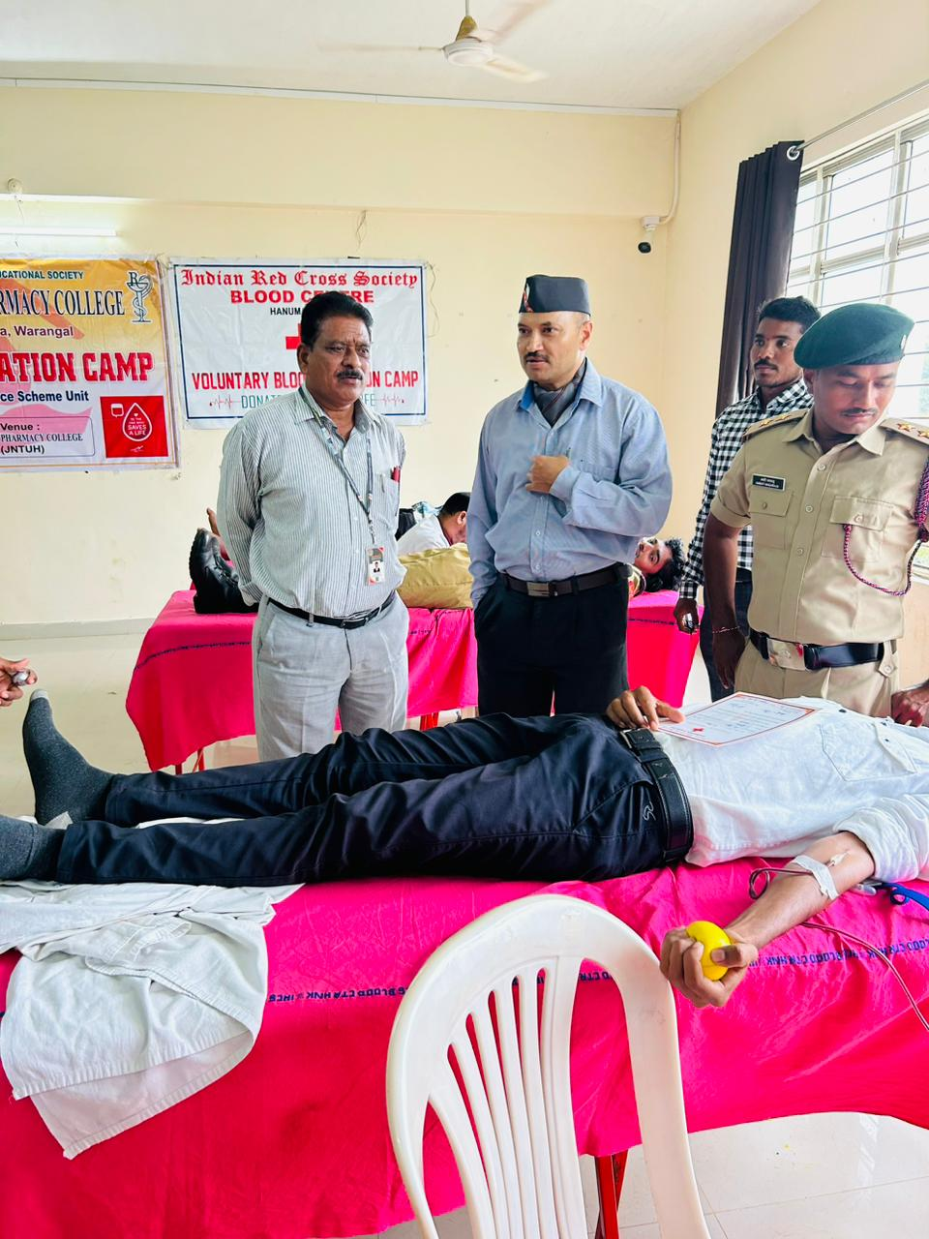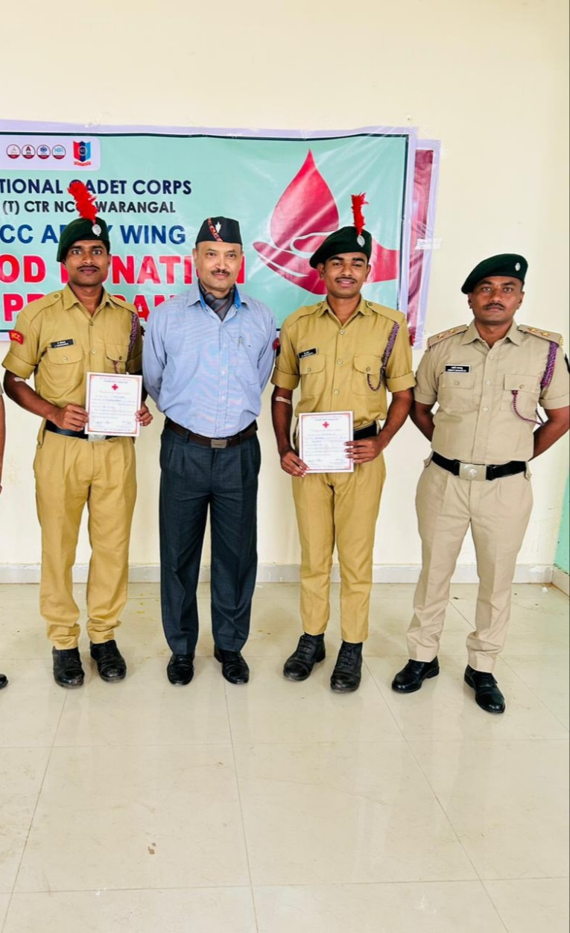
BE-HALF OF NCC Day /Blood Donation(24/11/2023)
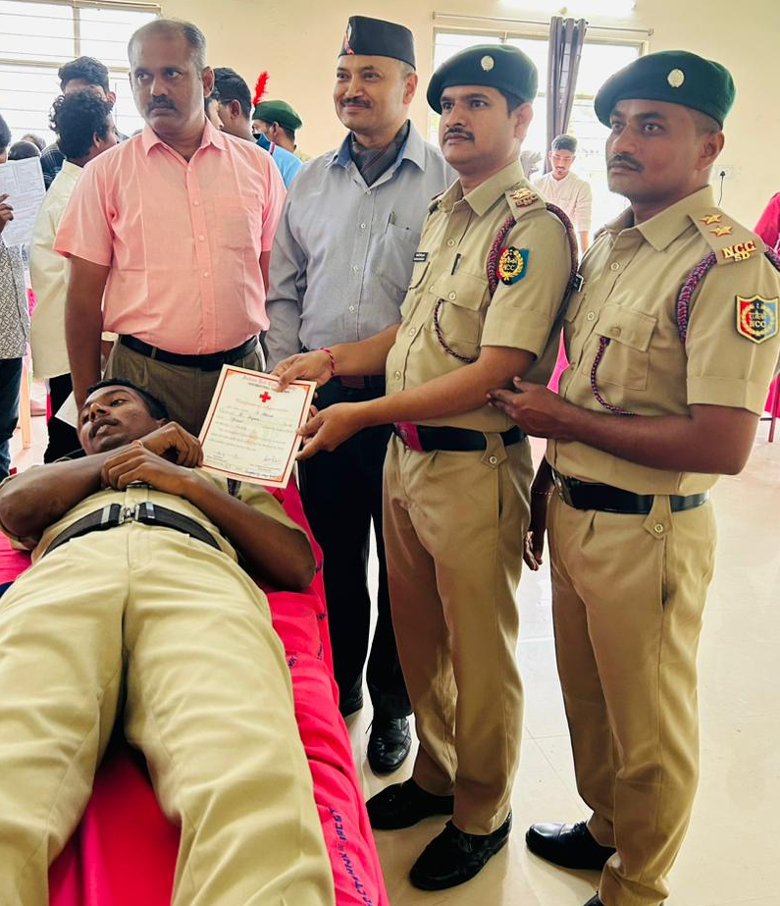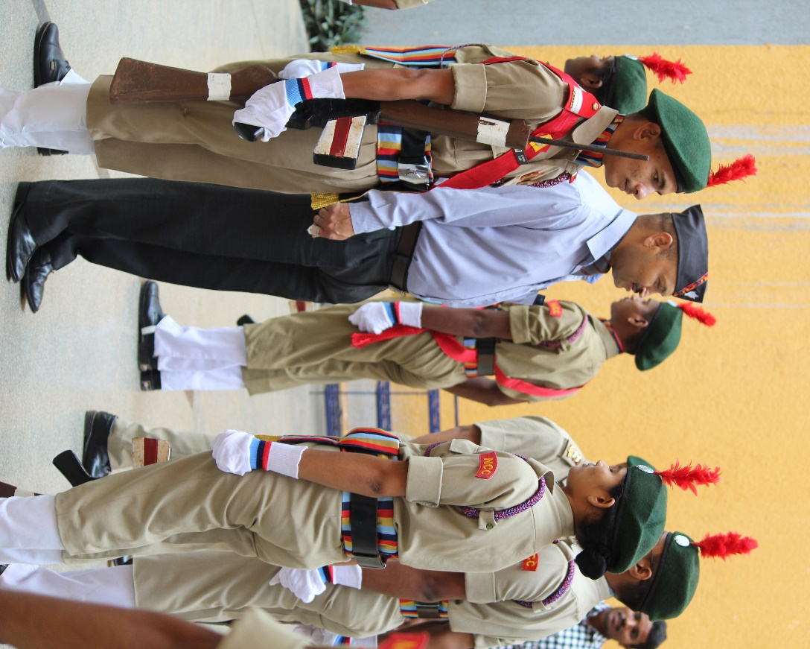
BE-HALF OF NCC Day /Blood Donation(24/11/2023)

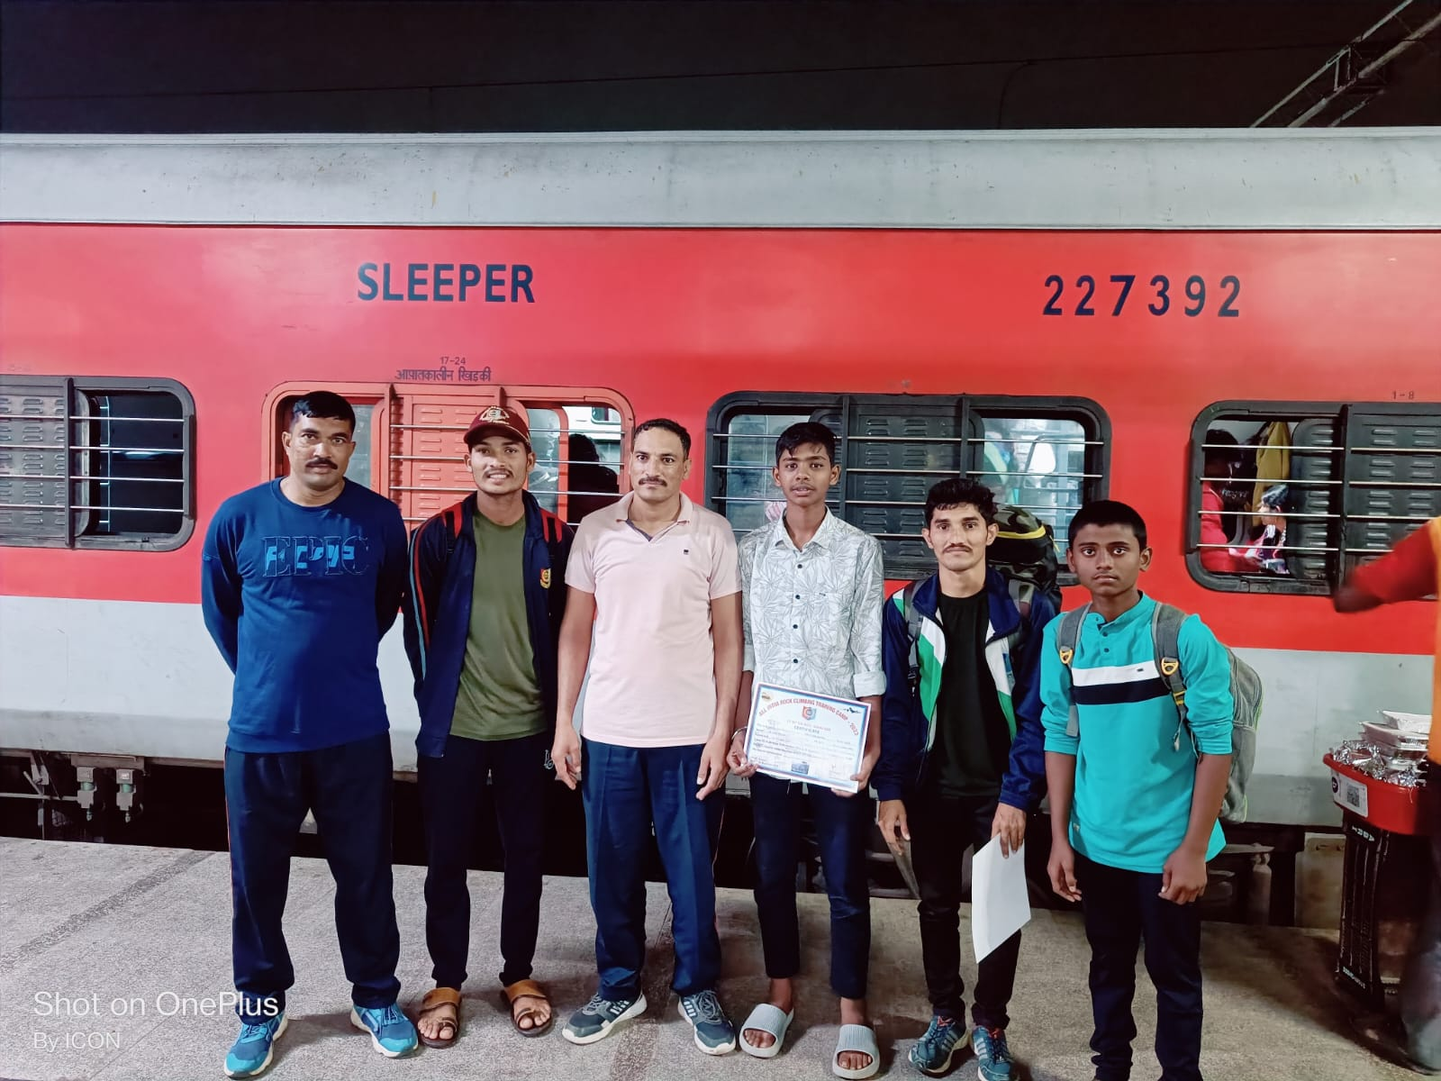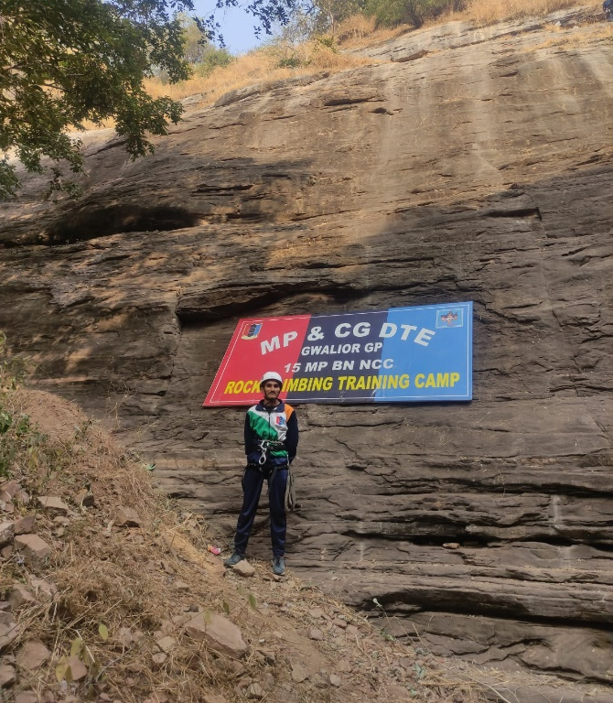

ALL INDIA ROCK CLIMBING & TRAINING CAMP(RCTC)GWALIOR
S, NO | Regt. No | RANK | NAME | ROLL NO | BRANCH | SECTION | YEAR
01 | TS/21/SDA/200132 | JUO | J. PRASHANTH | 21645A0515 | CSE | D | 4TH

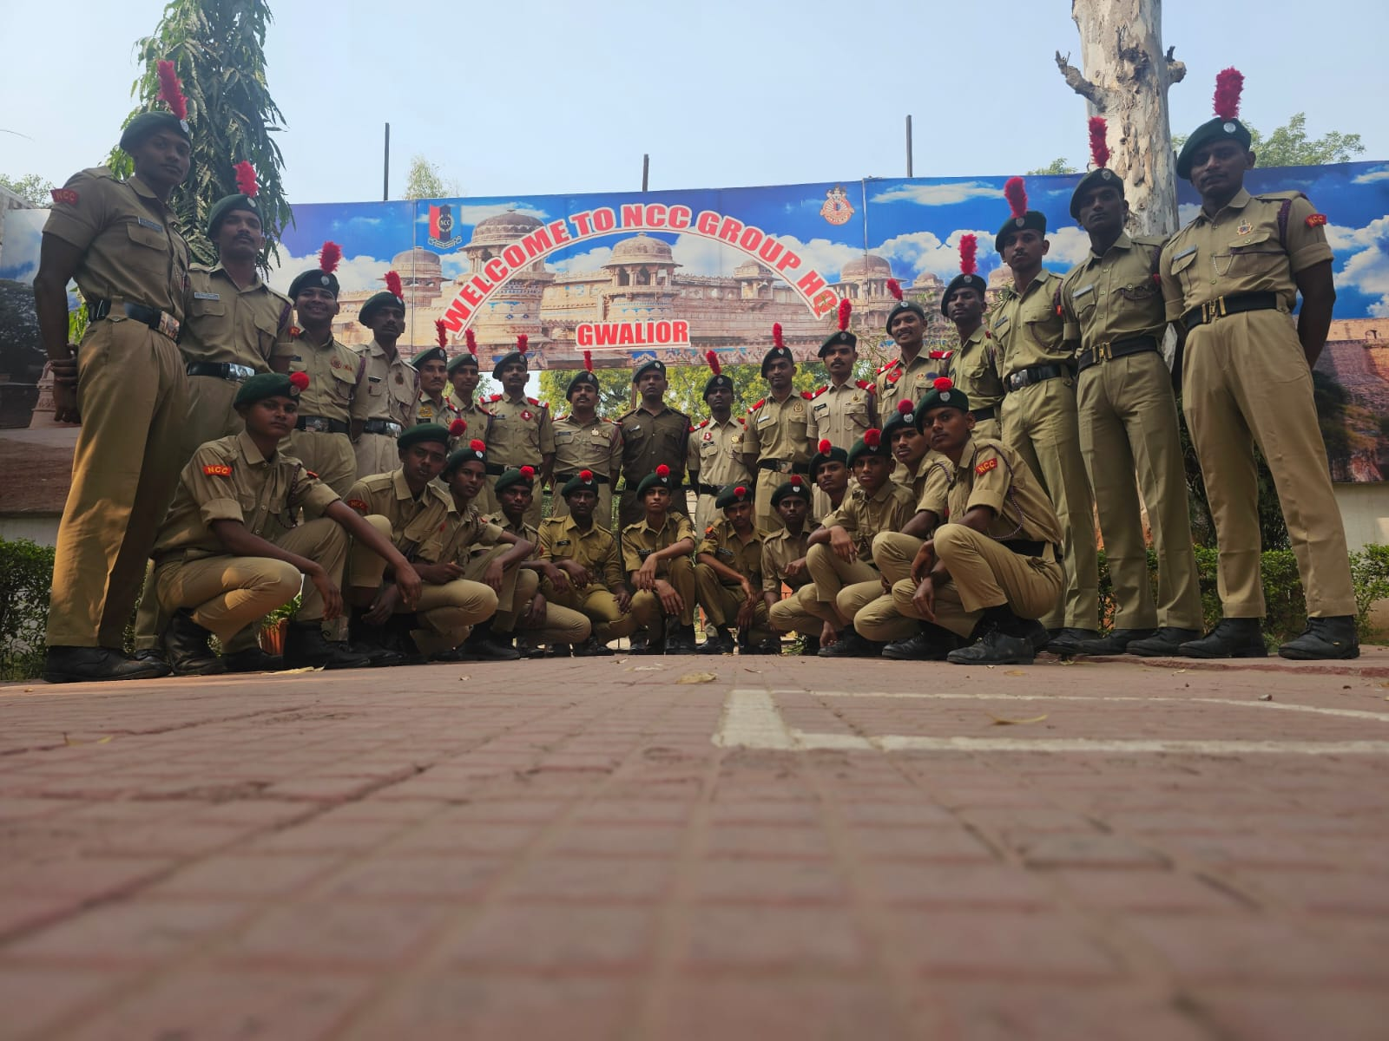
ALL INDIA ROCK CLIMBING & TRAINING CAMP(RCTC)GWALIOR

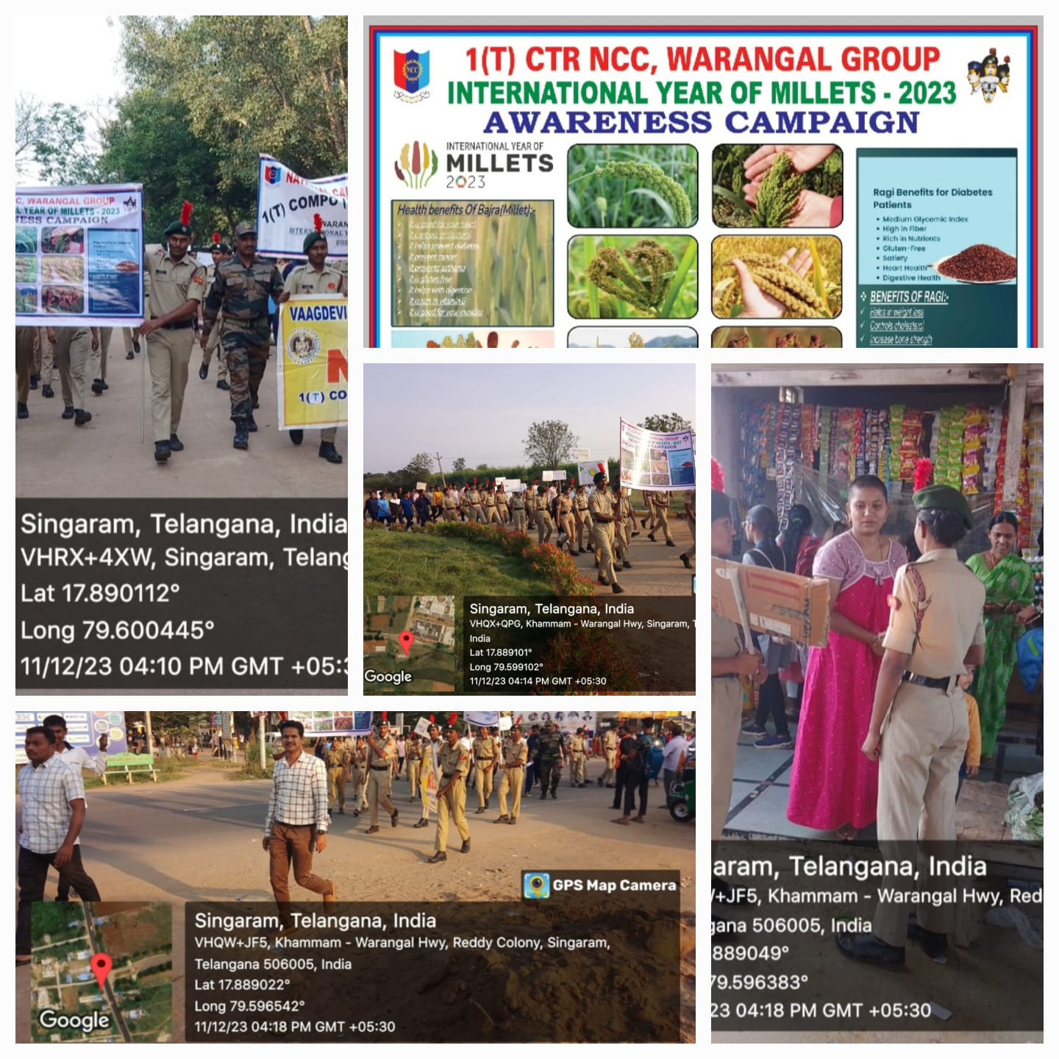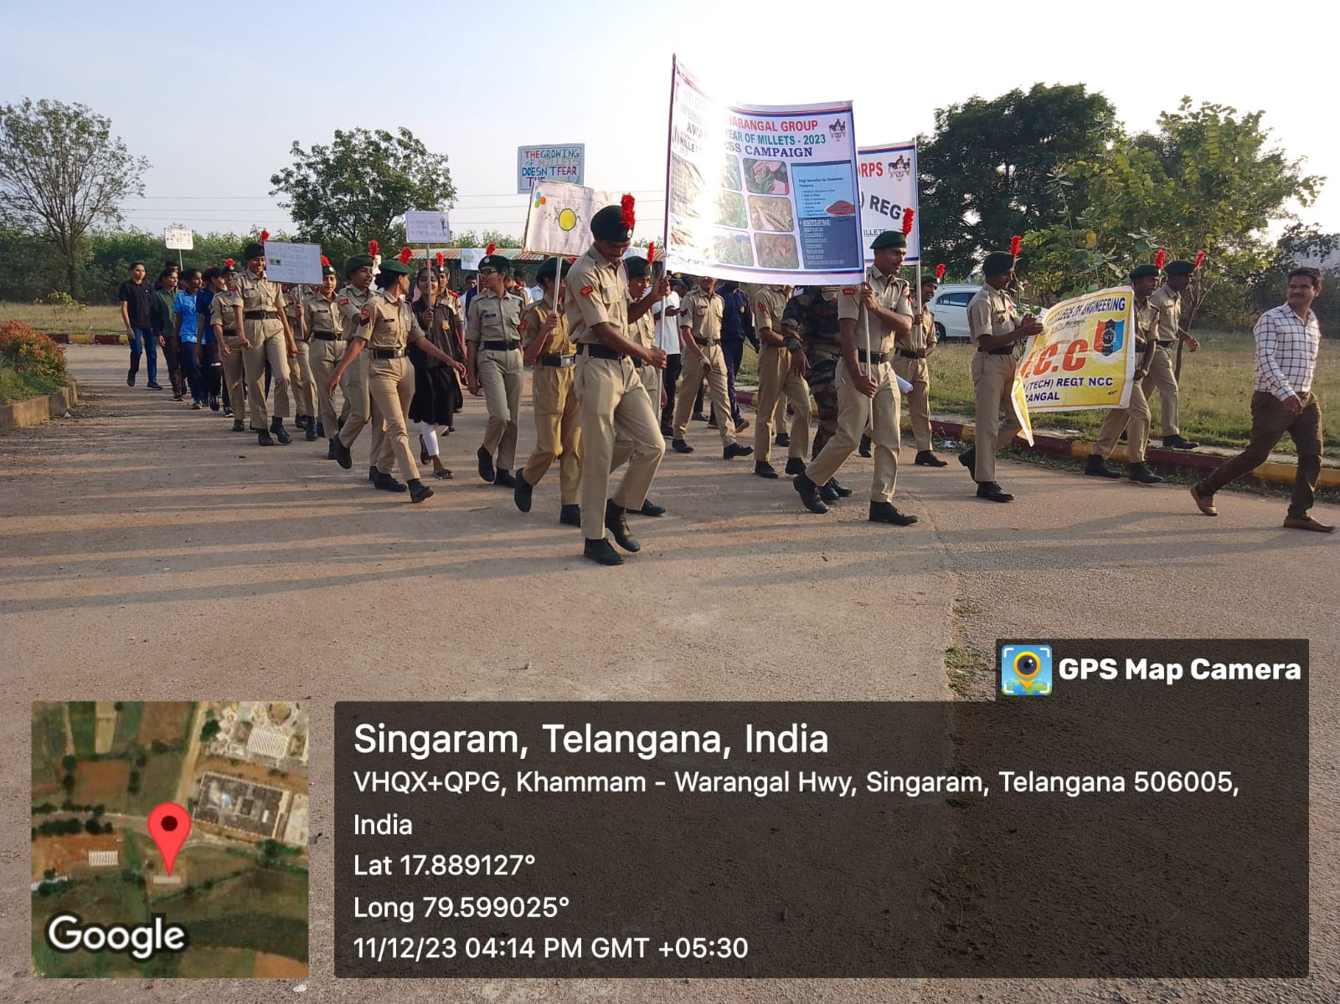
MILLET RALLEY (SINGARAM)

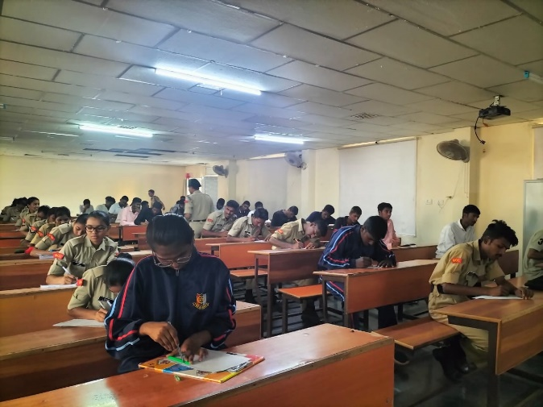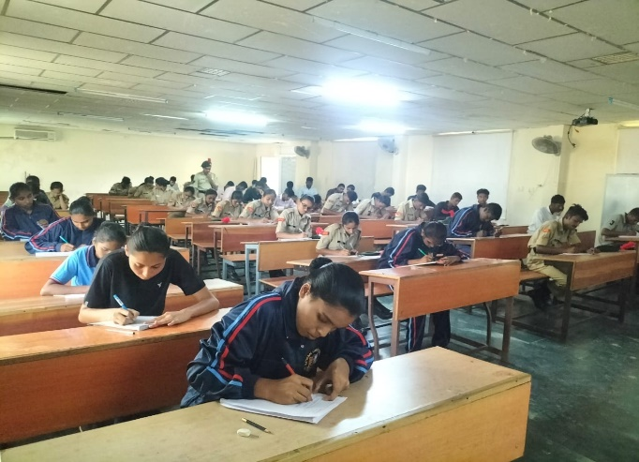

Rally/Essay Writing on Millets (VAAGDEVI COLLEGE OF ENGINEERING) (11/12/2023)

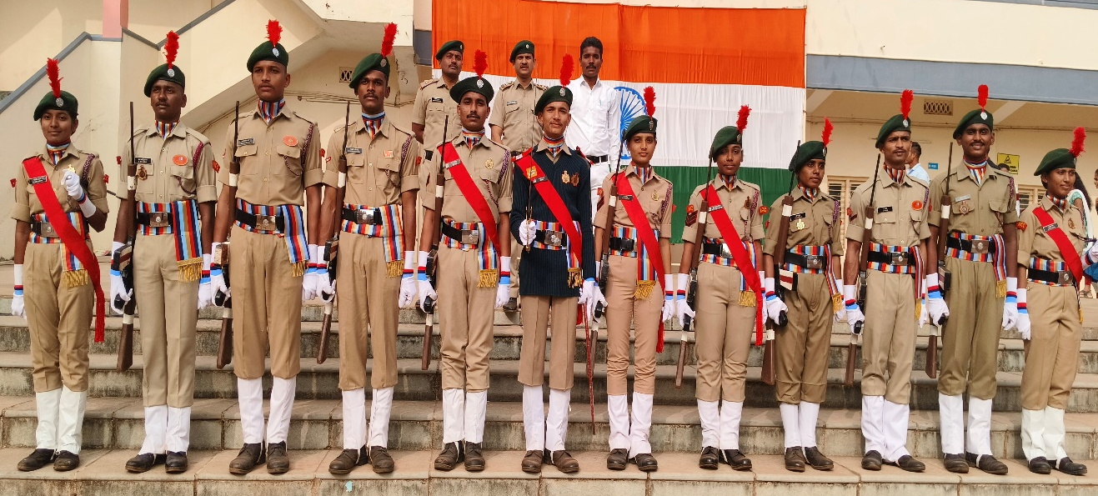
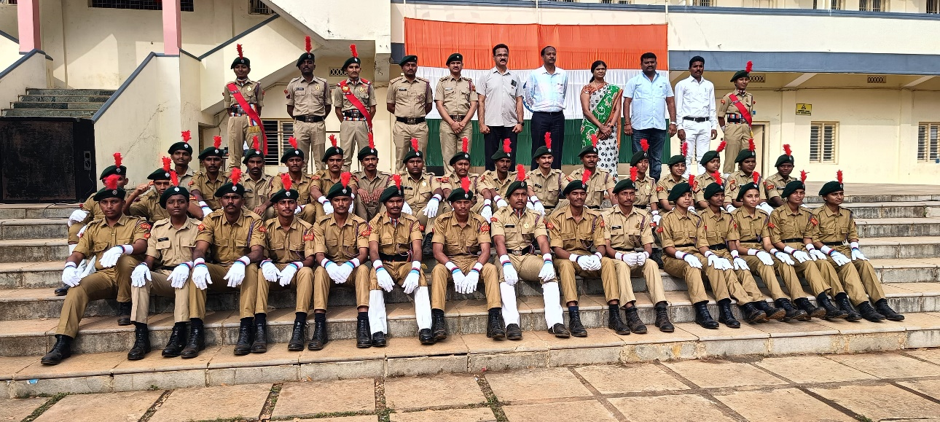
Republic Day 26-01-2024
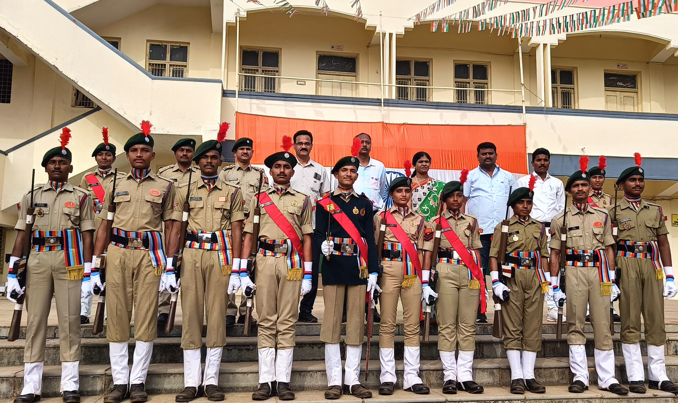
Republic Day 26-01-2024
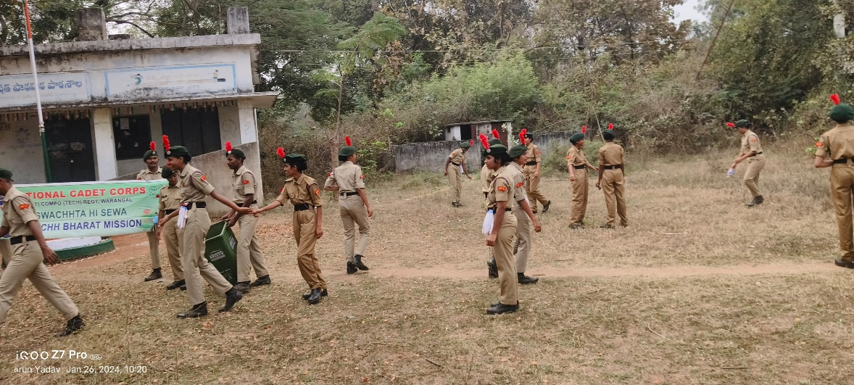
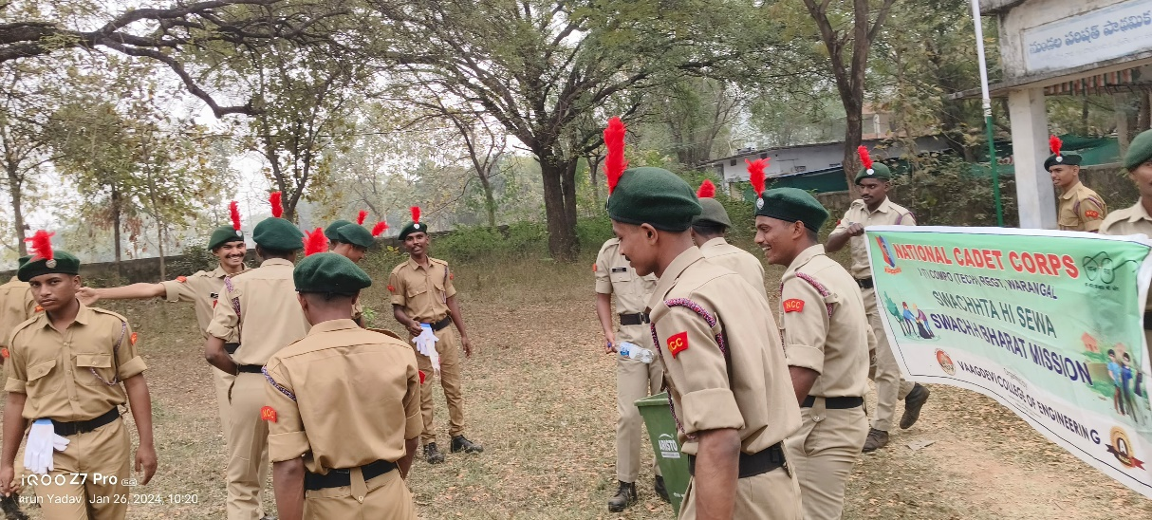
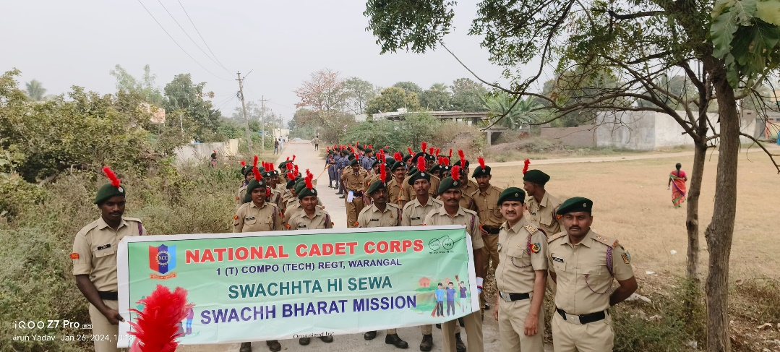
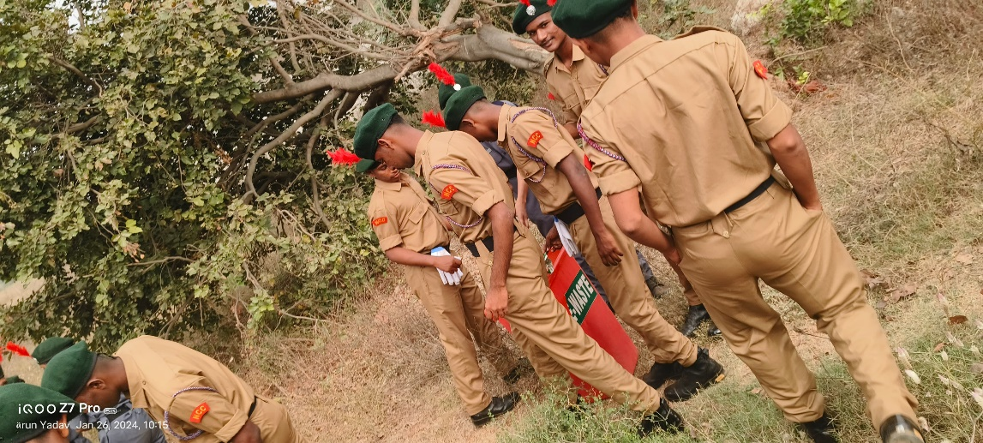

Swatch Bharath Abhyan (Swatch Hi Seva) (26-01-2024)
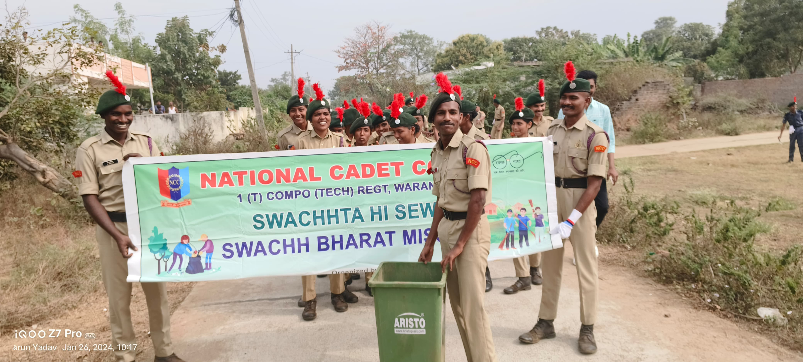

Swatch Bharath Abhyan (Swatch Hi Sewa) (26-01-202)

